United States
SECURITIES AND EXCHANGE COMMISSION
Washington, D.C. 20549

——————————————————————————

FORM 8-K

——————————————————————————

CURRENT REPORT
Pursuant to Section 13 or 15(d)
of The Securities Exchange Act of 1934

September 18, 2026
Date of Report (date of earliest event reported)

——————————————————————————
Burke & Herbert Financial Services Corp.
(Exact name of registrant as specified in its charter)

——————————————————————————
Virginia | 001-41633 | 92-0289417
(State or other jurisdiction | (Commission | (I.R.S. Employer
of incorporation) | File Number) | Identification No.)

100 S. Fairfax Street
Alexandria, VA 22314
(Address of principal executive offices and zip code)

(703) 666-3555
(Registrant’s telephone number, including area code)

——————————————————————————

Check the appropriate box below if the Form 8-K filing is intended to simultaneously satisfy the filing obligation of the registrant under any of the following provisions:

 | ☐ | Written communications pursuant to Rule 425 under the Securities Act (17 CFR 230.425)

 | ☐ | Soliciting material pursuant to Rule 14a-12 under the Exchange Act (17 CFR 240.14a-12)

 | ☐ | Pre-commencement communications pursuant to Rule 14d-2(b) under the Exchange Act (17 CFR 240.14d-2(b))

 | ☐ | Pre-commencement communications pursuant to Rule 13e-4(c) under the Exchange Act (17 CFR 240.13e-4(c))

Securities registered pursuant to Section 12(b) of the Act:
Title of each class |  | Trading Symbol(s) |  | Name of each exchange on which registered
Common Stock, par value $0.50 |  | BHRB |  | The Nasdaq Stock Market LLC

Indicate by check mark whether the registrant is an emerging growth company as defined in Rule 405 of the Securities Act of 1933 (§230.405 of this chapter) or Rule 12b-2 of the Securities Exchange Act of 1934 (§240.12b-2 of this chapter).

Emerging growth company | ☐

If an emerging growth company, indicate by check mark if the registrant has elected not to use the extended transition period for complying with any new or revised financial accounting standards provided pursuant to Section 13(a) of the Exchange Act. | ☐

Item 7.01 Regulation FD Disclosures.

Attached as Exhibit 99.1 is a presentation containing information that certain members of Burke & Herbert Financial Services Corp. (the “Company”) management will use during meetings with investors, analysts, and other interested parties to assist their understanding of the Company from time to time during the third quarter of 2026. Other presentations and related materials will be made available as they are presented.

The information in this Item 7.01 of this Current Report on Form 8-K, including Exhibit 99.1 attached hereto, is being furnished and shall not be deemed “filed” for the purposes of Section 18 of the Securities Exchange Act of 1934, as amended (the “Exchange Act”), or otherwise subject to the liabilities of that Section, nor shall it be deemed subject to the requirements of amended Item 10 of Regulation S-K, nor shall it be deemed incorporated by reference into any filing of the Company under the Securities Act of 1933, as amended, or the Exchange Act, whether made before or after the date hereof, regardless of any general incorporation language in such filing. The furnishing of this information hereby shall not be deemed an admission as to the materiality of any such information.

Item 9.01 Financial Statements and Exhibits.

(d) The following exhibits are being filed herewith:
Exhibit No. |  | Description
99.1 |  | Burke & Herbert Financial Services Corp. investor presentation
104 |  | Cover Page Interactive Data File – the cover page iXBRL tags are embedded within the Inline XBRL document

SIGNATURE

Pursuant to the requirements of the Securities Exchange Act of 1934, as amended, the Registrant has duly caused this report to be signed on its behalf by the undersigned hereunto duly authorized.

 | Burke & Herbert Financial Services Corp.
Date: September 18, 2026 | By: | /s/ Kirtan Parikh
 | Name: | Kirtan Parikh
 | Title: | Executive Vice President, CFO

Exhibit 99.1

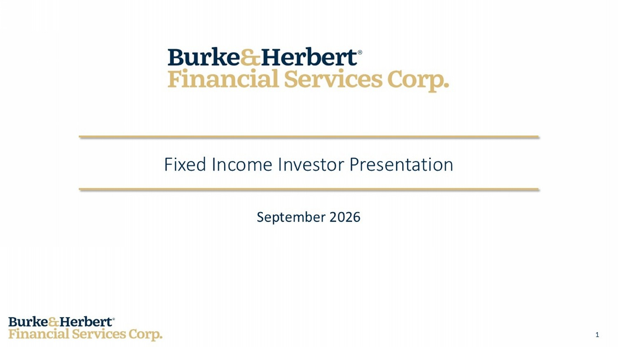
1 September 2026 Fixed Income Investor Presentation

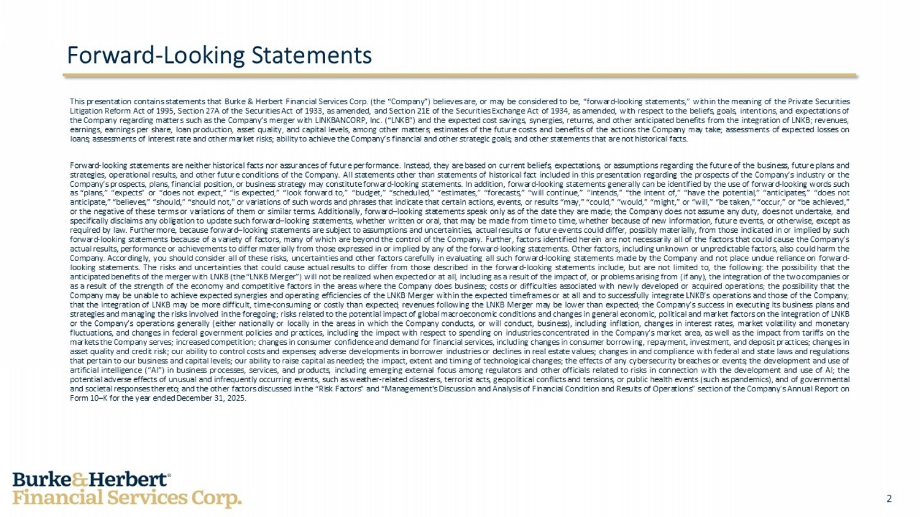
2 Forward - Looking Statements This presentation contains statements that Burke & Herbert Financial Services Corp . (the “Company”) believes are, or may be considered to be, “forward - looking statements,” within the meaning of the Private Securities Litigation Reform Act of 1995 , Section 27 A of the Securities Act of 1933 , as amended, and Section 21 E of the Securities Exchange Act of 1934 , as amended, with respect to the beliefs, goals, intentions, and expectations of the Company regarding matters such as the Company’s merger with LINKBANCORP, Inc . (“LNKB”) and the expected cost savings, synergies, returns, and other anticipated benefits from the integration of LNKB ; revenues, earnings, earnings per share, loan production, asset quality, and capital levels, among other matters ; estimates of the future costs and benefits of the actions the Company may take ; assessments of expected losses on loans ; assessments of interest rate and other market risks ; ability to achieve the Company’s financial and other strategic goals ; and other statements that are not historical facts . Forward - looking statements are neither historical facts nor assurances of future performance . Instead, they are based on current beliefs, expectations, or assumptions regarding the future of the business, future plans and strategies, operational results, and other future conditions of the Company . All statements other than statements of historical fact included in this presentation regarding the prospects of the Company’s industry or the Company’s prospects, plans, financial position, or business strategy may constitute forward - looking statements . In addition, forward - looking statements generally can be identified by the use of forward - looking words such as “plans,” “expects” or “does not expect,” “is expected,” “look forward to,” “budget,” “scheduled,” “estimates,” “forecasts,” “will continue,” “intends,” “the intent of,” “have the potential,” “anticipates,” “does not anticipate,” “believes,” “should,” “should not,” or variations of such words and phrases that indicate that certain actions, events, or results “may,” “could,” “would,” “might,” or “will,” “be taken,” “occur,” or “be achieved,” or the negative of these terms or variations of them or similar terms . Additionally, forward – looking statements speak only as of the date they are made ; the Company does not assume any duty, does not undertake, and specifically disclaims any obligation to update such forward – looking statements, whether written or oral, that may be made from time to time, whether because of new information, future events, or otherwise, except as required by law . Furthermore, because forward – looking statements are subject to assumptions and uncertainties, actual results or future events could differ, possibly materially, from those indicated in or implied by such forward - looking statements because of a variety of factors, many of which are beyond the control of the Company . Further, factors identified herein are not necessarily all of the factors that could cause the Company’s actual results, performance or achievements to differ materially from those expressed in or implied by any of the forward - looking statements . Other factors, including unknown or unpredictable factors, also could harm the Company . Accordingly, you should consider all of these risks, uncertainties and other factors carefully in evaluating all such forward - looking statements made by the Company and not place undue reliance on forward - looking statements . The risks and uncertainties that could cause actual results to differ from those described in the forward - looking statements include, but are not limited to, the following : the possibility that the anticipated benefits of the merger with LNKB (the “LNKB Merger”) will not be realized when expected or at all, including as a result of the impact of, or problems arising from (if any), the integration of the two companies or as a result of the strength of the economy and competitive factors in the areas where the Company does business ; costs or difficulties associated with newly developed or acquired operations ; the possibility that the Company may be unable to achieve expected synergies and operating efficiencies of the LNKB Merger within the expected timeframes or at all and to successfully integrate LNKB’s operations and those of the Company ; that the integration of LNKB may be more difficult, time - consuming or costly than expected ; revenues following the LNKB Merger may be lower than expected ; the Company’s success in executing its business plans and strategies and managing the risks involved in the foregoing ; risks related to the potential impact of global macroeconomic conditions and changes in general economic, political and market factors on the integration of LNKB or the Company’s operations generally (either nationally or locally in the areas in which the Company conducts, or will conduct, business), including inflation, changes in interest rates, market volatility and monetary fluctuations, and changes in federal government policies and practices, including the impact with respect to spending on industries concentrated in the Company’s market area, as well as the impact from tariffs on the markets the Company serves ; increased competition ; changes in consumer confidence and demand for financial services, including changes in consumer borrowing, repayment, investment, and deposit practices ; changes in asset quality and credit risk ; our ability to control costs and expenses ; adverse developments in borrower industries or declines in real estate values ; changes in and compliance with federal and state laws and regulations that pertain to our business and capital levels ; our ability to raise capital as needed ; the impact, extent and timing of technological changes ; the effects of any cybersecurity breaches or events ; the development and use of artificial intelligence (“AI”) in business processes, services, and products, including emerging external focus among regulators and other officials related to risks in connection with the development and use of AI ; the potential adverse effects of unusual and infrequently occurring events, such as weather - related disasters, terrorist acts, geopolitical conflicts and tensions, or public health events (such as pandemics), and of governmental and societal responses thereto ; and the other factors discussed in the “Risk Factors” and “Management's Discussion and Analysis of Financial Condition and Results of Operations” section of the Company's Annual Report on Form 10 – K for the year ended December 31 , 2025 .

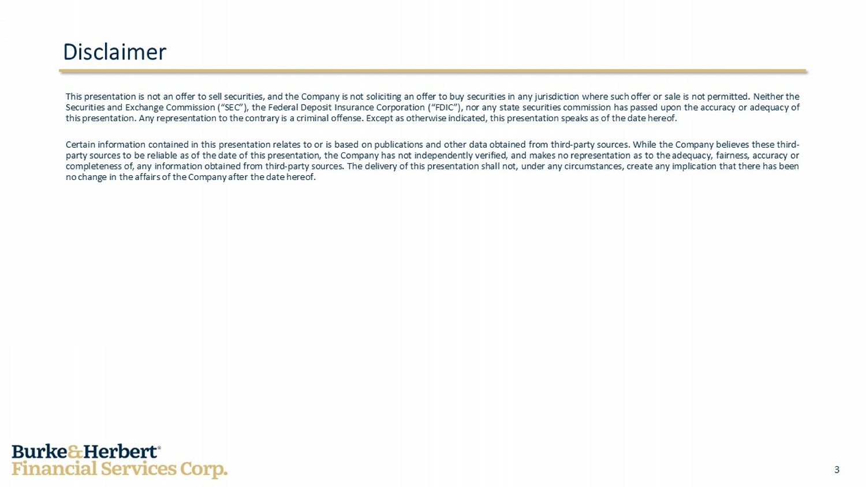
3 Disclaimer This presentation is not an offer to sell securities, and the Company is not soliciting an offer to buy securities in any jurisdiction where such offer or sale is not permitted . Neither the Securities and Exchange Commission (“SEC”), the Federal Deposit Insurance Corporation (“FDIC”), nor any state securities commission has passed upon the accuracy or adequacy of this presentation . Any representation to the contrary is a criminal offense . Except as otherwise indicated, this presentation speaks as of the date hereof . Certain information contained in this presentation relates to or is based on publications and other data obtained from third - party sources . While the Company believes these third - party sources to be reliable as of the date of this presentation, the Company has not independently verified, and makes no representation as to the adequacy, fairness, accuracy or completeness of, any information obtained from third - party sources . The delivery of this presentation shall not, under any circumstances, create any implication that there has been no change in the affairs of the Company after the date hereof .

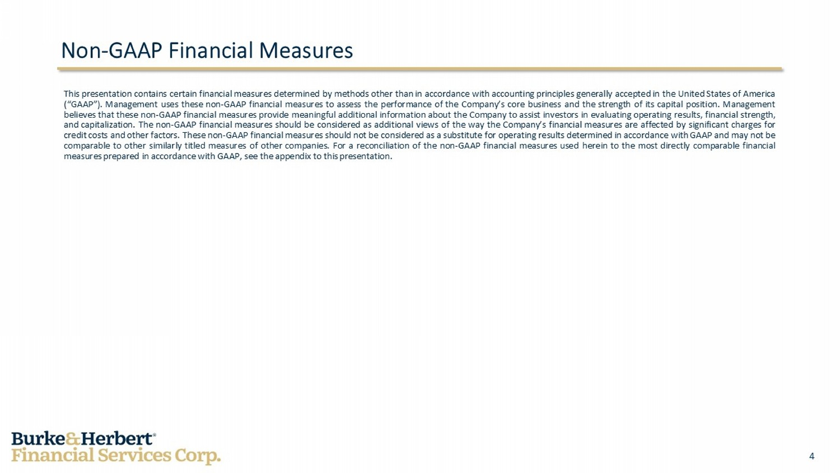
4 Non - GAAP Financial Measures This presentation contains certain financial measures determined by methods other than in accordance with accounting principles generally accepted in the United States of America (“GAAP”) . Management uses these non - GAAP financial measures to assess the performance of the Company’s core business and the strength of its capital position . Management believes that these non - GAAP financial measures provide meaningful additional information about the Company to assist investors in evaluating operating results, financial strength, and capitalization . The non - GAAP financial measures should be considered as additional views of the way the Company’s financial measures are affected by significant charges for credit costs and other factors . These non - GAAP financial measures should not be considered as a substitute for operating results determined in accordance with GAAP and may not be comparable to other similarly titled measures of other companies . For a reconciliation of the non - GAAP financial measures used herein to the most directly comparable financial measures prepared in accordance with GAAP, see the appendix to this presentation .

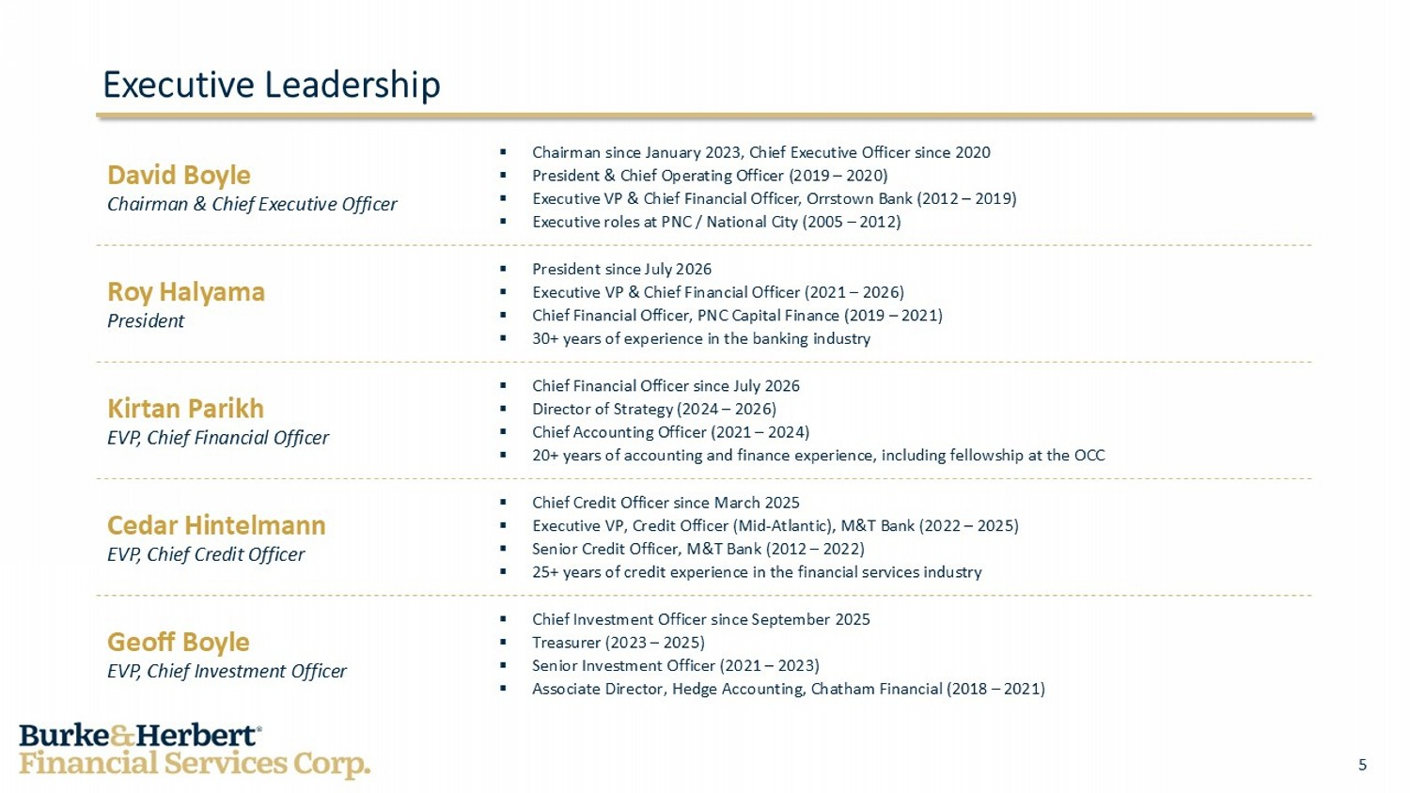
5 Executive Leadership David Boyle Chairman & Chief Executive Officer ▪ Chairman since January 2023, Chief Executive Officer since 2020 ▪ President & Chief Operating Officer (2019 – 2020) ▪ Executive VP & Chief Financial Officer, Orrstown Bank (2012 – 2019) ▪ Executive roles at PNC / National City (2005 – 2012) Roy Halyama President ▪ President since July 2026 ▪ Executive VP & Chief Financial Officer (2021 – 2026) ▪ Chief Financial Officer, PNC Capital Finance (2019 – 2021) ▪ 30+ years of experience in the banking industry Kirtan Parikh EVP, Chief Financial Officer ▪ Chief Financial Officer since July 2026 ▪ Director of Strategy (2024 – 2026) ▪ Chief Accounting Officer (2021 – 2024) ▪ 20+ years of accounting and finance experience, including fellowship at the OCC Cedar Hintelmann EVP, Chief Credit Officer ▪ Chief Credit Officer since March 2025 ▪ Executive VP, Credit Officer (Mid - Atlantic), M&T Bank (2022 – 2025) ▪ Senior Credit Officer, M&T Bank (2012 – 2022) ▪ 25+ years of credit experience in the financial services industry Geoff Boyle EVP, Chief Investment Officer ▪ Chief Investment Officer since September 2025 ▪ Treasurer (2023 – 2025) ▪ Senior Investment Officer (2021 – 2023) ▪ Associate Director, Hedge Accounting, Chatham Financial (2018 – 2021)

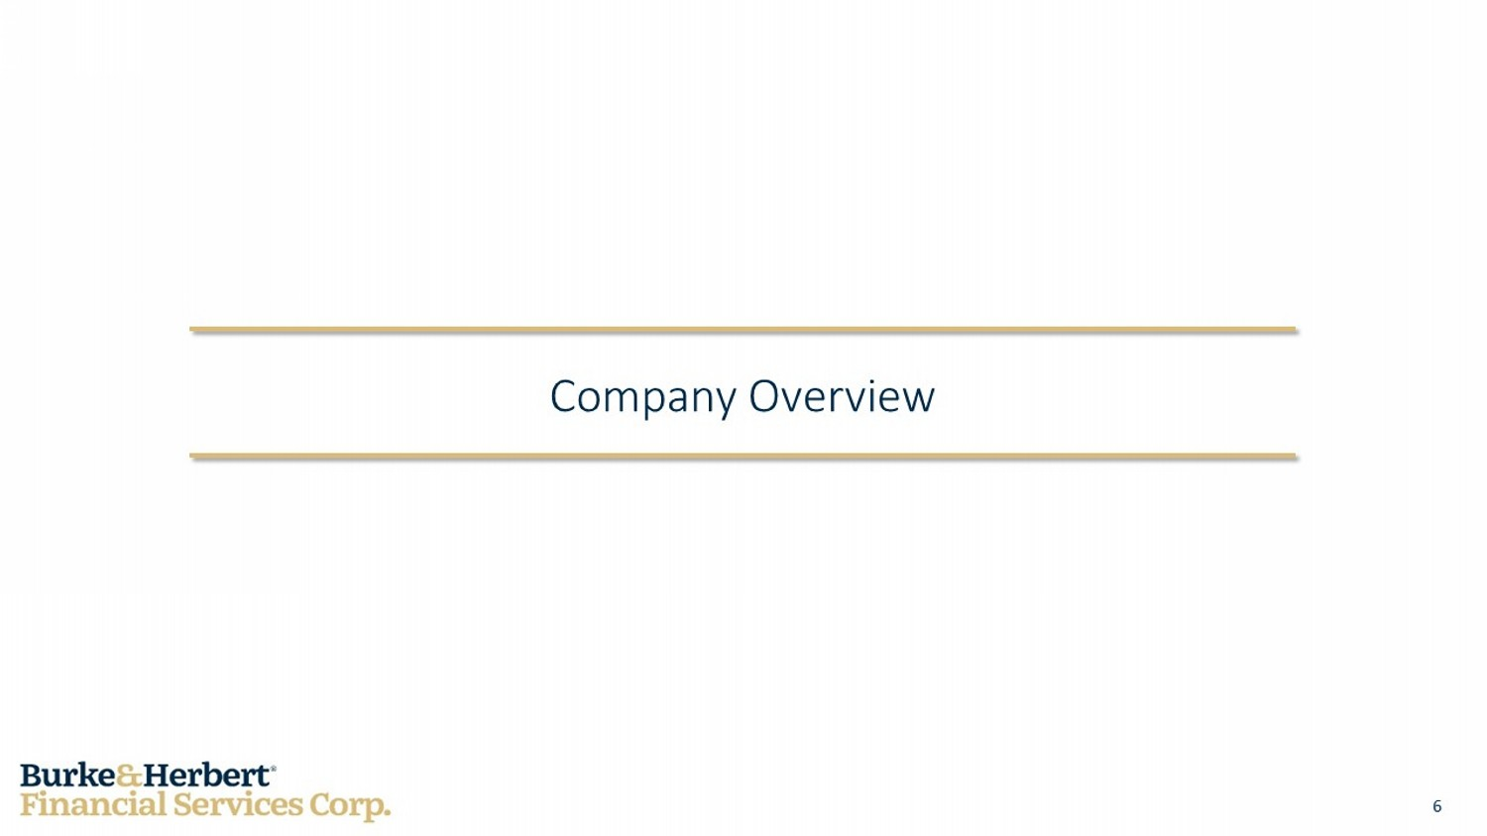
6 Company Overview

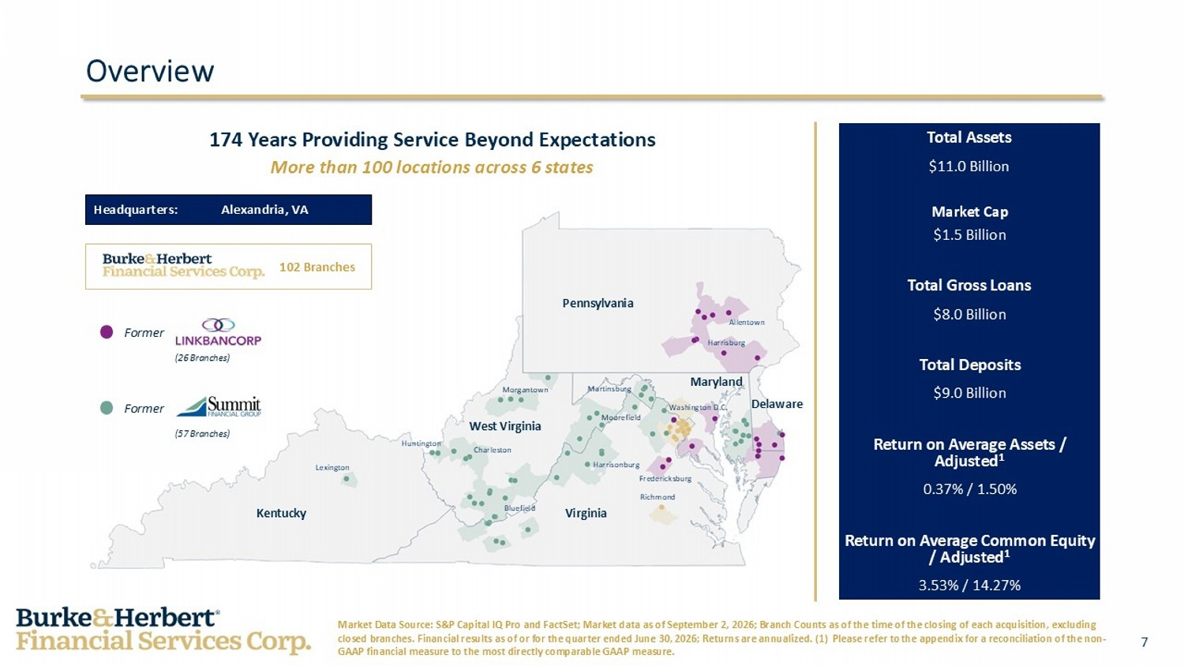
7 Delaware Maryland West Virginia Kentucky Virginia Pennsylvania Lexington Charleston Huntington Bluefield Richmond Harrisonburg Moorefield Morgantown Martinsburg Washington D.C. Harrisburg Allentown Overview Headquarters: Alexandria, VA 174 Years Providing Service Beyond Expectations More than 100 locations across 6 states Total Assets $11.0 Billion Market Cap $1.5 Billion Total Gross Loans $8.0 Billion Total Deposits $9.0 Billion Return on Average Assets / Adjusted 1 0.37% / 1.50% Return on Average Common Equity / Adjusted 1 3.53% / 14.27% Market Data Source: S&P Capital IQ Pro and FactSet; Market data as of September 2, 2026; Branch Counts as of the time of the clo sing of each acquisition, excluding closed branches. Financial results as of or for the quarter ended June 30, 2026; Returns are annualized. (1) Please refer to th e appendix for a reconciliation of the non - GAAP financial measure to the most directly comparable GAAP measure. Former Former (57 Branches) (26 Branches) 102 Branches Fredericksburg

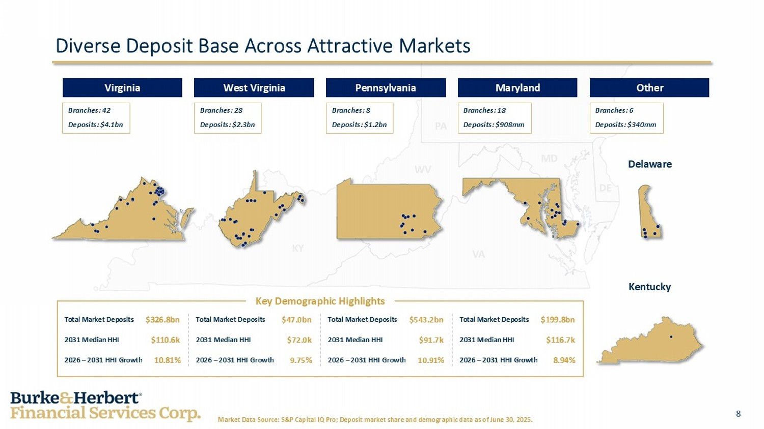
8 Market Data Source: S&P Capital IQ Pro; Deposit market share and demographic data as of June 30, 2025. Diverse Deposit Base Across Attractive Markets West Virginia Branches: 28 Deposits: $2.3bn Pennsylvania Branches: 8 Deposits: $1.2bn Other Branches: 6 Deposits: $340mm Virginia Branches: 42 Deposits: $4.1bn Maryland Branches: 18 Deposits: $908mm Delaware Kentucky Key Demographic Highlights Total Market Deposits $326.8bn 2031 Median HHI $110.6k 2026 – 2031 HHI Growth 10.81% Total Market Deposits $47.0bn 2031 Median HHI $72.0k 2026 – 2031 HHI Growth 9.75% Total Market Deposits $543.2bn 2031 Median HHI $91.7k 2026 – 2031 HHI Growth 10.91% Total Market Deposits $199.8bn 2031 Median HHI $116.7k 2026 – 2031 HHI Growth 8.94%

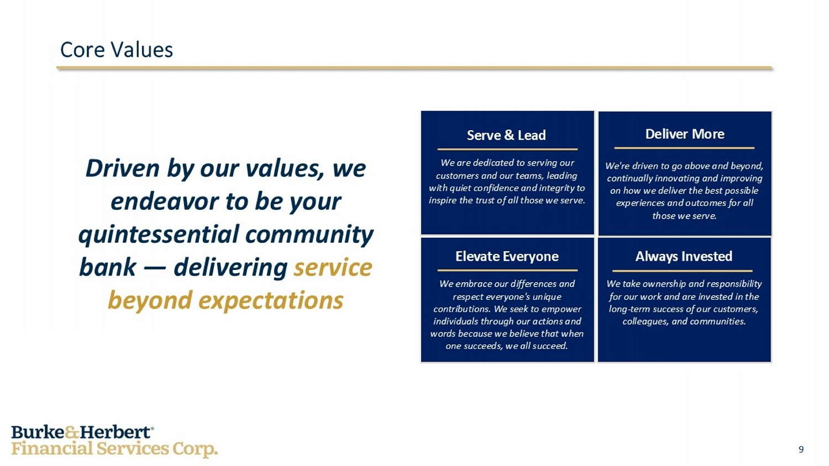
9 Core Values Driven by our values, we endeavor to be your quintessential community bank — delivering service beyond expectations Serve & Lead We are dedicated to serving our customers and our teams, leading with quiet confidence and integrity to inspire the trust of all those we serve. Deliver More We're driven to go above and beyond, continually innovating and improving on how we deliver the best possible experiences and outcomes for all those we serve. Elevate Everyone We embrace our differences and respect everyone's unique contributions. We seek to empower individuals through our actions and words because we believe that when one succeeds, we all succeed. Always Invested We take ownership and responsibility for our work and are invested in the long - term success of our customers, colleagues, and communities.

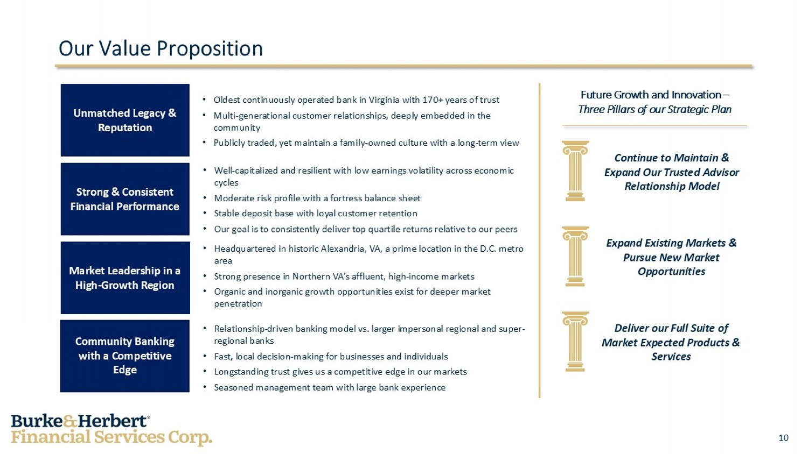
10 Our Value Proposition Strong & Consistent Financial Performance Market Leadership in a High - Growth Region Community Banking with a Competitive Edge • Well - capitalized and resilient with low earnings volatility across economic cycles • Moderate risk profile with a fortress balance sheet • Stable deposit base with loyal customer retention • Our goal is to consistently deliver top quartile returns relative to our peers • Headquartered in historic Alexandria, VA, a prime location in the D.C. metro area • Strong presence in Northern VA’s affluent, high - income markets • Organic and inorganic growth opportunities exist for deeper market penetration • Relationship - driven banking model vs. larger impersonal regional and super - regional banks • Fast, local decision - making for businesses and individuals • Longstanding trust gives us a competitive edge in our markets • Seasoned management team with large bank experience Continue to Maintain & Expand Our Trusted Advisor Relationship Model Expand Existing Markets & Pursue New Market Opportunities Deliver our Full Suite of Market Expected Products & Services Unmatched Legacy & Reputation • Oldest continuously operated bank in Virginia with 170+ years of trust • Multi - generational customer relationships, deeply embedded in the community • Publicly traded, yet maintain a family - owned culture with a long - term view Future Growth and Innovation – Three Pillars of our Strategic Plan

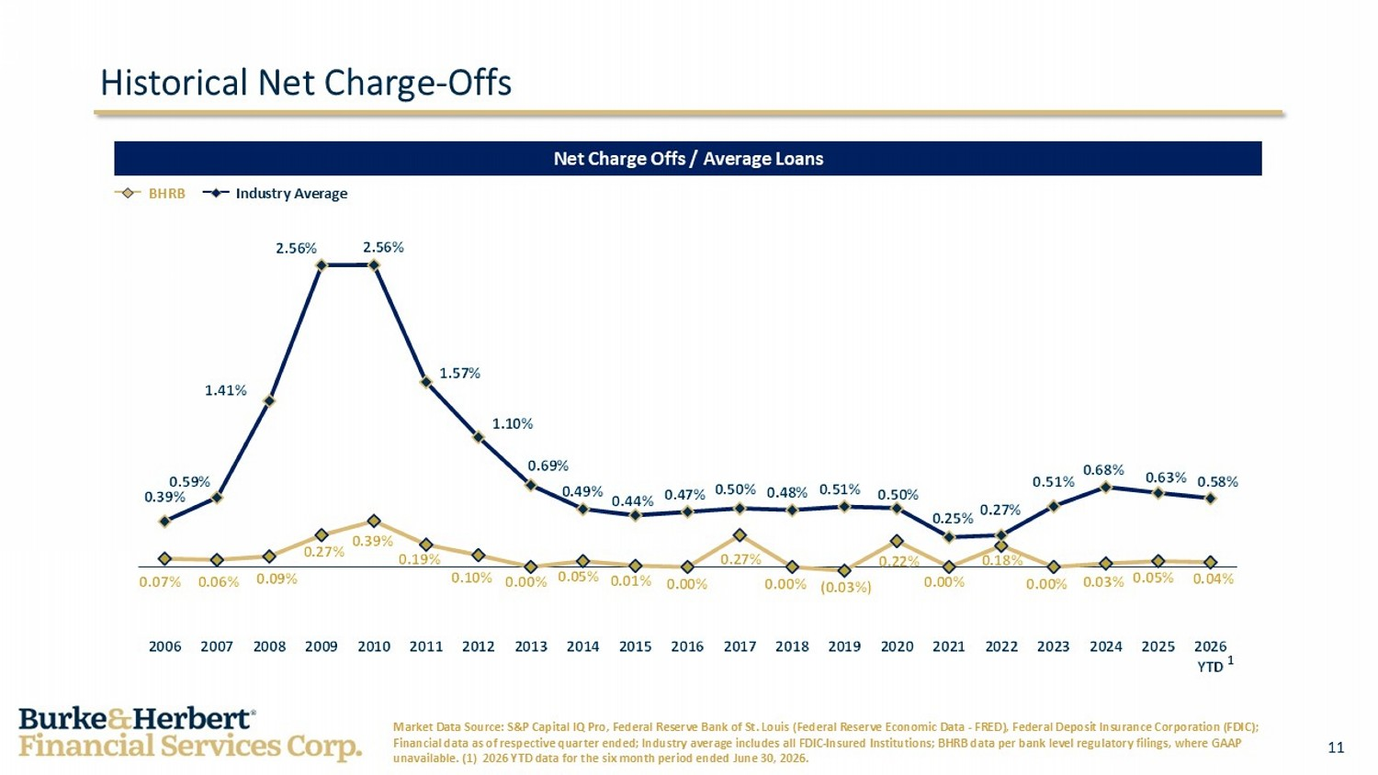
11 0.07% 0.06% 0.09% 0.27% 0.39% 0.19% 0.10% 0.00% 0.05% 0.01% 0.00% 0.27% 0.00% (0.03%) 0.22% 0.00% 0.18% 0.00% 0.03% 0.05% 0.04% 0.39% 0.59% 1.41% 2.56% 2.56% 1.57% 1.10% 0.69% 0.49% 0.44% 0.47% 0.50% 0.48% 0.51% 0.50% 0.25% 0.27% 0.51% 0.68% 0.63% 0.58% 2006 2007 2008 2009 2010 2011 2012 2013 2014 2015 2016 2017 2018 2019 2020 2021 2022 2023 2024 2025 2026 YTD BHRB Industry Average Historical Net Charge - Offs Net Charge Offs / Average Loans Market Data Source: S&P Capital IQ Pro, Federal Reserve Bank of St. Louis (Federal Reserve Economic Data - FRED), Federal Deposi t Insurance Corporation (FDIC); Financial data as of respective quarter ended; Industry average includes all FDIC - Insured Institutions; BHRB data per bank level regulatory filings, where GAAP unavailable. (1) 2026 YTD data for the six month period ended June 30, 2026. 1

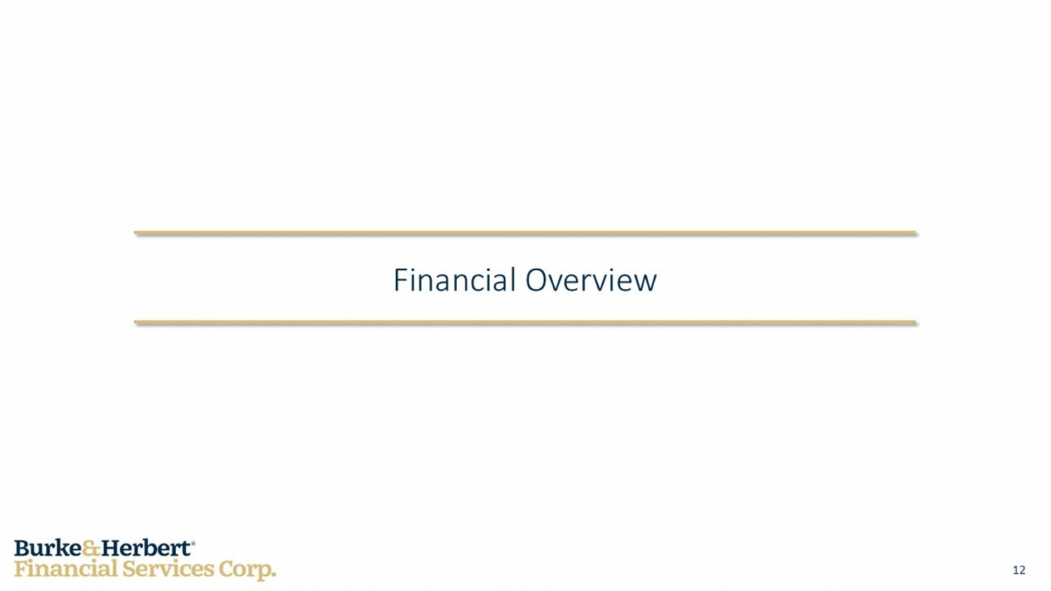
12 Financial Overview

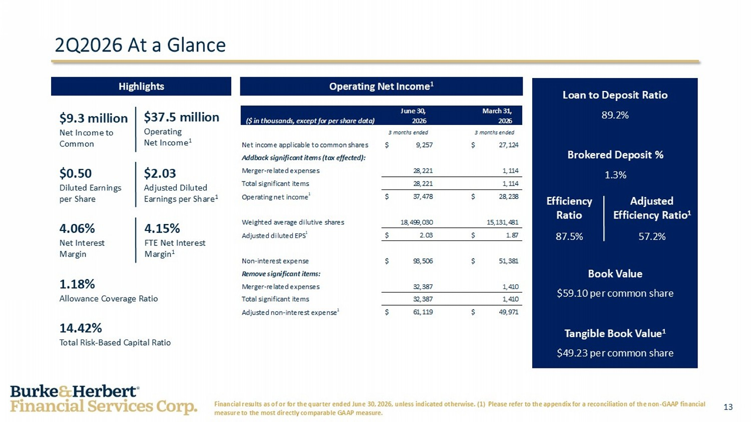
13 June 30, March 31, ($ in thousands, except for per share data) 2026 2026 3 months ended 3 months ended Net income applicable to common shares 9,257$ 27,124$ Addback significant items (tax effected): Merger-related expenses 28,221 1,114 Total significant items 28,221 1,114 Operating net income 1 37,478$ 28,238$ Weighted average dilutive shares 18,499,030 15,131,481 Adjusted diluted EPS 1 2.03$ 1.87$ Non-interest expense 93,506$ 51,381$ Remove significant items: Merger-related expenses 32,387 1,410 Total significant items 32,387 1,410 Adjusted non-interest expense 1 61,119$ 49,971$ 2Q2026 At a Glance Highlights Operating Net Income 1 Loan to Deposit Ratio 89.2% Brokered Deposit % 1.3% Book Value $59.10 per common share Tangible Book Value 1 $49.23 per common share Financial results as of or for the quarter ended June 30, 2026, unless indicated otherwise. (1) Please refer to the appendix fo r a reconciliation of the non - GAAP financial measure to the most directly comparable GAAP measure. $9.3 million Net Income to Common $0.50 Diluted Earnings per Share 1.18% Allowance Coverage Ratio 14.42% Total Risk - Based Capital Ratio $37.5 million Operating Net Income 1 $2.03 Adjusted Diluted Earnings per Share 1 4.06% Net Interest Margin 4.15% FTE Net Interest Margin 1 Efficiency Ratio 87.5% Adjusted Efficiency Ratio 1 57.2%

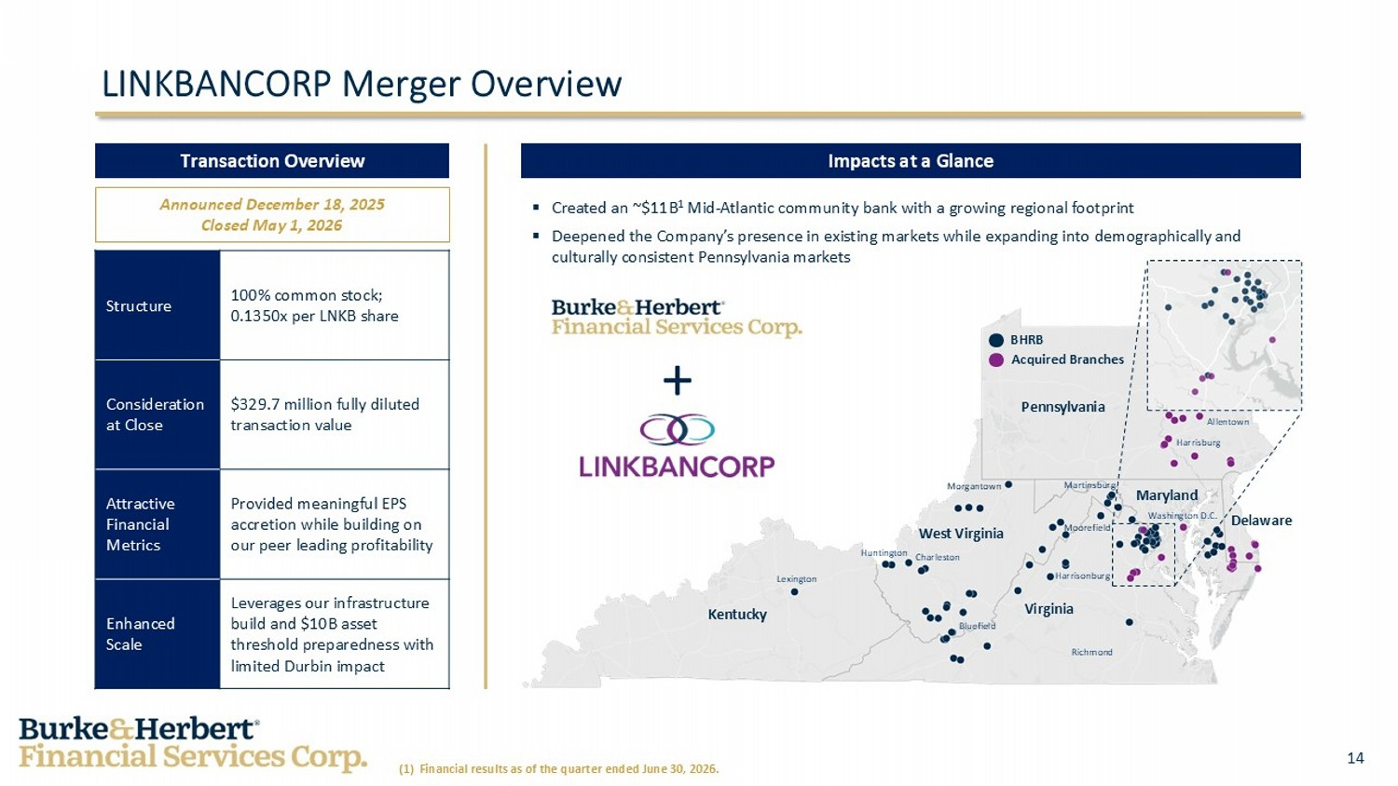
14 Delaware Maryland West Virginia Kentucky Virginia Acquired Branches BHRB Pennsylvania Lexington Charleston Huntington Bluefield Richmond Harrisonburg Moorefield Morgantown Martinsburg Washington D.C. Harrisburg Allentown Impacts at a Glance LINKBANCORP Merger Overview Transaction Overview 100% common stock; 0.1350x per LNKB share Structure $329.7 million fully diluted transaction value Consideration at Close Provided meaningful EPS accretion while building on our peer leading profitability Attractive Financial Metrics Leverages our infrastructure build and $10B asset threshold preparedness with limited Durbin impact Enhanced Scale Announced December 18, 2025 Closed May 1, 2026 ▪ Created an ~$11B 1 Mid - Atlantic community bank with a growing regional footprint ▪ Deepened the Company’s presence in existing markets while expanding into demographically and culturally consistent Pennsylvania markets + (1) Financial results as of the quarter ended June 30, 2026.

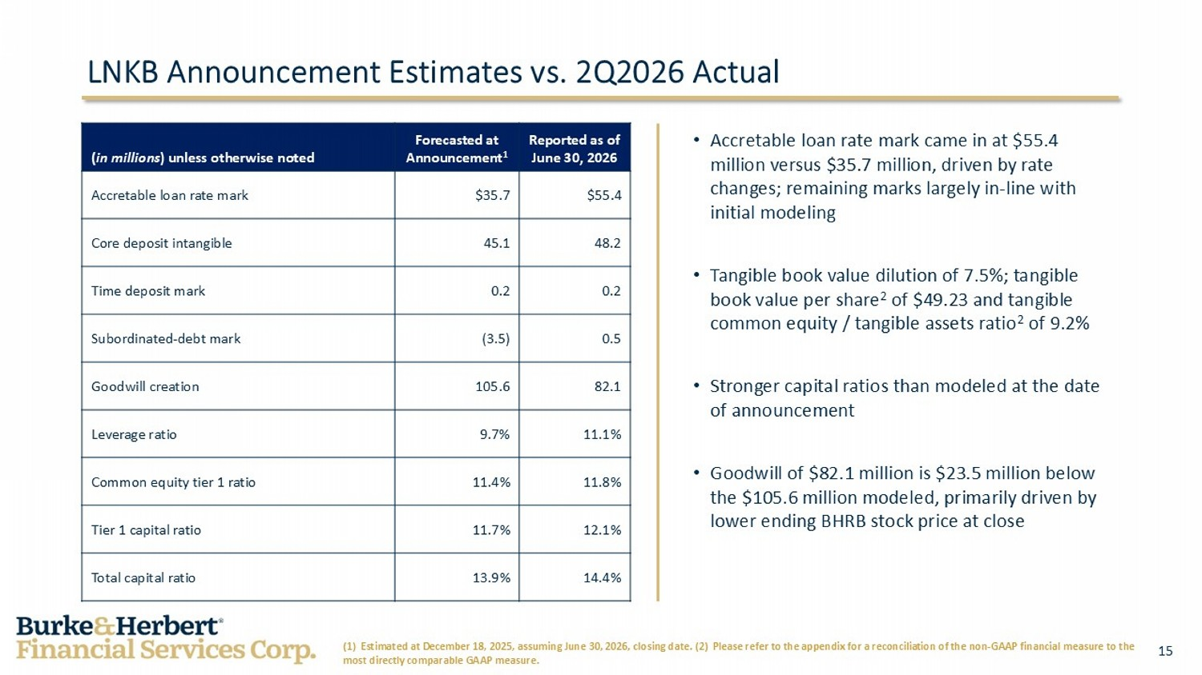
15 Reported as of June 30, 2026 Forecasted at Announcement 1 ( in millions ) unless otherwise noted $55.4 $35.7 Accretable loan rate mark 48.2 45.1 Core deposit intangible 0.2 0.2 Time deposit mark 0.5 (3.5) Subordinated - debt mark 82.1 105.6 Goodwill creation 11.1% 9.7% Leverage ratio 11.8% 11.4% Common equity tier 1 ratio 12.1% 11.7% Tier 1 capital ratio 14.4% 13.9% Total capital ratio LNKB Announcement Estimates vs . 2Q2026 Actual (1) Estimated at December 18, 2025, assuming June 30, 2026, closing date. (2) Please refer to the appendix for a reconcilia tio n of the non - GAAP financial measure to the most directly comparable GAAP measure. • Accretable loan rate mark came in at $55.4 million versus $35.7 million, driven by rate changes; remaining marks largely in - line with initial modeling • Tangible book value dilution of 7.5%; tangible book value per share 2 of $49.23 and tangible common equity / tangible assets ratio 2 of 9.2% • Stronger capital ratios than modeled at the date of announcement • Goodwill of $82.1 million is $23.5 million below the $105.6 million modeled, primarily driven by lower ending BHRB stock price at close

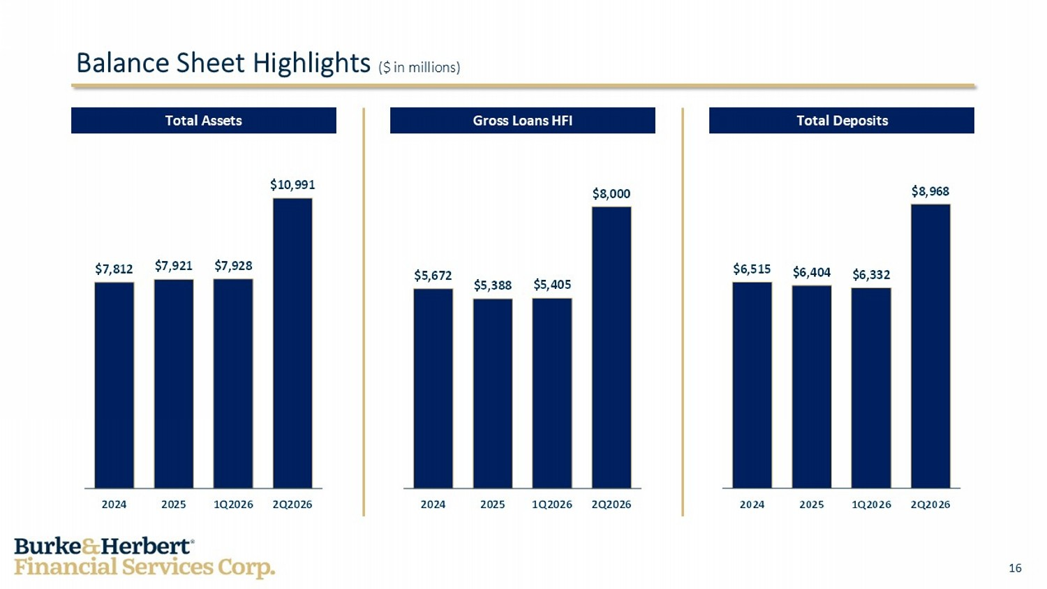
16 $5,672 $5,388 $5,405 $8,000 2024 2025 1Q2026 2Q2026 $7,812 $7,921 $7,928 $10,991 2024 2025 1Q2026 2Q2026 Total Assets Balance Sheet Highlights ($ in millions) Total Deposits Gross Loans HFI

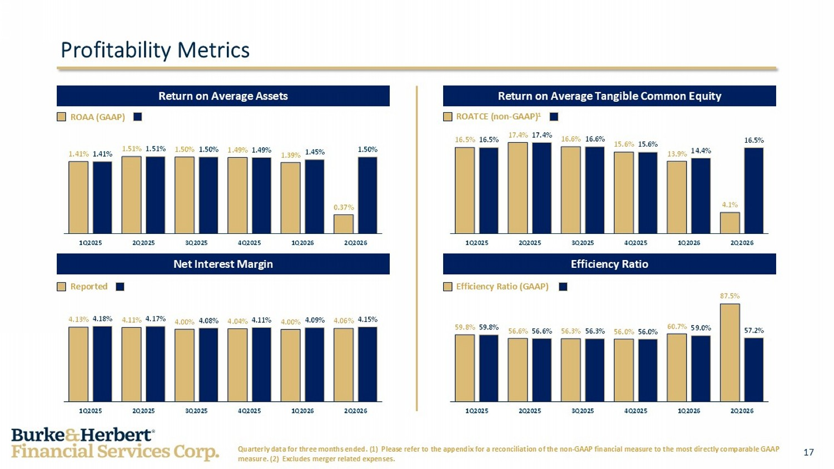
17 59.8% 56.6% 56.3% 56.0% 60.7% 87.5% 59.8% 56.6% 56.3% 56.0% 59.0% 57.2% 1Q2025 2Q2025 3Q2025 4Q2025 1Q2026 2Q2026 4.13% 4.11% 4.00% 4.04% 4.00% 4.06% 4.18% 4.17% 4.08% 4.11% 4.09% 4.15% 1Q2025 2Q2025 3Q2025 4Q2025 1Q2026 2Q2026 16.5% 17.4% 16.6% 15.6% 13.9% 4.1% 16.5% 17.4% 16.6% 15.6% 14.4% 16.5% 1Q2025 2Q2025 3Q2025 4Q2025 1Q2026 2Q2026 1.41% 1.51% 1.50% 1.49% 1.39% 0.37% 1.41% 1.51% 1.50% 1.49% 1.45% 1.50% 1Q2025 2Q2025 3Q2025 4Q2025 1Q2026 2Q2026 Net Interest Margin Return on Average Tangible Common Equity ROATCE (non - GAAP) 1 Profitability Metrics Return on Average Assets Efficiency Ratio Quarterly data for three months ended. (1) Please refer to the appendix for a reconciliation of the non - GAAP financial measure to the most directly comparable GAAP measure. (2) Excludes merger related expenses. ROAA (GAAP) Reported Efficiency Ratio (GAAP)

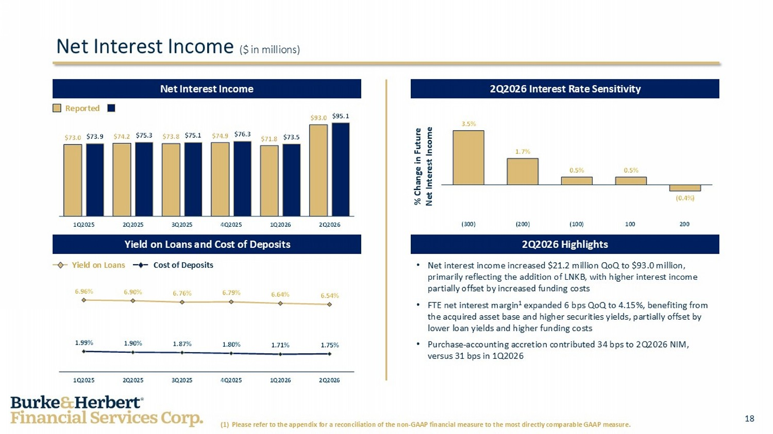
18 3.5% 1.7% 0.5% 0.5% (0.4%) (300) (200) (100) 100 200 6.96% 6.90% 6.76% 6.79% 6.64% 6.54% 1.99% 1.90% 1.87% 1.80% 1.71% 1.75% 1Q2025 2Q2025 3Q2025 4Q2025 1Q2026 2Q2026 $73.0 $74.2 $73.8 $74.9 $71.8 $93.0 $73.9 $75.3 $75.1 $76.3 $73.5 $95.1 1Q2025 2Q2025 3Q2025 4Q2025 1Q2026 2Q2026 • Net interest income increased $21.2 million QoQ to $93.0 million, primarily reflecting the addition of LNKB, with higher interest income partially offset by increased funding costs • FTE net interest margin 1 expanded 6 bps QoQ to 4.15%, benefiting from the acquired asset base and higher securities yields, partially offset by lower loan yields and higher funding costs • Purchase - accounting accretion contributed 34 bps to 2Q2026 NIM, versus 31 bps in 1Q2026 Net Interest Income ($ in millions) Reported Yield on Loans Cost of Deposits % Change in Future Net Interest Income Yield on Loans and Cost of Deposits 2Q2026 Interest Rate Sensitivity Net Interest Income 2Q2026 Highlights (1) Please refer to the appendix for a reconciliation of the non - GAAP financial measure to the most directly comparable GAAP me asure.

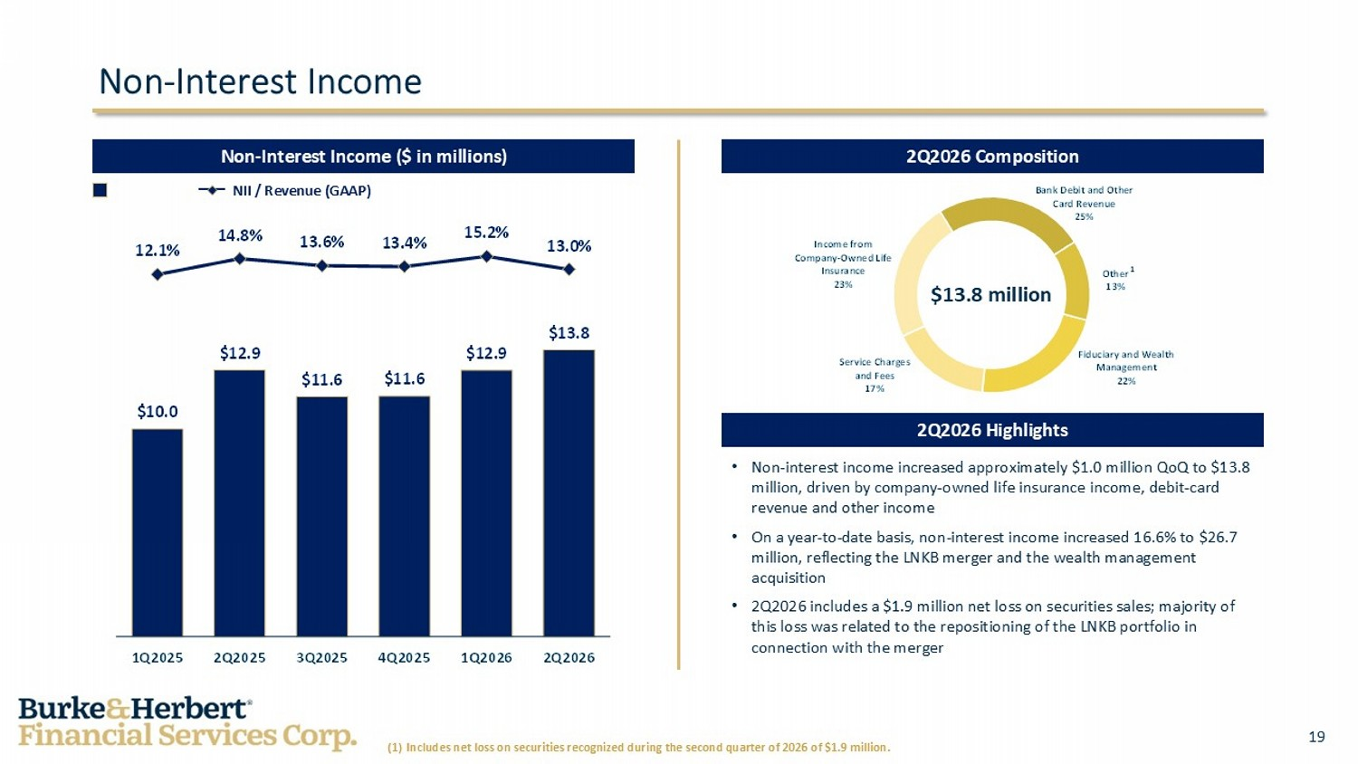
19 $10.0 $12.9 $11.6 $11.6 $12.9 $13.8 12.1% 14.8% 13.6% 13.4% 15.2% 13.0% 1Q2025 2Q2025 3Q2025 4Q2025 1Q2026 2Q2026 Fiduciary and Wealth Management 22% Service Charges and Fees 17% Income from Company - Owned Life Insurance 23% Bank Debit and Other Card Revenue 25% Other 13% Non - Interest Income 1 (1) Includes net loss on securities recognized during the second quarter of 2026 of $1.9 million. Non - Interest Income ($ in millions) NII / Revenue (GAAP) • Non - interest income increased approximately $1.0 million QoQ to $13.8 million, driven by company - owned life insurance income, debit - card revenue and other income • On a year - to - date basis, non - interest income increased 16.6% to $26.7 million, reflecting the LNKB merger and the wealth management acquisition • 2Q2026 includes a $1.9 million net loss on securities sales; majority of this loss was related to the repositioning of the LNKB portfolio in connection with the merger $13.8 million 2Q2026 Composition 2Q2026 Highlights

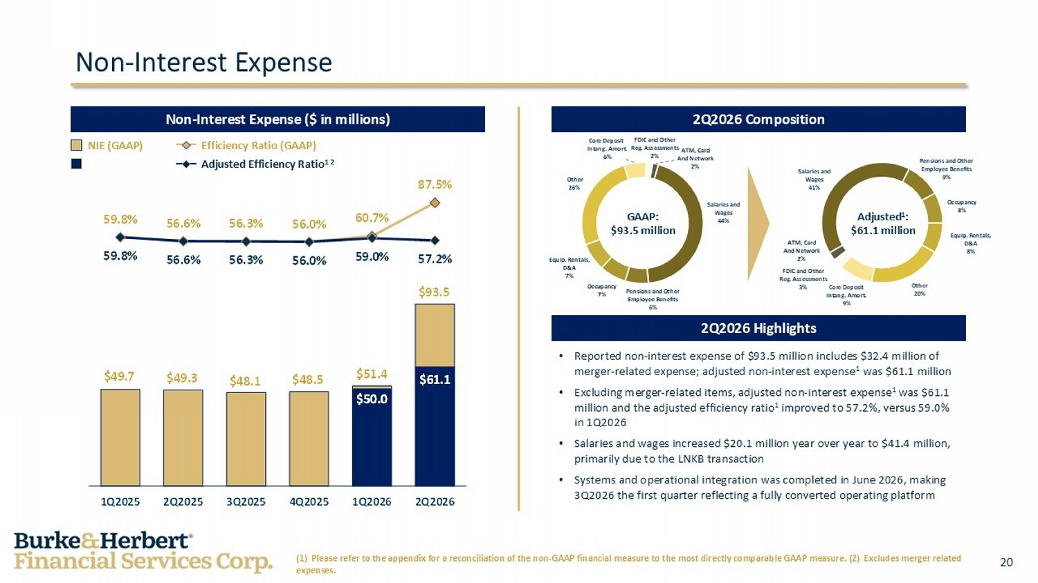
20 $49.7 $49.3 $48.1 $48.5 $51.4 $93.5 $50.0 $61.1 59.8% 56.6% 56.3% 56.0% 60.7% 87.5% 59.8% 56.6% 56.3% 56.0% 59.0% 57.2% 1Q2025 2Q2025 3Q2025 4Q2025 1Q2026 2Q2026 Non - Interest Expense Adjusted Efficiency Ratio 1 2 NIE (GAAP) Efficiency Ratio (GAAP) (1) Please refer to the appendix for a reconciliation of the non - GAAP financial measure to the most directly comparable GAAP me asure. (2) Excludes merger related expenses. 2Q2026 Composition Non - Interest Expense ($ in millions) 2Q2026 Highlights • Reported non - interest expense of $93.5 million includes $32.4 million of merger - related expense; adjusted non - interest expense 1 was $61.1 million • Excluding merger - related items, adjusted non - interest expense 1 was $61.1 million and the adjusted efficiency ratio 1 improved to 57.2%, versus 59.0% in 1Q2026 • Salaries and wages increased $20.1 million year over year to $41.4 million, primarily due to the LNKB transaction • Systems and operational integration was completed in June 2026, making 3Q2026 the first quarter reflecting a fully converted operating platform Core Deposit Intang . Amort. 6% Other 26% Equip. Rentals, D&A 7% Occupancy 7% Pensions and Other Employee Benefits 6% Salaries and Wages 44% FDIC and Other Reg. Assessments 3% ATM, Card And Network 2% Salaries and Wages 41% Pensions and Other Employee Benefits 9% Occupancy 8% Equip. Rentals, D&A 8% Other 20% Core Deposit Intang . Amort. 9% ATM, Card And Network 2% GAAP: $93.5 million Adjusted 1 : $61.1 million FDIC and Other Reg. Assessments 2%

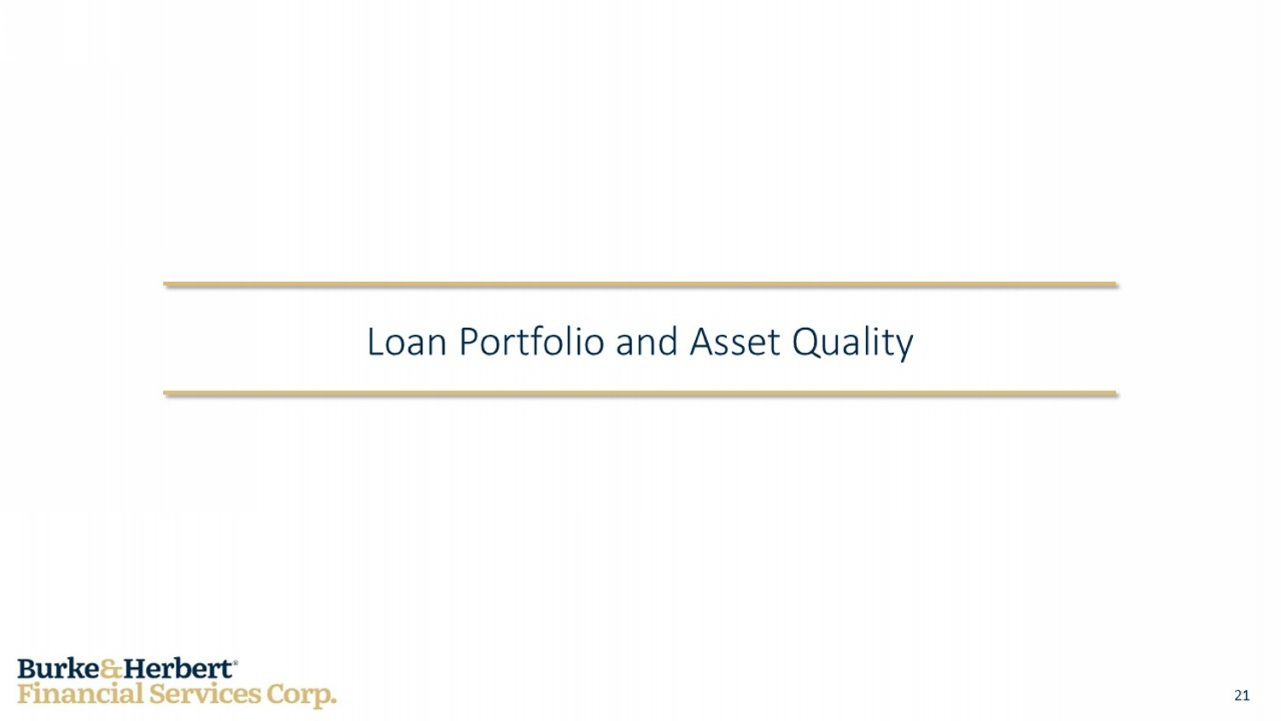
21 Loan Portfolio and Asset Quality

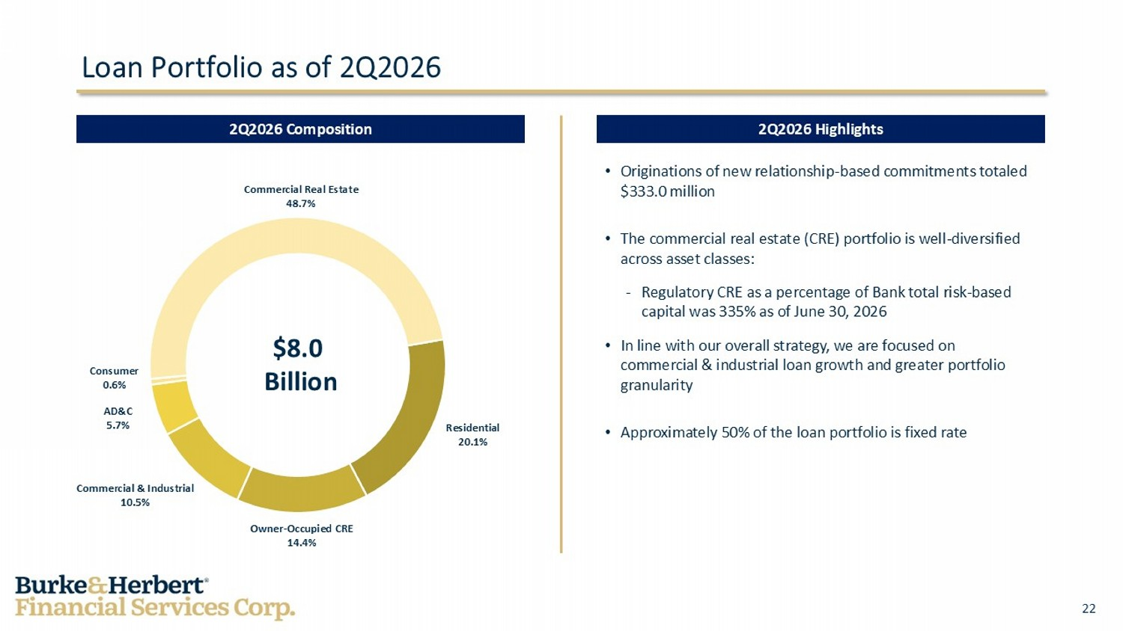
22 • Originations of new relationship - based commitments totaled $333.0 million • The commercial real estate (CRE) portfolio is well - diversified across asset classes: - Regulatory CRE as a percentage of Bank total risk - based capital was 335% as of June 30, 2026 • In line with our overall strategy, we are focused on commercial & industrial loan growth and greater portfolio granularity • Approximately 50% of the loan portfolio is fixed rate Loan Portfolio as of 2Q2026 2Q2026 Composition 2Q2026 Highlights Residential 20.1% Owner - Occupied CRE 14.4% Commercial & Industrial 10.5% AD&C 5.7% Consumer 0.6% Commercial Real Estate 48.7% $8.0 Billion

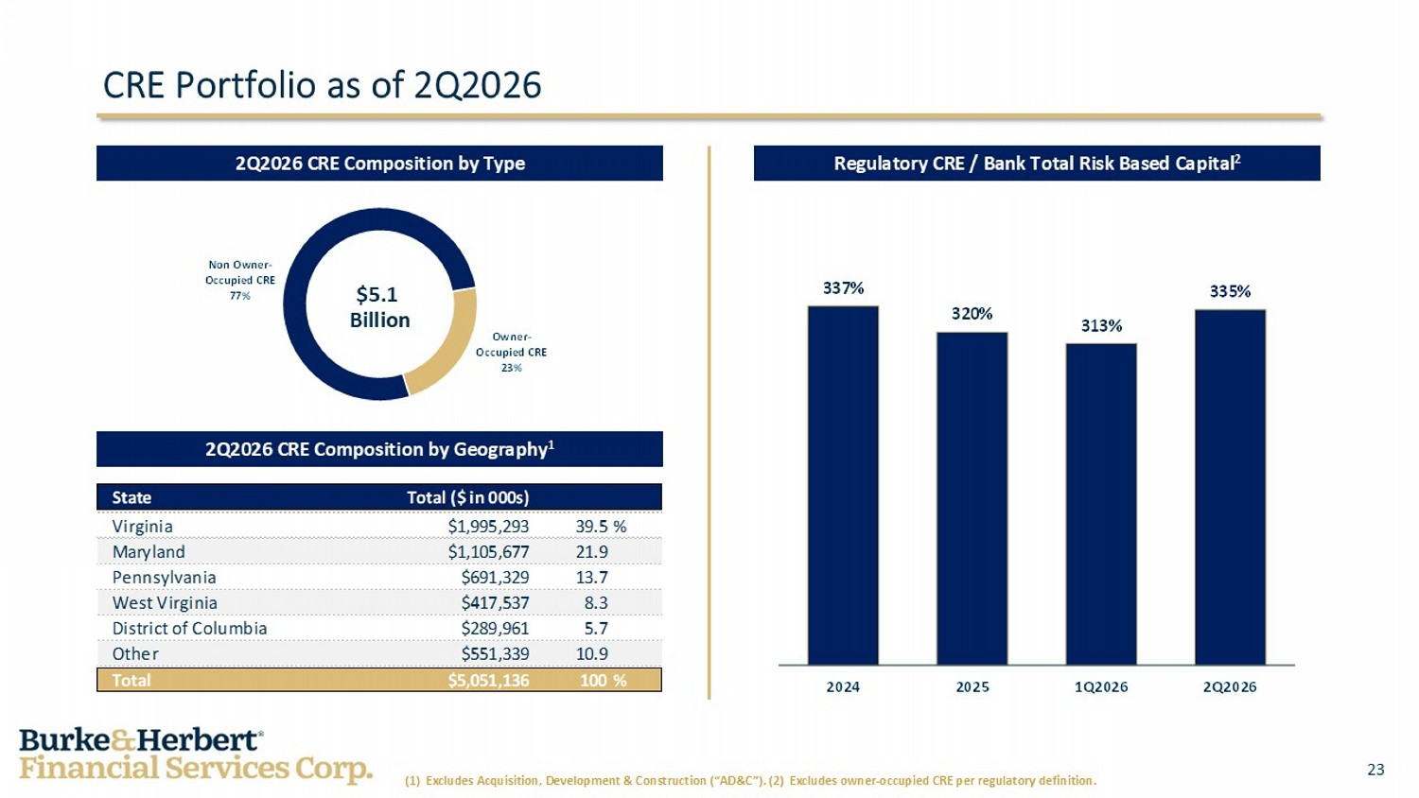
23 Owner - Occupied CRE 23% Non Owner - Occupied CRE 77% 337% 320% 313% 335% 2024 2025 1Q2026 2Q2026 State Total ($ in 000s) Virginia $1,995,293 39.5% Maryland $1,105,677 21.9 Pennsylvania $691,329 13.7 West Virginia $417,537 8.3 District of Columbia $289,961 5.7 Other $551,339 10.9 Total $5,051,136 100% CRE Portfolio as of 2Q2026 Regulatory CRE / Bank Total Risk Based Capital 2 2Q2026 CRE Composition by Type 2Q2026 CRE Composition by Geography 1 (1) Excludes Acquisition, Development & Construction (“AD&C”). (2) Excludes owner - occupied CRE per regulatory definition. $5.1 Billion

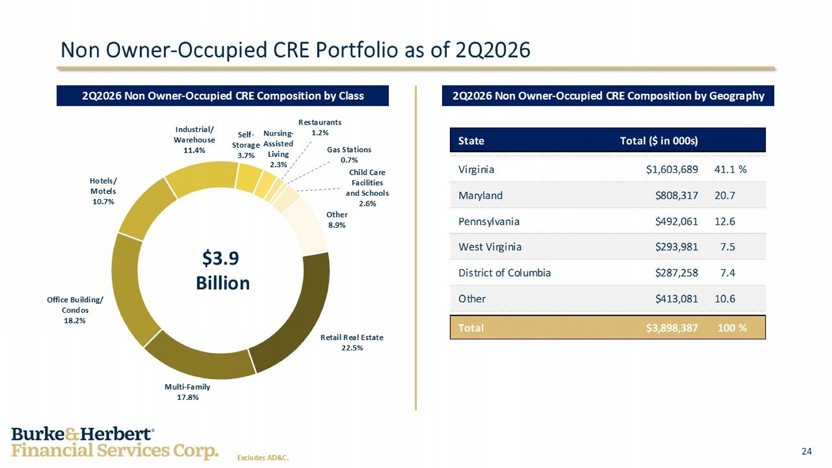
24 State Total ($ in 000s) Virginia $1,603,689 41.1% Maryland $808,317 20.7 Pennsylvania $492,061 12.6 West Virginia $293,981 7.5 District of Columbia $287,258 7.4 Other $413,081 10.6 Total $3,898,387 100% Non Owner - Occupied CRE Portfolio as of 2Q2026 2Q2026 Non Owner - Occupied CRE Composition by Geography 2Q2026 Non Owner - Occupied CRE Composition by Class Retail Real Estate 22.5% Multi - Family 17.8% Office Building/ Condos 18.2% Hotels/ Motels 10.7% Industrial/ Warehouse 11.4% Self - Storage 3.7% Nursing - Assisted Living 2.3% Restaurants 1.2% Gas Stations 0.7% Other 8.9% Child Care Facilities and Schools 2.6% Excludes AD&C. $3.9 Billion

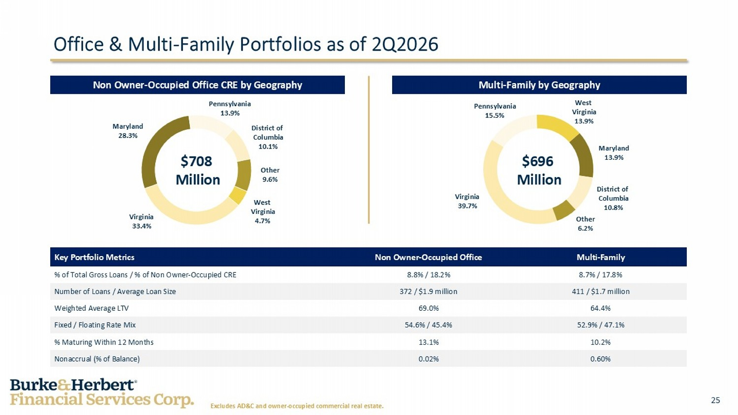
25 Office & Multi - Family Portfolios as of 2Q2026 Excludes AD&C and owner - occupied commercial real estate. Multi - F amily Non Owner - Occupied Office Key Portfolio Metrics 8.7% / 17.8% 8.8% / 18.2% % of Total Gross Loans / % of Non Owner - Occupied CRE 411 / $1.7 million 372 / $1.9 million Number of Loans / Average Loan Size 64.4% 69.0% Weighted Average LTV 52.9% / 47.1% 54.6% / 45.4% Fixed / Floating Rate Mix 10.2% 13.1% % Maturing Within 12 Months 0.60% 0.02% Nonaccrual (% of Balance) Multi - Family by Geography Non Owner - Occupied Office CRE by Geography Virginia 33.4% Maryland 13.9% Pennsylvania 13.9% District of Columbia 10.1% Other 9.6% West Virginia 4.7% $708 Million $696 Million Virginia 39.7% Pennsylvania 15.5% West Virginia 13.9% District of Columbia 10.8% Other 6.2% Maryland 28.3%

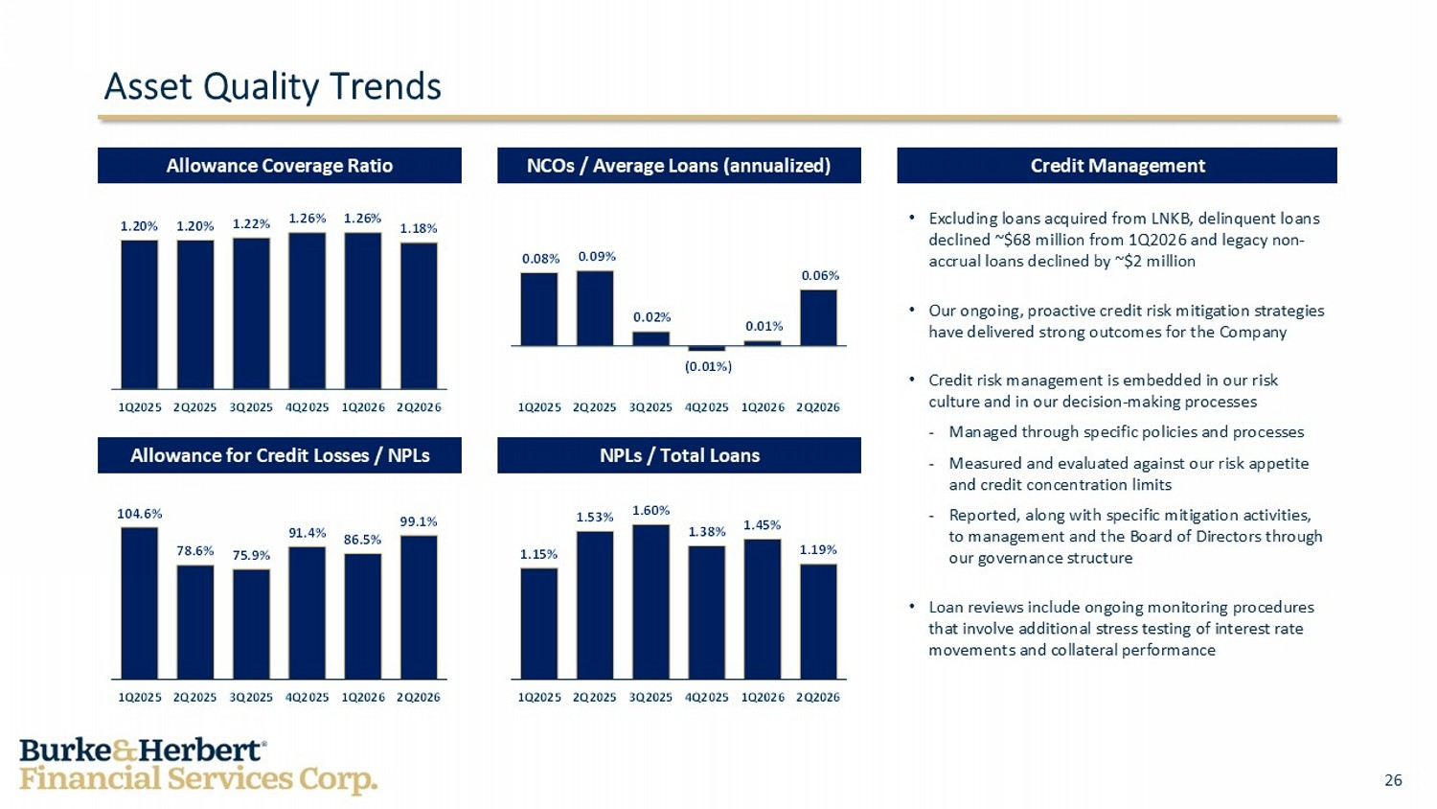
26 1.15% 1.53% 1.60% 1.38% 1.45% 1.19% 1Q2025 2Q2025 3Q2025 4Q2025 1Q2026 2Q2026 104.6% 78.6% 75.9% 91.4% 86.5% 99.1% 1Q2025 2Q2025 3Q2025 4Q2025 1Q2026 2Q2026 0.08% 0.09% 0.02% (0.01%) 0.01% 0.06% 1Q2025 2Q2025 3Q2025 4Q2025 1Q2026 2Q2026 1.20% 1.20% 1.22% 1.26% 1.26% 1.18% 1Q2025 2Q2025 3Q2025 4Q2025 1Q2026 2Q2026 Asset Quality Trends • Excluding loans acquired from LNKB, delinquent loans declined ~$68 million from 1Q2026 and legacy non - accrual loans declined by ~$2 million • Our ongoing, proactive credit risk mitigation strategies have delivered strong outcomes for the Company • Credit risk management is embedded in our risk culture and in our decision - making processes - Managed through specific policies and processes - Measured and evaluated against our risk appetite and credit concentration limits - Reported, along with specific mitigation activities, to management and the Board of Directors through our governance structure • Loan reviews include ongoing monitoring procedures that involve additional stress testing of interest rate movements and collateral performance Credit Management NCOs / Average Loans (annualized) Allowance Coverage Ratio Allowance for Credit Losses / NPLs NPLs / Total Loans

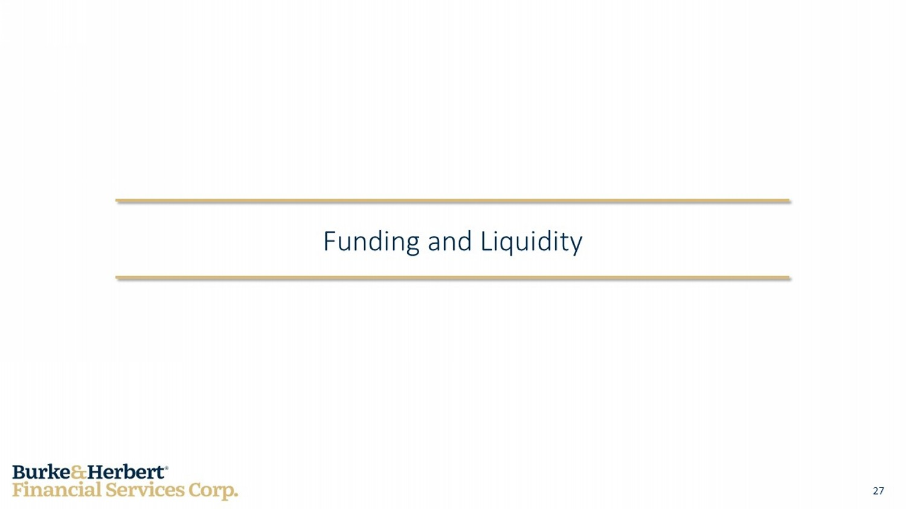
27 Funding and Liquidity

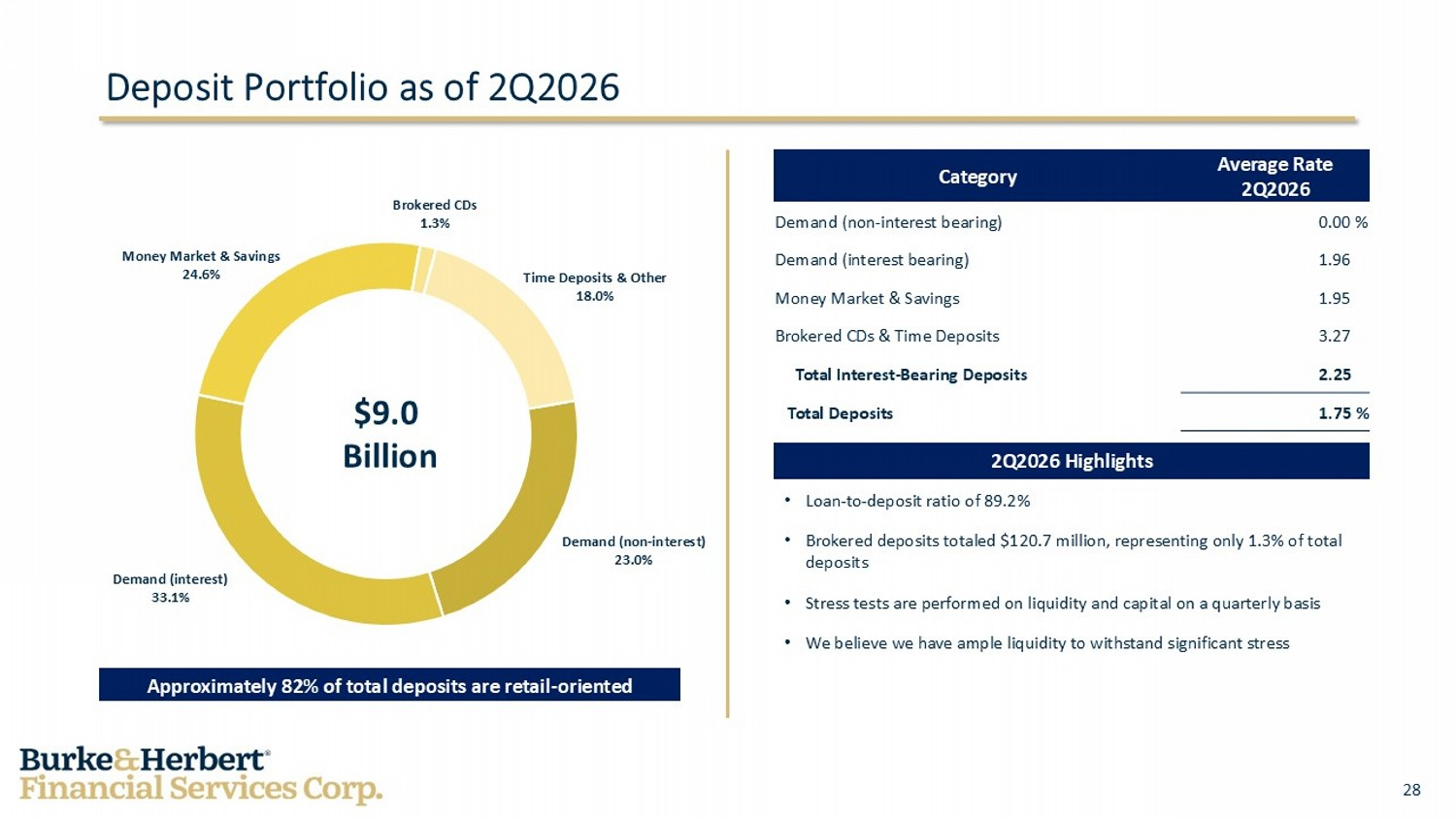
28 Average Rate 2Q2026 Category 0.00 % Demand (non - interest bearing) 1.96 % Demand (interest bearing) 1.95 % Money Market & Savings 3.27 % Brokered CDs & Time Deposits 2.25 % Total Interest - Bearing Deposits 1.75 % Total Deposits Deposit Portfolio as of 2Q2026 2Q2026 Highlights • Loan - to - deposit ratio of 89.2% • Brokered deposits totaled $120.7 million, representing only 1.3% of total deposits • Stress tests are performed on liquidity and capital on a quarterly basis • We believe we have ample liquidity to withstand significant stress Money Market & Savings 24.6% Brokered CDs 1.3% Time Deposits & Other 18.0% Demand (non - interest) 23.0% Demand (interest) 33.1% Approximately 82% of total deposits are retail - oriented $9.0 Billion

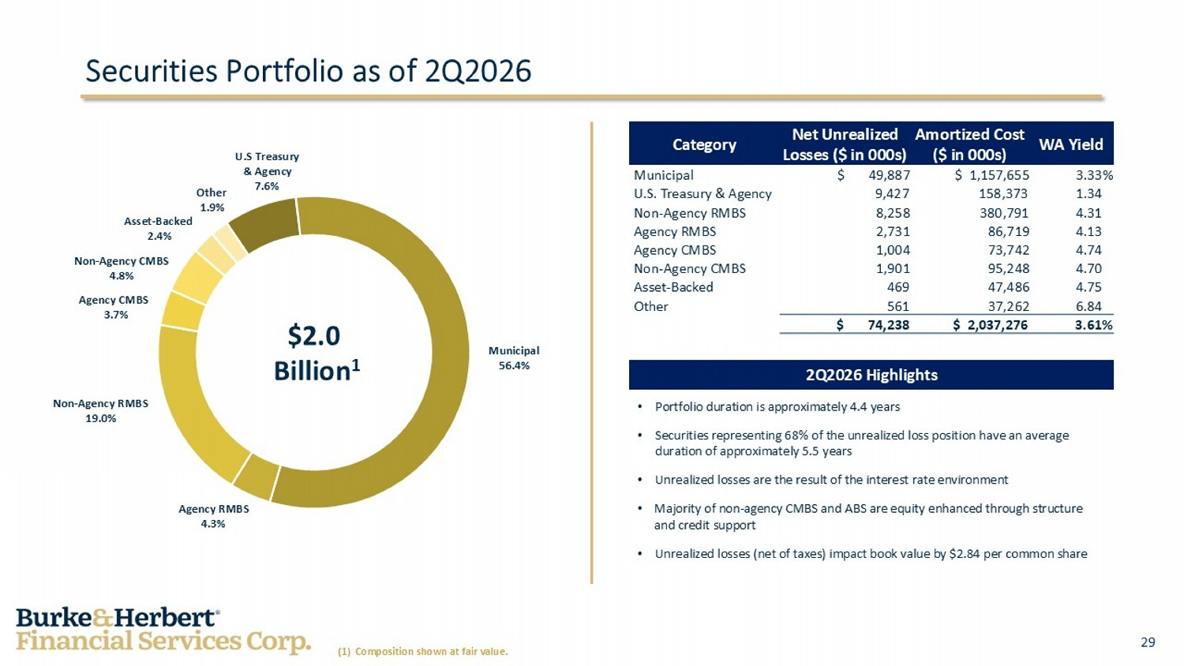
29 • Portfolio duration is approximately 4.4 years • Securities representing 68% of the unrealized loss position have an average duration of approximately 5.5 years • Unrealized losses are the result of the interest rate environment • Majority of non - agency CMBS and ABS are equity enhanced through structure and credit support • Unrealized losses (net of taxes) impact book value by $2.84 per common share WA Yield Amortized Cost ($ in 000s) Net Unrealized Losses ($ in 000s) Category 3.33% $ 1,157,655 $ 49,887 Municipal 1.34 % 158,373 9,427 U.S. Treasury & Agency 4.31 % 380,791 8,258 Non - Agency RMBS 4.13 % 86,719 2,731 Agency RMBS 4.74 % 73,742 1,004 Agency CMBS 4.70 % 95,248 1,901 Non - Agency CMBS 4.75 % 47,486 469 Asset - Backed 6.84 % 37,262 561 Other 3.61% $ 2,037,276 $ 74,238 Securities Portfolio as of 2Q2026 2Q2026 Highlights Non - Agency RMBS 19.0% Municipal 56.4% Agency RMBS 4.3% Agency CMBS 3.7% Non - Agency CMBS 4.8% Asset - Backed 2.4% Other 1.9% U.S Treasury & Agency 7.6% $2.0 Billion 1 (1) Composition shown at fair value.

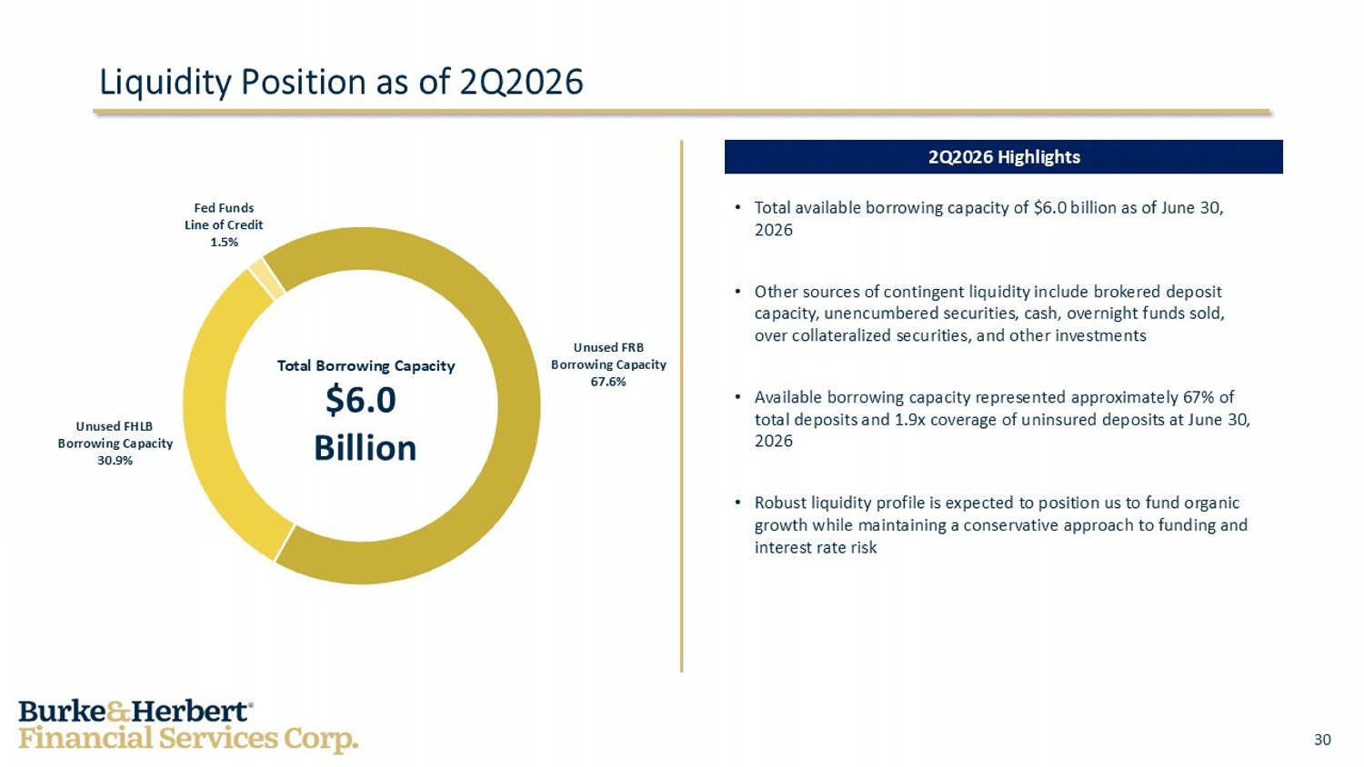
30 • Total available borrowing capacity of $6.0 billion as of June 30, 2026 • Other sources of contingent liquidity include brokered deposit capacity, unencumbered securities, cash, overnight funds sold, over collateralized securities, and other investments • Available borrowing capacity represented approximately 67% of total deposits and 1.9x coverage of uninsured deposits at June 30, 2026 • Robust liquidity profile is expected to position us to fund organic growth while maintaining a conservative approach to funding and interest rate risk Liquidity Position as of 2Q2026 Unused FRB Borrowing Capacity 67.6% 2Q2026 Highlights Unused FHLB Borrowing Capacity 30.9% Fed Funds Line of Credit 1.5% Total Borrowing Capacity $6.0 Billion

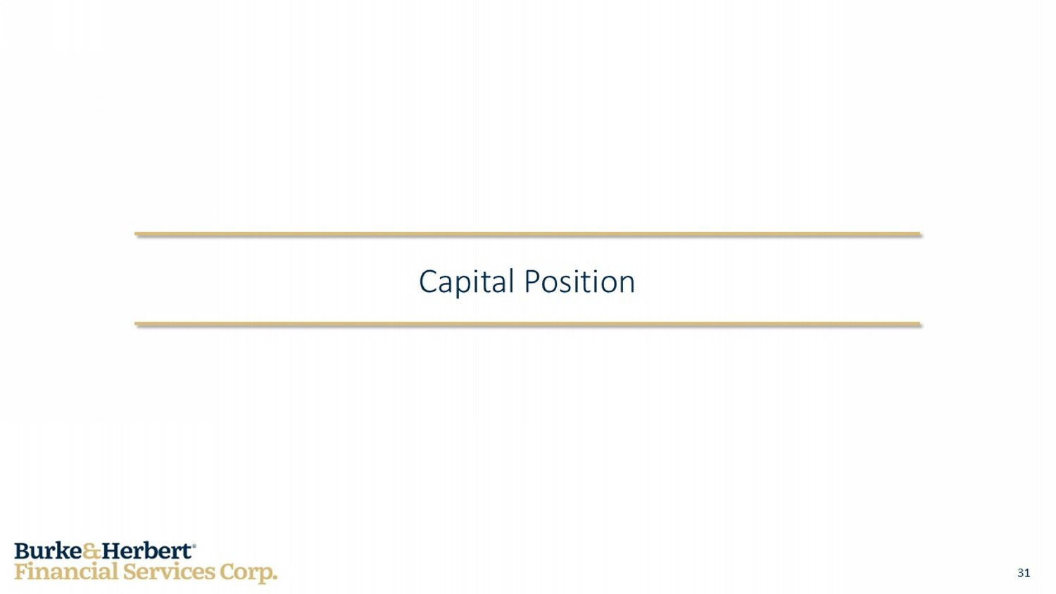
31 Capital Position

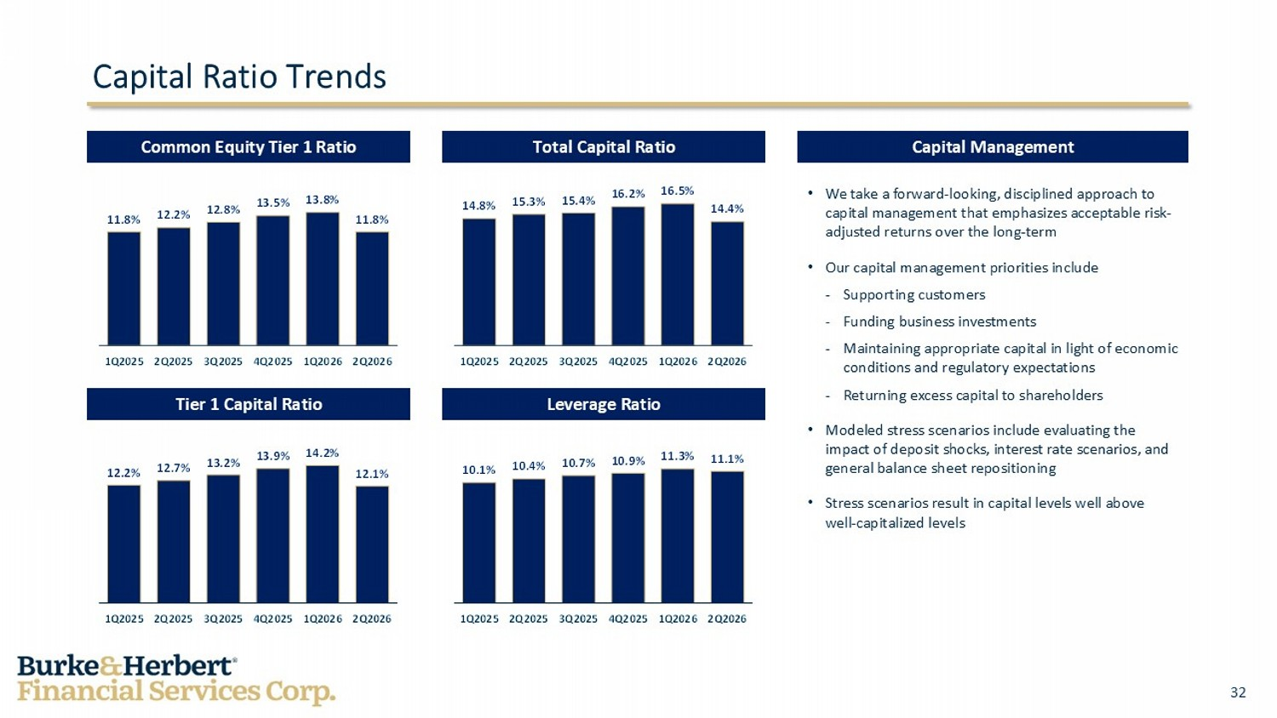
32 10.1% 10.4% 10.7% 10.9% 11.3% 11.1% 1Q2025 2Q2025 3Q2025 4Q2025 1Q2026 2Q2026 12.2% 12.7% 13.2% 13.9% 14.2% 12.1% 1Q2025 2Q2025 3Q2025 4Q2025 1Q2026 2Q2026 14.8% 15.3% 15.4% 16.2% 16.5% 14.4% 1Q2025 2Q2025 3Q2025 4Q2025 1Q2026 2Q2026 11.8% 12.2% 12.8% 13.5% 13.8% 11.8% 1Q2025 2Q2025 3Q2025 4Q2025 1Q2026 2Q2026 Capital Ratio Trends • We take a forward - looking, disciplined approach to capital management that emphasizes acceptable risk - adjusted returns over the long - term • Our capital management priorities include - Supporting customers - Funding business investments - Maintaining appropriate capital in light of economic conditions and regulatory expectations - Returning excess capital to shareholders • Modeled stress scenarios include evaluating the impact of deposit shocks, interest rate scenarios, and general balance sheet repositioning • Stress scenarios result in capital levels well above well - capitalized levels Capital Management Total Capital Ratio Common Equity Tier 1 Ratio Tier 1 Capital Ratio Leverage Ratio

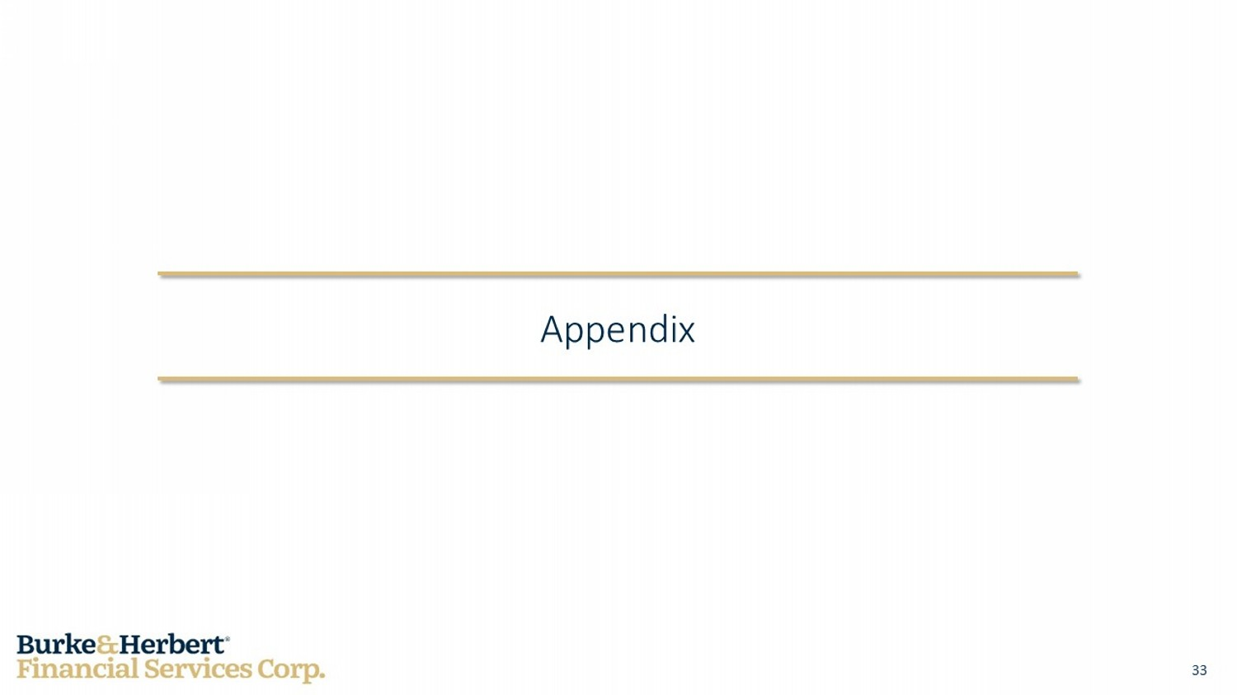
33 Appendix

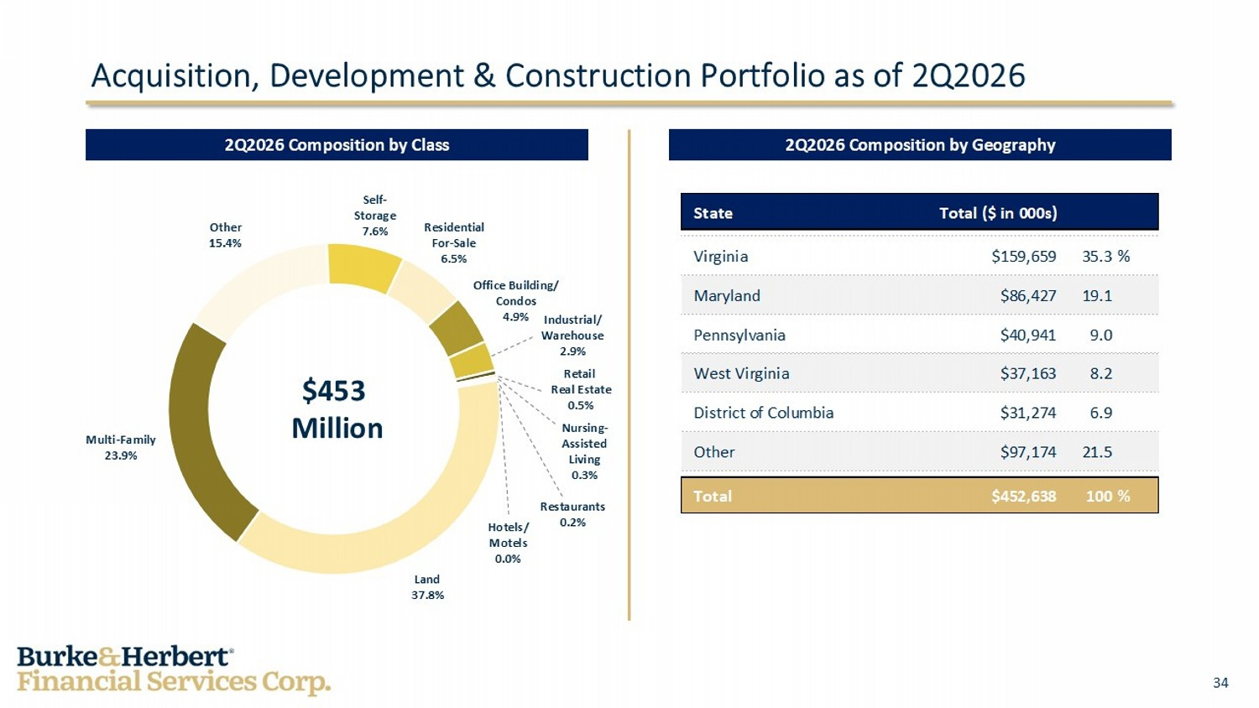
34 State Total ($ in 000s) Virginia $159,659 35.3% Maryland $86,427 19.1 Pennsylvania $40,941 9.0 West Virginia $37,163 8.2 District of Columbia $31,274 6.9 Other $97,174 21.5 Total $452,638 100% Acquisition, Development & Construction Portfolio as of 2Q2026 2Q2026 Composition by Geography 2Q2026 Composition by Class Land 37.8% Multi - Family 23.9% Other 15.4% $453 Million Self - Storage 7.6% Residential For - Sale 6.5% Office Building/ Condos 4.9% Industrial/ Warehouse 2.9% Retail Real Estate 0.5% Hotels/ Motels 0.0% Nursing - Assisted Living 0.3% Restaurants 0.2%

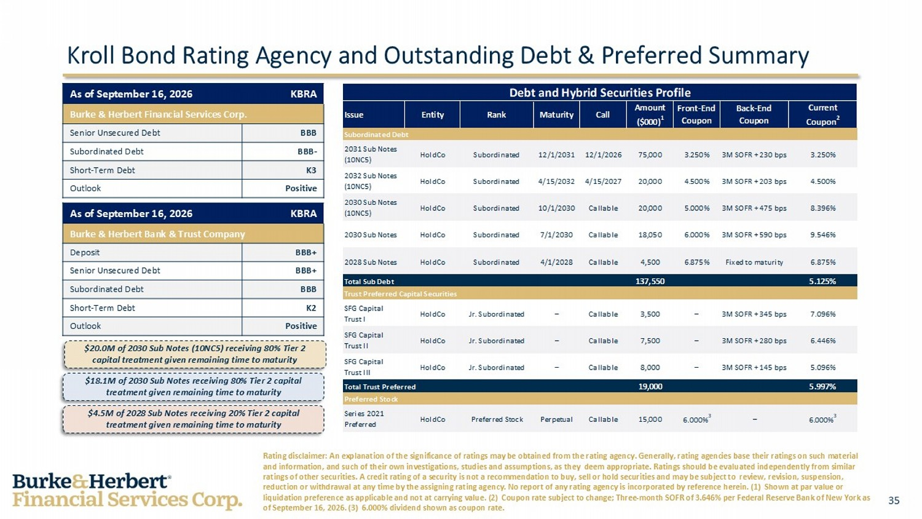
35 Debt and Hybrid Securities Profile Issue Entity Rank Maturity Call Amount ($000) 1 Front-End Coupon Back-End Coupon Current Coupon 2 Subordinated Debt 2031 Sub Notes (10NC5) HoldCo Subordinated 12/1/2031 12/1/2026 75,000 3.250% 3M SOFR + 230 bps 3.250% 2032 Sub Notes (10NC5) HoldCo Subordinated 4/15/2032 4/15/2027 20,000 4.500% 3M SOFR + 203 bps 4.500% 2030 Sub Notes (10NC5) HoldCo Subordinated 10/1/2030 Callable 20,000 5.000% 3M SOFR + 475 bps 8.396% 2030 Sub Notes HoldCo Subordinated 7/1/2030 Callable 18,050 6.000% 3M SOFR + 590 bps 9.546% 2028 Sub Notes HoldCo Subordinated 4/1/2028 Callable 4,500 6.875% Fixed to maturity 6.875% Total Sub Debt 137,550 5.125% Trust Preferred Capital Securities SFG Capital Trust I HoldCo Jr. Subordinated – Callable 3,500 – 3M SOFR + 345 bps 7.096% SFG Capital Trust II HoldCo Jr. Subordinated – Callable 7,500 – 3M SOFR + 280 bps 6.446% SFG Capital Trust III HoldCo Jr. Subordinated – Callable 8,000 – 3M SOFR + 145 bps 5.096% Total Trust Preferred 19,000 5.997% Preferred Stock Series 2021 Preferred HoldCo Preferred Stock Perpetual Callable 15,000 6.000% 3 – 6.000% 3 Kroll Bond Rating Agency and Outstanding Debt & Preferred Summary KBRA As of September 16, 2026 Burke & Herbert Financial Services Corp. BBB Senior Unsecured Debt BBB - Subordinated Debt K3 Short - Term Debt Positive Outlook $4.5M of 2028 Sub Notes receiving 20% Tier 2 capital treatment given remaining time to maturity KBRA As of September 16, 2026 Burke & Herbert Bank & Trust Company BBB+ Deposit BBB+ Senior Unsecured Debt BBB Subordinated Debt K2 Short - Term Debt Positive Outlook Rating disclaimer: An explanation of the significance of ratings may be obtained from the rating agency. Generally, rating ag enc ies base their ratings on such material and information, and such of their own investigations, studies and assumptions, as they deem appropriate. Ratings should be eva luated independently from similar ratings of other securities. A credit rating of a security is not a recommendation to buy, sell or hold securities and may be su bject to review, revision, suspension, reduction or withdrawal at any time by the assigning rating agency. No report of any rating agency is incorporated by referen ce herein. (1) Shown at par value or liquidation preference as applicable and not at carrying value. (2) Coupon rate subject to change; Three - month SOFR of 3.646% p er Federal Reserve Bank of New York as of September 16, 2026. (3) 6.000% dividend shown as coupon rate. $20.0M of 2030 Sub Notes (10NC5) receiving 80% Tier 2 capital treatment given remaining time to maturity $18.1M of 2030 Sub Notes receiving 80% Tier 2 capital treatment given remaining time to maturity

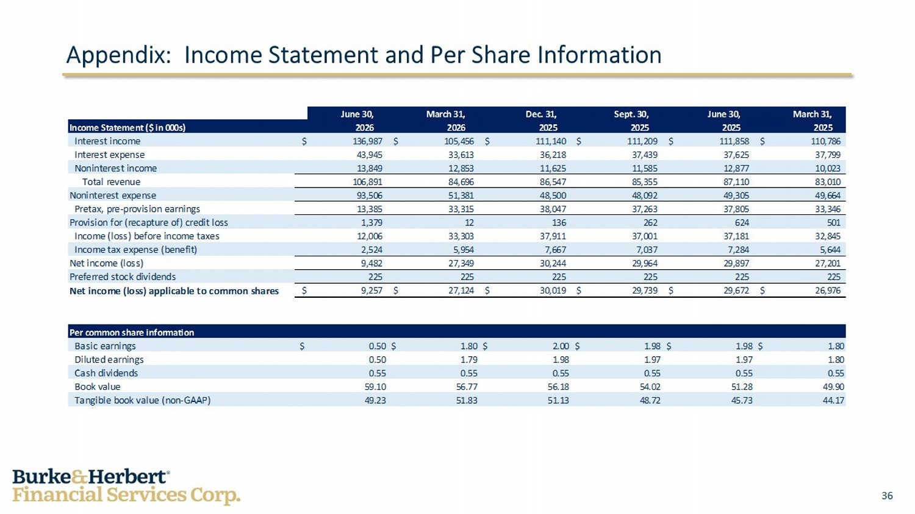
36 June 30, March 31, Dec. 31, Sept. 30, June 30, March 31, Income Statement ($ in 000s) 2026 2026 2025 2025 2025 2025 Interest income $ 136,987 $ 105,456 $ 111,140 $ 111,209 $ 111,858 $ 110,786 Interest expense 43,945 33,613 36,218 37,439 37,625 37,799 Noninterest income 13,849 12,853 11,625 11,585 12,877 10,023 Total revenue 106,891 84,696 86,547 85,355 87,110 83,010 Noninterest expense 93,506 51,381 48,500 48,092 49,305 49,664 Pretax, pre-provision earnings 13,385 33,315 38,047 37,263 37,805 33,346 Provision for (recapture of) credit loss 1,379 12 136 262 624 501 Income (loss) before income taxes 12,006 33,303 37,911 37,001 37,181 32,845 Income tax expense (benefit) 2,524 5,954 7,667 7,037 7,284 5,644 Net income (loss) 9,482 27,349 30,244 29,964 29,897 27,201 Preferred stock dividends 225 225 225 225 225 225 Net income (loss) applicable to common shares $ 9,257 $ 27,124 $ 30,019 $ 29,739 $ 29,672 $ 26,976 Per common share information Basic earnings $ 0.50 $ 1.80 $ 2.00 $ 1.98 $ 1.98 $ 1.80 Diluted earnings 0.50 1.79 1.98 1.97 1.97 1.80 Cash dividends 0.55 0.55 0.55 0.55 0.55 0.55 Book value 59.10 56.77 56.18 54.02 51.28 49.90 Tangible book value (non-GAAP) 49.23 51.83 51.13 48.72 45.73 44.17 Appendix: Income Statement and Per Share Information

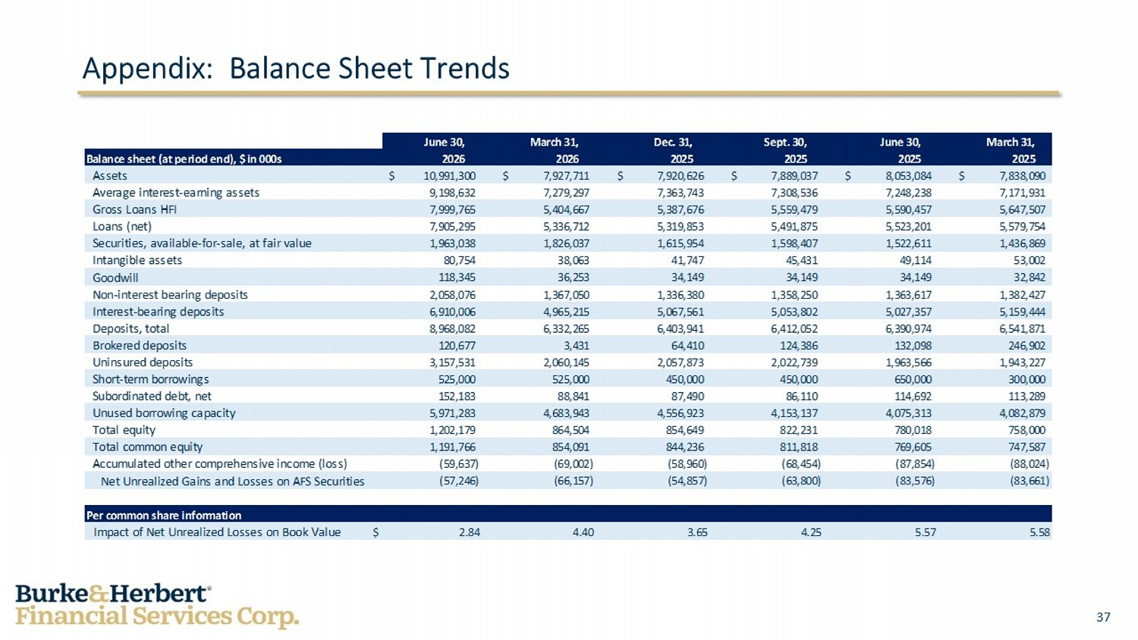
37 June 30, March 31, Dec. 31, Sept. 30, June 30, March 31, Balance sheet (at period end), $ in 000s 2026 2026 2025 2025 2025 2025 Assets 10,991,300$ 7,927,711$ 7,920,626$ 7,889,037$ 8,053,084$ 7,838,090$ Average interest-earning assets 9,198,632 7,279,297 7,363,743 7,308,536 7,248,238 7,171,931 Gross Loans HFI 7,999,765 5,404,667 5,387,676 5,559,479 5,590,457 5,647,507 Loans (net) 7,905,295 5,336,712 5,319,853 5,491,875 5,523,201 5,579,754 Securities, available-for-sale, at fair value 1,963,038 1,826,037 1,615,954 1,598,407 1,522,611 1,436,869 Intangible assets 80,754 38,063 41,747 45,431 49,114 53,002 Goodwill 118,345 36,253 34,149 34,149 34,149 32,842 Non-interest bearing deposits 2,058,076 1,367,050 1,336,380 1,358,250 1,363,617 1,382,427 Interest-bearing deposits 6,910,006 4,965,215 5,067,561 5,053,802 5,027,357 5,159,444 Deposits, total 8,968,082 6,332,265 6,403,941 6,412,052 6,390,974 6,541,871 Brokered deposits 120,677 3,431 64,410 124,386 132,098 246,902 Uninsured deposits 3,157,531 2,060,145 2,057,873 2,022,739 1,963,566 1,943,227 Short-term borrowings 525,000 525,000 450,000 450,000 650,000 300,000 Subordinated debt, net 152,183 88,841 87,490 86,110 114,692 113,289 Unused borrowing capacity 5,971,283 4,683,943 4,556,923 4,153,137 4,075,313 4,082,879 Total equity 1,202,179 864,504 854,649 822,231 780,018 758,000 Total common equity 1,191,766 854,091 844,236 811,818 769,605 747,587 Accumulated other comprehensive income (loss) (59,637) (69,002) (58,960) (68,454) (87,854) (88,024) Net Unrealized Gains and Losses on AFS Securities (57,246) (66,157) (54,857) (63,800) (83,576) (83,661) Per common share information Impact of Net Unrealized Losses on Book Value $ 2.84 4.40 3.65 4.25 5.57 5.58 Appendix: Balance Sheet Trends

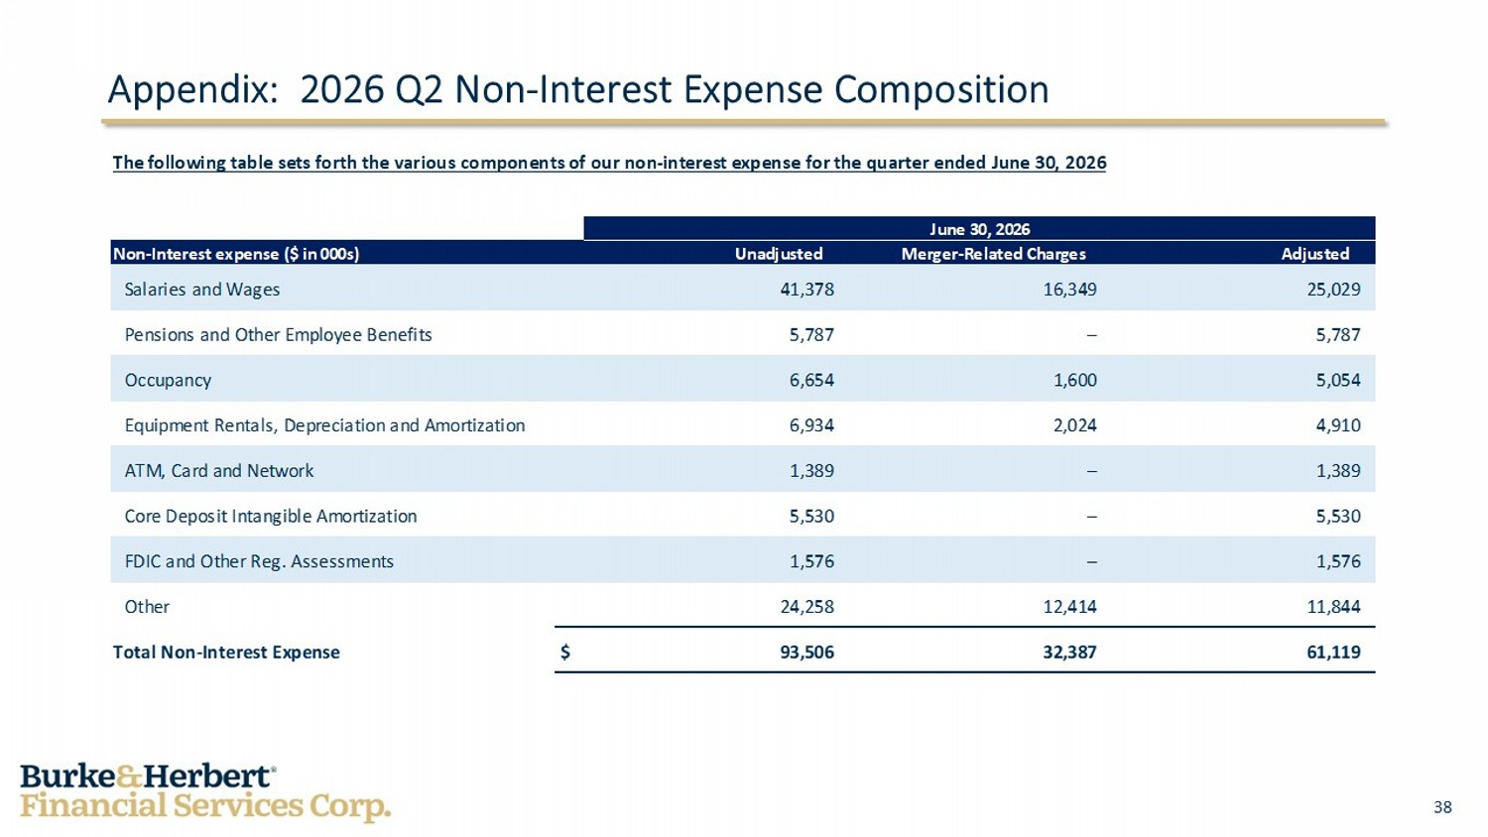
38 June 30, 2026 Non-Interest expense ($ in 000s) Unadjusted Merger-Related Charges Adjusted Salaries and Wages 41,378 16,349 25,029 Pensions and Other Employee Benefits 5,787 – 5,787 Occupancy 6,654 1,600 5,054 Equipment Rentals, Depreciation and Amortization 6,934 2,024 4,910 ATM, Card and Network 1,389 – 1,389 Core Deposit Intangible Amortization 5,530 – 5,530 FDIC and Other Reg. Assessments 1,576 – 1,576 Other 24,258 12,414 11,844 Total Non-Interest Expense $ 93,506 32,387 61,119 The following table sets forth the various components of our non - interest expense for the quarter ended June 30 , 2026 Appendix: 2026 Q2 Non - Interest Expense Composition

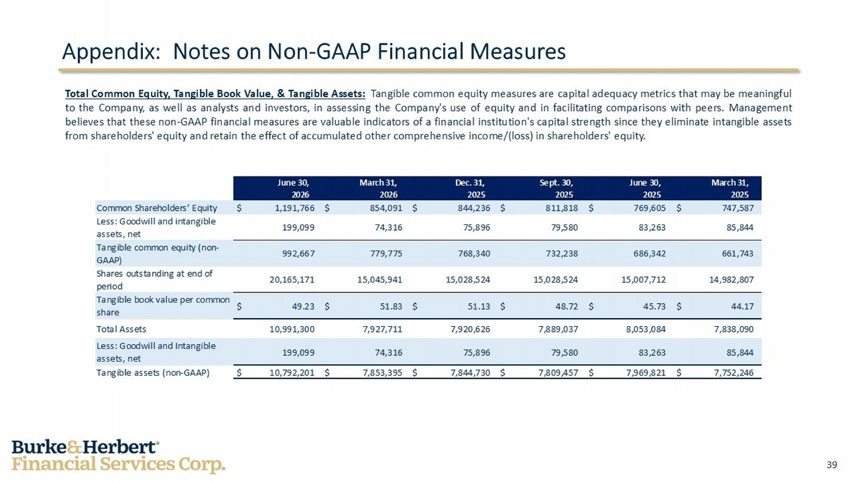
39 June 30, March 31, Dec. 31, Sept. 30, June 30, March 31, 2026 2026 2025 2025 2025 2025 Common Shareholders’ Equity $ 1,191,766 $ 854,091 $ 844,236 $ 811,818 $ 769,605 $ 747,587 Less: Goodwill and intangible assets, net 199,099 74,316 75,896 79,580 83,263 85,844 Tangible common equity (non- GAAP) 992,667 779,775 768,340 732,238 686,342 661,743 Shares outstanding at end of period 20,165,171 15,045,941 15,028,524 15,028,524 15,007,712 14,982,807 Tangible book value per common share $ 49.23 $ 51.83 $ 51.13 $ 48.72 $ 45.73 $ 44.17 Total Assets 10,991,300 7,927,711 7,920,626 7,889,037 8,053,084 7,838,090 Less: Goodwill and Intangible assets, net 199,099 74,316 75,896 79,580 83,263 85,844 Tangible assets (non-GAAP) $ 10,792,201 $ 7,853,395 $ 7,844,730 $ 7,809,457 $ 7,969,821 $ 7,752,246 Appendix: Notes on Non - GAAP Financial Measures Total Common Equity, Tangible Book Value, & Tangible Assets : Tangible common equity measures are capital adequacy metrics that may be meaningful to the Company, as well as analysts and investors, in assessing the Company's use of equity and in facilitating comparisons with peers . Management believes that these non - GAAP financial measures are valuable indicators of a financial institution's capital strength since they eliminate intangible assets from shareholders' equity and retain the effect of accumulated other comprehensive income/(loss) in shareholders' equity .

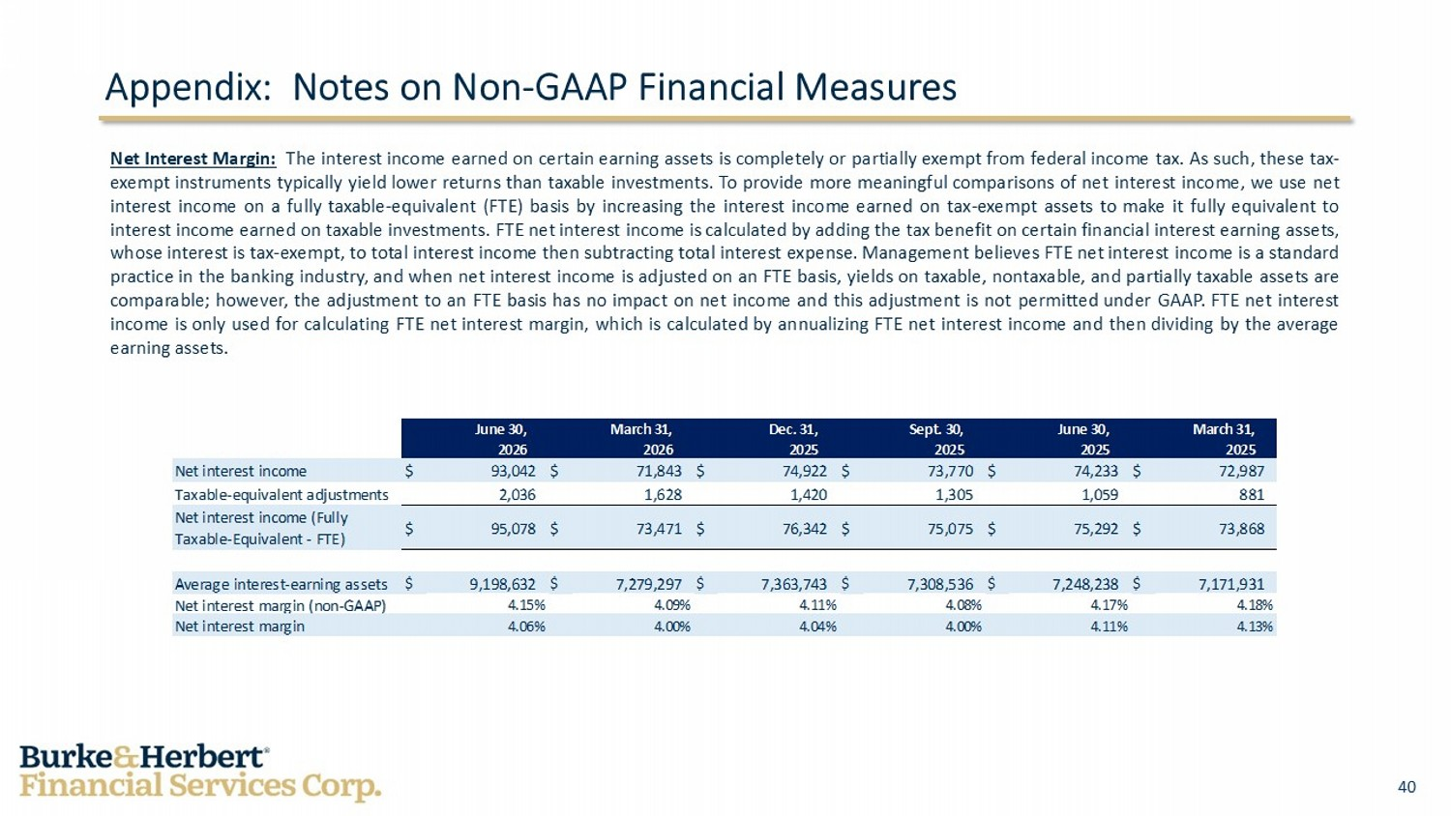
40 June 30, March 31, Dec. 31, Sept. 30, June 30, March 31, 2026 2026 2025 2025 2025 2025 Net interest income $ 93,042 $ 71,843 $ 74,922 $ 73,770 $ 74,233 $ 72,987 Taxable-equivalent adjustments 2,036 1,628 1,420 1,305 1,059 881 Net interest income (Fully Taxable-Equivalent - FTE) $ 95,078 $ 73,471 $ 76,342 $ 75,075 $ 75,292 $ 73,868 Average interest-earning assets $ 9,198,632 $ 7,279,297 $ 7,363,743 $ 7,308,536 $ 7,248,238 $ 7,171,931 Net interest margin (non-GAAP) 4.15% 4.09% 4.11% 4.08% 4.17% 4.18% Net interest margin 4.06% 4.00% 4.04% 4.00% 4.11% 4.13% Appendix: Notes on Non - GAAP Financial Measures Net Interest Margin : The interest income earned on certain earning assets is completely or partially exempt from federal income tax . As such, these tax - exempt instruments typically yield lower returns than taxable investments . To provide more meaningful comparisons of net interest income, we use net interest income on a fully taxable - equivalent (FTE) basis by increasing the interest income earned on tax - exempt assets to make it fully equivalent to interest income earned on taxable investments . FTE net interest income is calculated by adding the tax benefit on certain financial interest earning assets, whose interest is tax - exempt, to total interest income then subtracting total interest expense . Management believes FTE net interest income is a standard practice in the banking industry, and when net interest income is adjusted on an FTE basis, yields on taxable, nontaxable, and partially taxable assets are comparable ; however, the adjustment to an FTE basis has no impact on net income and this adjustment is not permitted under GAAP . FTE net interest income is only used for calculating FTE net interest margin, which is calculated by annualizing FTE net interest income and then dividing by the average earning assets .

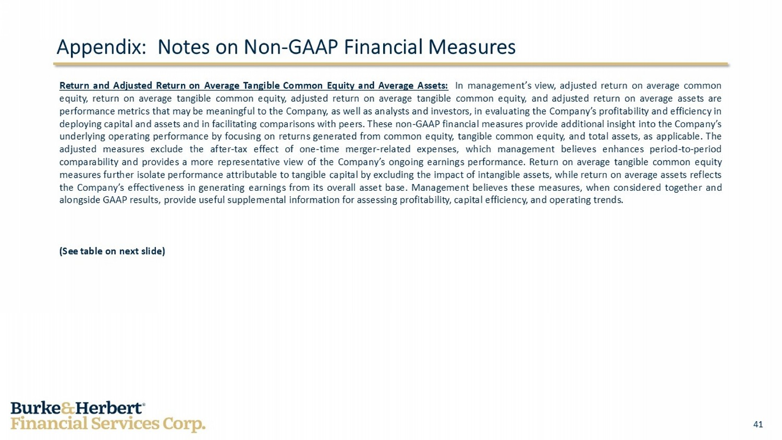
41 Appendix: Notes on Non - GAAP Financial Measures Return and Adjusted Return on Average Tangible Common Equity and Average Assets : In management’s view, adjusted return on average common equity, return on average tangible common equity, adjusted return on average tangible common equity, and adjusted return on average assets are performance metrics that may be meaningful to the Company, as well as analysts and investors, in evaluating the Company’s profitability and efficiency in deploying capital and assets and in facilitating comparisons with peers . These non - GAAP financial measures provide additional insight into the Company’s underlying operating performance by focusing on returns generated from common equity, tangible common equity, and total assets, as applicable . The adjusted measures exclude the after - tax effect of one - time merger - related expenses, which management believes enhances period - to - period comparability and provides a more representative view of the Company’s ongoing earnings performance . Return on average tangible common equity measures further isolate performance attributable to tangible capital by excluding the impact of intangible assets, while return on average assets reflects the Company’s effectiveness in generating earnings from its overall asset base . Management believes these measures, when considered together and alongside GAAP results, provide useful supplemental information for assessing profitability, capital efficiency, and operating trends . (See table on next slide)

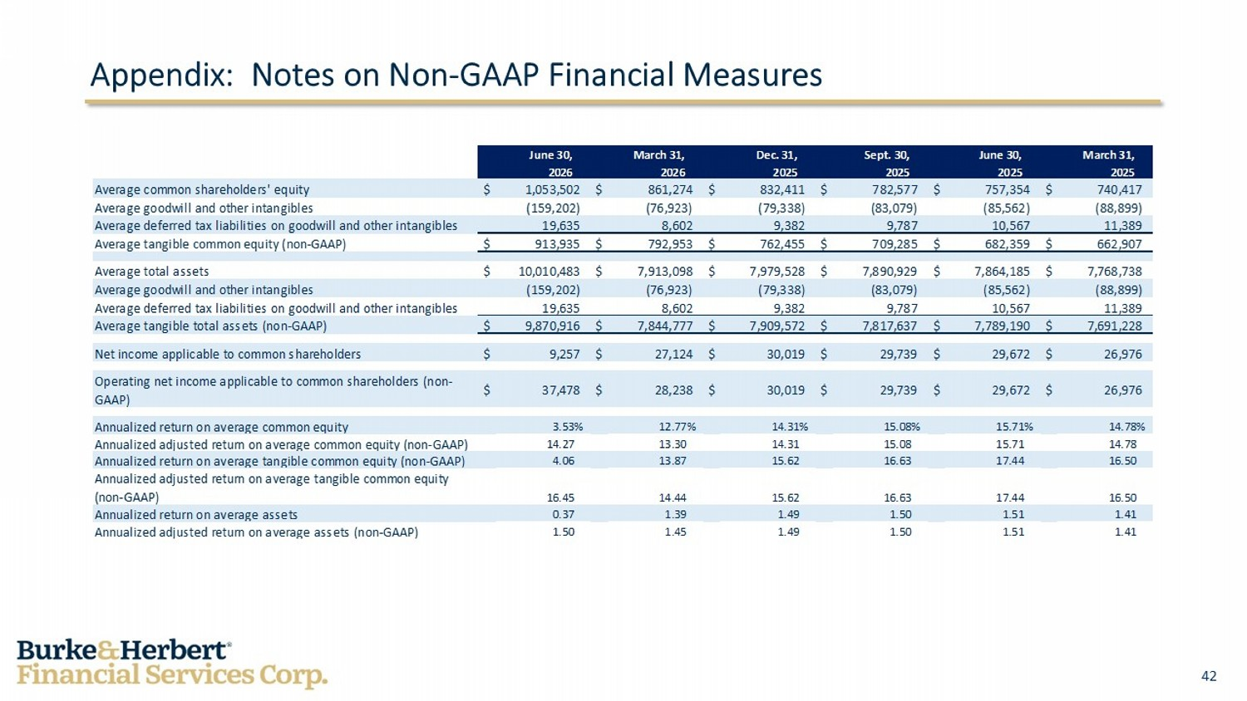
42 June 30, March 31, Dec. 31, Sept. 30, June 30, March 31, 2026 2026 2025 2025 2025 2025 Average common shareholders' equity $ 1,053,502 $ 861,274 $ 832,411 $ 782,577 $ 757,354 $ 740,417 Average goodwill and other intangibles (159,202) (76,923) (79,338) (83,079) (85,562) (88,899) Average deferred tax liabilities on goodwill and other intangibles 19,635 8,602 9,382 9,787 10,567 11,389 Average tangible common equity (non-GAAP) $ 913,935 $ 792,953 $ 762,455 $ 709,285 $ 682,359 $ 662,907 Average total assets $ 10,010,483 $ 7,913,098 $ 7,979,528 $ 7,890,929 $ 7,864,185 $ 7,768,738 Average goodwill and other intangibles (159,202) (76,923) (79,338) (83,079) (85,562) (88,899) Average deferred tax liabilities on goodwill and other intangibles 19,635 8,602 9,382 9,787 10,567 11,389 Average tangible total assets (non-GAAP) $ 9,870,916 $ 7,844,777 $ 7,909,572 $ 7,817,637 $ 7,789,190 $ 7,691,228 Net income applicable to common shareholders $ 9,257 $ 27,124 $ 30,019 $ 29,739 $ 29,672 $ 26,976 Operating net income applicable to common shareholders (non- GAAP) $ 37,478 $ 28,238 $ 30,019 $ 29,739 $ 29,672 $ 26,976 Annualized return on average common equity 3.53% 12.77% 14.31% 15.08% 15.71% 14.78% Annualized adjusted return on average common equity (non-GAAP) 14.27 13.30 14.31 15.08 15.71 14.78 Annualized return on average tangible common equity (non-GAAP) 4.06 13.87 15.62 16.63 17.44 16.50 Annualized adjusted return on average tangible common equity (non-GAAP) 16.45 14.44 15.62 16.63 17.44 16.50 Annualized return on average assets 0.37 1.39 1.49 1.50 1.51 1.41 Annualized adjusted return on average assets (non-GAAP) 1.50 1.45 1.49 1.50 1.51 1.41 Appendix: Notes on Non - GAAP Financial Measures

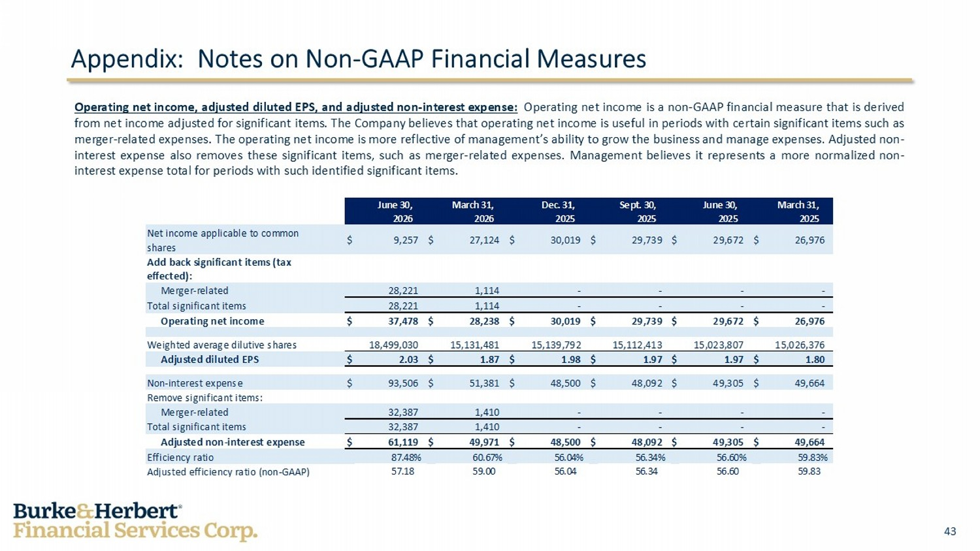
43 June 30, March 31, Dec. 31, Sept. 30, June 30, March 31, 2026 2026 2025 2025 2025 2025 Net income applicable to common shares $ 9,257 $ 27,124 $ 30,019 $ 29,739 $ 29,672 $ 26,976 Add back significant items (tax effected): Merger-related 28,221 1,114 - - - - Total significant items 28,221 1,114 - - - - Operating net income $ 37,478 $ 28,238 $ 30,019 $ 29,739 $ 29,672 $ 26,976 Weighted average dilutive shares 18,499,030 15,131,481 15,139,792 15,112,413 15,023,807 15,026,376 Adjusted diluted EPS $ 2.03 $ 1.87 $ 1.98 $ 1.97 $ 1.97 $ 1.80 Non-interest expense $ 93,506 $ 51,381 $ 48,500 $ 48,092 $ 49,305 $ 49,664 Remove significant items: Merger-related 32,387 1,410 - - - - Total significant items 32,387 1,410 - - - - Adjusted non-interest expense $ 61,119 $ 49,971 $ 48,500 $ 48,092 $ 49,305 $ 49,664 Efficiency ratio 87.48% 60.67% 56.04% 56.34% 56.60% 59.83% Adjusted efficiency ratio (non-GAAP) 57.18 59.00 56.04 56.34 56.60 59.83 Operating net income, adjusted diluted EPS, and adjusted non - interest expense : Operating net income is a non - GAAP financial measure that is derived from net income adjusted for significant items . The Company believes that operating net income is useful in periods with certain significant items such as merger - related expenses . The operating net income is more reflective of management’s ability to grow the business and manage expenses . Adjusted non - interest expense also removes these significant items, such as merger - related expenses . Management believes it represents a more normalized non - interest expense total for periods with such identified significant items . Appendix: Notes on Non - GAAP Financial Measures

