SEC Form 3
FORM 3 | UNITED STATES SECURITIES AND EXCHANGE COMMISSION
 | Washington, D.C. 20549
 | Washington, D.C. 20549 |  | OMB APPROVAL
 | INITIAL STATEMENT OF BENEFICIAL OWNERSHIP OF SECURITIES
 | INITIAL STATEMENT OF BENEFICIAL OWNERSHIP OF SECURITIES |  | OMB Number: | 3235-0104
 |  |  | Estimated average burden
 | Filed pursuant to Section 16(a) of the Securities Exchange Act of 1934 |  | hours per response: | 0.5
or Section 30(h) of the Investment Company Act of 1940
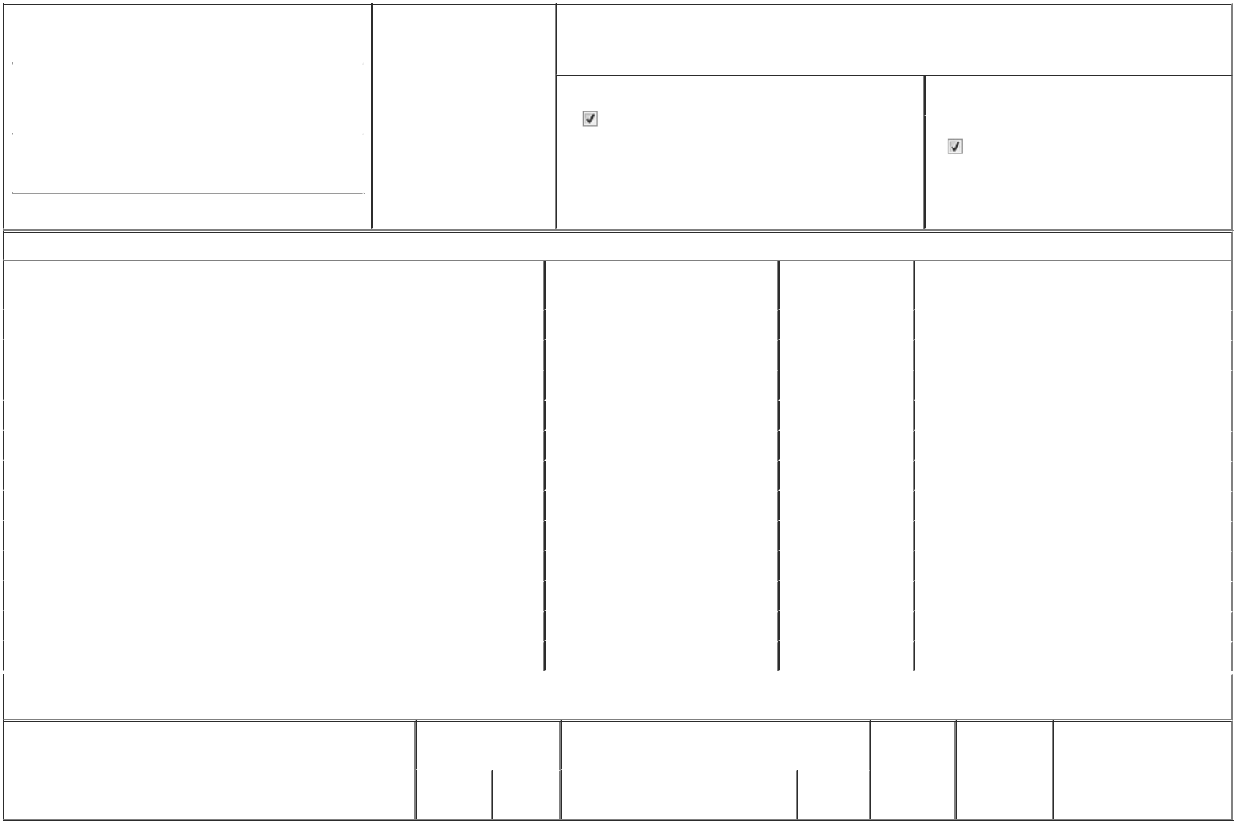

1. Name and Address of Reporting Person* |  |  |  |  |  | 2. Date of Event Requiring
 |  | WILSON DAVID |  |  |  | Statement (Month/Day/Year)
 |  |  |  |  | 06/18/2026
 |  | (Last) | (First) |  | (Middle)
 |  | 100 SOUTH FAIRFAX STREET
(Street)
 |  | ALEXANDRIA | VA |  | 22314

3. Issuer Name and Ticker or Trading Symbol

Burke & Herbert Financial Services Corp. [ BHRB ]

4. Relationship of Reporting Person(s) to Issuer |  | 5. | If Amendment, Date of Original Filed (Month/Day/Year)
(Check all applicable)
Director | 10% Owner
Director | 10% Owner | 6. | Individual or Joint/Group Filing (Check Applicable Line)
Officer (give title |  | 6. | Individual or Joint/Group Filing (Check Applicable Line)
Officer (give title | Other (specify below) |  | Form filed by One Reporting Person
below) | Other (specify below) |  | Form filed by One Reporting Person
Form filed by More than One Reporting Person

(City) (State) (Zip)

Table I - Non-Derivative Securities Beneficially Owned

1. Title of Security (Instr. 4) | 2. Amount of Securities Beneficially | 3. Ownership Form: | 4. Nature of Indirect Beneficial Ownership (Instr. 5)
 | Owned (Instr. 4) | Direct (D) or Indirect
 |  | (I) (Instr. 5)

 | Common Stock | 22,348 | D
 | Common Stock | 2,751 | I | By Spouse
 | Common Stock | 5,445 | I | By A.D.B.M. Properties, LLC
 | Common Stock | 38,142 | I | By ADBM Landholdings, LLC
 | Common Stock | 881 | I | By Boulevard Auto Sales, Inc.
 | Common Stock | 881 | I | By Millsboro Auto Mart II, LLC
 | Common Stock | 385 | I | As Custodian for Foxi Holland under UGMA
 | Common Stock | 198 | I | As Custodian for Miles Holland under UGMA
 | Common Stock | 260 | I | As Custodian for Poppy Kline under UGMA
 | Common Stock | 400 | I | As Custodian for Leo McCraken under UGMA
 | Common Stock | 362 | I | As Custodian for David Wilson, III under UGMA
 | Common Stock | 205 | I | As Custodian for Madison Wilson under UGMA

Table II - Derivative Securities Beneficially Owned

(e.g., puts, calls, warrants, options, convertible securities)

1. Title of Derivative Security (Instr. 4) | 2. Date Exercisable and |  | 3. Title and Amount of Securities Underlying |  | 4. | 5. Ownership | 6. Nature of Indirect Beneficial
 | Expiration Date |  | Derivative Security (Instr. 4) |  | Conversion | Form: Direct | Ownership (Instr. 5)
 | (Month/Day/Year) |  |  |  | or Exercise | (D) or Indirect
 |  |  |  |  | Price of | (I) (Instr. 5)
 |  |  |  | Amount or | Price of | (I) (Instr. 5)
 |  |  |  | Amount or | Derivative
 | Date | Expiration | Title | Number of | Security
 | Exercisable | Date | Title | Shares

Explanation of Responses:

Remarks:

/s/ Matthew Rucker, as Attorney-in-

Fact for David H. Wilson, Sr.

** Signature of Reporting Person

Reminder: Report on a separate line for each class of securities beneficially owned directly or indirectly.

* If the form is filed by more than one reporting person, see Instruction 5 (b)(v).

- Intentional misstatements or omissions of facts constitute Federal Criminal Violations See 18 U.S.C. 1001 and 15 U.S.C. 78ff(a). Note: File three copies of this Form, one of which must be manually signed. If space is insufficient, see Instruction 6 for procedure.
Persons who respond to the collection of information contained in this form are not required to respond unless the form displays a currently valid OMB Number.

06/18/2026

Date



