UNITED STATES
SECURITIES AND EXCHANGE COMMISSION
Washington, D.C. 20549
___________________________________
FORM 8-K
___________________________________
CURRENT REPORT
Pursuant to Section 13 or 15(d)
of the Securities Exchange Act of 1934

July 23, 2026
Date of Report (date of earliest event reported)
___________________________________
Burke & Herbert Financial Services Corp.
(Exact name of registrant as specified in its charter)
___________________________________

Virginia  (State or other jurisdiction of  incorporation or organization) |  |  | 001-41633  (Commission File Number) |  |  | 92-0289417  (I.R.S. Employer Identification Number)
100 S. Fairfax Street
Alexandria, VA 22314
(Address of principal executive offices and zip code)
(703) 666-3555
(Registrant's telephone number, including area code)
___________________________________
Check the appropriate box below if the Form 8-K filing is intended to simultaneously satisfy the filing obligation of the registrant under any of the following provisions:

☐ |  |  | Written communications pursuant to Rule 425 under the Securities Act (17 CFR 230.425)
☐ |  |  | Soliciting material pursuant to Rule 14a-12 under the Exchange Act (17 CFR 240.14a-12)
☐ |  |  | Pre-commencement communications pursuant to Rule 14d-2(b) under the Exchange Act (17 CFR 240.14d-2(b))
☐ |  |  | Pre-commencement communications pursuant to Rule 13e-4(c) under the Exchange Act (17 CFR 240.13e-4(c))
Securities registered pursuant to Section 12(b) of the Act:
Title of each class |  |  | Trading Symbol |  |  | Name of each exchange on which registered
Common stock, par value $0.50 |  |  | BHRB |  |  | The Nasdaq Stock Market LLC
Indicate by check mark whether the registrant is an emerging growth company as defined in Rule 405 of the Securities Act of 1933 (§230.405 of this chapter) or Rule 12b-2 of the Securities Exchange Act of 1934 (§240.12b-2 of this chapter).
Emerging growth company ☐
If an emerging growth company, indicate by check mark if the registrant has elected not to use the extended transition period for complying with any new or revised financial accounting standards provided pursuant to Section 13(a) of the Exchange Act. ☐

Item 2.02 - Results of Operations and Financial Condition.
On July 23, 2026, Burke & Herbert Financial Services Corp. (the "Company") issued a press release announcing its results of operations and financial condition for the quarter ended June 30, 2026. A copy of the press release is included as Exhibit 99.1 to this report.
Item 7.01 - Regulation FD Disclosure
The management of Burke & Herbert Financial Services Corp. anticipates meetings with investors during 2026. A copy of presentation materials will be made available on the investor relations section of the Company's website (https://www.burkeandherbertbank.com) and is furnished as exhibit 99.2 to this report. All information included in this presentation is presented as of the dates indicated, and the Company does not assume any obligation to correct or update such information in the future. The Company disclaims any inferences regarding the materiality of such information which otherwise may arise as a result of it furnishing such information under Item 7.01 of this Form 8-K.

In accordance with General Instruction B.2 of Form 8-K, the information furnished in this Item 7.01, including Exhibit 99.2, shall not be deemed "filed" for purposes of Section 18 of the Securities Exchange Act of 1934, as amended (the "Exchange Act"), or otherwise be subject to the liabilities of Section 18 of the Exchange Act.
Item 8.01 - Other Events
On July 23, 2026, the Company announced its Board of Directors declared a regular quarterly cash dividend on the Company's common stock of $0.55 per share, payable on September 1, 2026, to shareholders of record as of the close of business on August 14, 2026.

Item 9.01 - Financial Statements and Exhibits
(d) The following exhibits are being filed herewith:

Exhibit No. |  |  |  |  |  | Description
99.1 |  |  |  |  |  | Press release, dated July 23, 2026
99.2 |  |  |  |  |  | Earnings Presentation, dated July 23, 2026
104 |  |  |  |  |  | Cover Page Interactive Data File (embedded within the Inline XBRL document)

SIGNATURE

Pursuant to the requirements of the Securities Exchange Act of 1934, as amended, the Registrant has duly caused this report to be signed on its behalf by the undersigned hereunto duly authorized.

Date: July 23, 2026

Burke & Herbert Financial Services Corp.
By: |  |  | /s/ Kirtan Parikh
Name: |  |  | Kirtan Parikh
Title: |  |  | Executive Vice President, CFO



Burke & Herbert Financial Services Corp. Announces Second Quarter 2026 Results and Declares Common Stock Dividend
For Immediate Release
July 23, 2026
Alexandria, VA – Burke & Herbert Financial Services Corp. (the “Company” or “Burke & Herbert”) (Nasdaq: BHRB) reported financial results for the quarter ended June 30, 2026. In addition, at its meeting on July 23, 2026, the board of directors declared a $0.55 per share regular cash dividend to be paid on September 1, 2026, to shareholders of record as of the close of business on August 14, 2026.
From David P. Boyle, Company Chair and Chief Executive Officer
“The successful integration of LINKBANCORP brings together two organizations with a shared commitment to being the quintessential community bank in our markets - one that is deeply invested in the people and businesses we serve every day. Our operating results for the second quarter reflect the strength of that combination, demonstrating both the financial benefits of the acquisition and the power of our disciplined execution. As we move forward, we remain firmly committed to delivering top-quartile financial performance, just as we achieved following the Summit merger, and to creating sustained value for our shareholders, customers, employees, and the communities we call home.”
Q2 2026 Highlights
•On May 1, 2026, the Company announced the completion of the merger of LINKBANCORP, Inc. (“LNKB”) with and into Burke & Herbert and the merger of LINKBANK with and into Burke & Herbert Bank & Trust Company, effective May 1, 2026. The merger created a financial holding company with approximately $11.0 billion in assets and over 100 branches across Delaware, Kentucky, Maryland, Pennsylvania, Virginia, and West Virginia.
•Related to the merger, the total aggregate consideration paid was approximately $329.7 million and resulted in approximately $82.1 million of preliminary goodwill subject to adjustment in accordance with ASC 805, Business Combinations.
•The Company reported net income applicable to common shares of $9.3 million for the quarter and diluted earnings per common share (“EPS”) of $0.50; reflective of merger and other related items, adjusted (non-GAAP1) operating net income applicable to common shares was $37.5 million for the quarter and adjusted (non-GAAP1) diluted EPS was $2.03.
•For the quarter, the annualized return on average assets (“ROA”) was 0.37%, the annualized return on average common equity (“ROCE”) was 3.53%, and the annualized return on average tangible common equity (“ROATCE”) (non-GAAP1) was 4.07%.
•On an adjusted basis (non-GAAP1), ROA was 1.50%, ROCE was 14.27%, and ROATCE was 16.45%.
•Total shareholders’ equity was $1.2 billion and tangible common equity to tangible assets (non-GAAP1) was 9.21%, reflecting the Company’s strong capital position.
•Ending total gross loans were $8.0 billion and ending total deposits were $9.0 billion; ending loan-to-deposit ratio was 89.2%. The net interest margin (non-GAAP1) was 4.15% for the three months ended June 30, 2026.

(1) Non-GAAP financial measures referenced in this release are used by management to measure performance in operating the business that management believes enhances investors’ ability to better understand the underlying business performance and trends related to core business activities. Reconciliations of non-GAAP operating measures to the most directly comparable GAAP financial measures are included in the non-GAAP reconciliation tables in this release. Non-GAAP measures should not be used as a substitute for the closest comparable GAAP measurements.
(2) Ratios as of June 30, 2026, are estimated.
1
•The balance sheet remains strong with ample liquidity. Total liquidity, including all available borrowing capacity with cash and cash equivalents, totaled $6.1 billion at the end of the second quarter.
•Asset quality metrics remain within the Company’s moderate risk profile with adequate reserve coverage.
•The Company continues to be well-capitalized, ending the quarter with 11.79%2 Common Equity Tier 1 capital to risk-weighted assets, 14.48%2 Total risk-based capital to risk-weighted assets, and a leverage ratio of 11.08%.2
Results of Operations reflecting the May 1, 2026 merger with LNKB and system & operational integration activities successfully completed in June 2026
Second Quarter 2026 compared to First Quarter 2026
The Company reported second quarter 2026 net income applicable to common shares of $9.3 million, or $0.50 per diluted common share, compared to first quarter 2026 net income applicable to common shares of $27.1 million, or $1.79 per diluted common share.
•Period-end total gross loans were $8.0 billion at June 30, 2026, an increase of $2.6 billion from March 31, 2026, mostly due to the merger. Additionally, the Company originated $333.0 million of new, relationship-based loan commitments during the quarter. During the month of April 2026, LNKB originated $78.2 million of new, relationship-based loan commitments.
•Period-end total deposits were $9.0 billion at June 30, 2026, an increase of $2.6 billion from March 31, 2026, mostly due to the merger. During the quarter, brokered deposits increased by $117.2 million and totaled $120.7 million at June 30, 2026, representing only 1.35% of total deposits.
•Net interest income for the quarter was $93.0 million compared to $71.8 million in the prior quarter due to an increase in interest income of $31.5 million, offset by an increase in interest expense of $10.3 million, primarily driven by the acquisition of LNKB.
•Net interest margin on a fully taxable equivalent basis (non-GAAP1) increased to 4.15% versus 4.09% in the first quarter of 2026, driven by growth in average interest-earning assets from the LNKB acquisition and higher securities yields, partially offset by lower loan yields and higher funding costs.
•Accretion income on loans during the quarter was $9.3 million, and the amortization expense impact on interest expense was $1.5 million, or 34.0 bps of net interest margin on an annualized basis in the second quarter of 2026. In the prior quarter, accretion income on loans during the quarter was $6.8 million, and the amortization expense impact on interest expense was $1.4 million, or 30.5 bps of net interest margin on an annualized basis.
•The cost of total deposits, including non-interest bearing deposits, was 1.75% in the second quarter of 2026, compared to 1.71% in the first quarter of 2026. The increase in the cost of deposits was mostly due to an increase in the rate paid on interest-bearing deposits and an increase in volume of interest-bearing deposits compared to the first quarter of 2026.
•The Company recorded credit provision expense in the second quarter of 2026 of $30.0 thousand on loans and a credit provision expense of $1.3 million on unfunded commitments. The Company’s allowance for credit losses as of June 30, 2026, was $94.5 million, or 1.2% of total loans. The credit provision expense increase in the unfunded commitment was primarily driven by a Day 2 impact of the LNKB acquisition.

2
•Total non-interest income increased $1.0 million to $13.8 million in the second quarter of 2026, compared to $12.9 million in the first quarter of 2026 driven by favorable contributions from company-owned life insurance income, debit card-related revenue, and other non-interest income categories. These increases were partially offset by lower income from the sale of LNKB-acquired securities compared to the prior quarter.
•Non-interest expense for the second quarter of 2026 was $93.5 million compared to $51.4 million in the first quarter of 2026; the increase was primarily driven by the LNKB acquisition. The increase in expense included conversion and integration costs, professional fees, contract termination costs, and employee-related expenses.
Regulatory capital ratios2
The Company continues to be well-capitalized with capital ratios that are above regulatory requirements. As of June 30, 2026, our Common Equity Tier 1 capital to risk-weighted asset and Total risk-based capital to risk-weighted asset ratios were 11.8%2 and 14.5%2, respectively, and significantly above the well-capitalized requirements of 6.5% and 10%, respectively. The leverage ratio was 11.1%2 compared to a 5% level to be considered well-capitalized.
Burke & Herbert Bank & Trust Company (the “Bank”), the Company’s wholly-owned bank subsidiary, also continues to be well-capitalized with capital ratios that are above regulatory requirements. As of June 30, 2026, the Bank’s Common Equity Tier 1 capital to risk-weighted asset and Total risk-based capital to risk-weighted asset ratios were 13.3%2 and 14.3%,2 respectively, and significantly above the well-capitalized requirements. In addition, the Bank’s leverage ratio of 12.3%2 is considered to be well-capitalized.
For more information about the Company’s financial condition, including additional disclosures pertinent to recent events in the banking industry, please see our financial statements and supplemental information attached to this release.
About Burke & Herbert
Burke & Herbert Financial Services Corp. is the financial holding company for Burke & Herbert Bank & Trust Company. Burke & Herbert Bank & Trust Company is the oldest continuously operating bank under its original name headquartered in the greater Washington, D.C. metropolitan area. With over 100 branches across Delaware, Kentucky, Maryland, Pennsylvania, Virginia, and West Virginia, Burke & Herbert Bank & Trust Company offers a full range of business and personal financial solutions designed to meet customers’ banking, borrowing, and investment needs. Learn more at investor.burkeandherbertbank.com.
Cautionary Note Regarding Forward-Looking Statements
This communication includes “forward-looking statements” within the meaning of the Private Securities Litigation Reform Act of 1995, Section 27A of the Securities Act of 1933, as amended, and Section 21E of the Securities Exchange Act of 1934, as amended, including with respect to (or based on) the beliefs, goals, intentions, and expectations of Burke & Herbert regarding our: merger with LINKBANCORP, Inc., effective as of May 1, 2026, and the expected cost savings, synergies, returns, and other anticipated benefits from the integration of LNKB; revenues, earnings, earnings per share, loan production, asset quality, and capital levels, among other matters; estimates of the future costs and benefits of the actions we may take; assessments of expected losses on loans; assessments of interest rate and other market risks; ability to achieve financial and other strategic goals; and other statements that are not historical facts. Forward–looking statements are typically identified by such words as “believe,” “expect,” “anticipate,”

3
“intend,” “outlook,” “estimate,” “forecast,” “project,” “will,” “should,” and other similar words and expressions, and are subject to numerous assumptions, risks, and uncertainties, which change over time.
Additionally, forward–looking statements speak only as of the date they are made; Burke & Herbert does not assume any duty, and does not undertake, to update such forward–looking statements, whether written or oral, that may be made from time to time, whether as a result of new information, future events, or otherwise. Furthermore, because forward–looking statements are subject to assumptions and uncertainties, actual results or future events could differ, possibly materially, from those indicated in or implied by such forward-looking statements as a result of a variety of factors, many of which are beyond the control of Burke & Herbert. Such statements are based upon the current beliefs and expectations of the management of Burke & Herbert and are subject to significant risks and uncertainties outside of its control. Caution should be exercised against placing undue reliance on forward-looking statements.
The factors that could cause actual results to differ materially include the following: the possibility that the anticipated benefits of the merger will not be realized when expected or at all, including as a result of the impact of, or problems arising from (if any), the integration of the two companies or as a result of the strength of the economy and competitive factors in the areas where Burke & Herbert and LNKB do business; costs or difficulties associated with newly developed or acquired operations; diversion of management’s attention from ongoing business operations and opportunities; the possibility that the parties may be unable to achieve expected synergies and operating efficiencies in the merger within the expected timeframes or at all and to successfully integrate LNKB’s operations and those of Burke & Herbert; that the integration of LNKB may be more difficult, time-consuming or costly than expected; revenues following the merger may be lower than expected; Burke & Herbert’s success in executing its business plans and strategies and managing the risks involved in the foregoing; and risks related to the potential impact of global macroeconomic conditions and changes in general economic, political and market factors on the merger or our operations, generally (either nationally or locally in the areas in which we conduct, or will conduct, business), including inflation, changes in interest rates, market volatility and monetary fluctuations, and changes in federal government policies and practices, including the impact with respect to spending on industries concentrated in our market area, as well as the impact from tariffs on the markets we serve; increased competition; changes in consumer confidence and demand for financial services, including changes in consumer borrowing, repayment, investment, and deposit practices; changes in asset quality and credit risk; our ability to control costs and expenses; adverse developments in borrower industries or declines in real estate values; changes in and compliance with federal and state laws and regulations that pertain to our business and capital levels; our ability to raise capital as needed; the impact, extent and timing of technological changes; emerging external focus among regulators and other officials related to risks in connection with the development and use of artificial intelligence; the effects of any cybersecurity breaches or events; the potential adverse effects of unusual and infrequently occurring events, such as weather-related disasters, terrorist acts, geopolitical conflicts and tensions, or public health events (such as pandemics), and of governmental and societal responses thereto; and the other factors discussed in the “Risk Factors” and “Management’s Discussion and Analysis of Financial Condition and Results of Operations” sections of Burke & Herbert’s Annual Report on Form 10-K for the year ended December 31, 2025, its Quarterly Report on Form 10-Q for the quarter ended March 31, 2026, and other reports Burke & Herbert files with the SEC.

Burke & Herbert Financial Services Corp.

4
Consolidated Statements of Income (unaudited)
(In thousands)
 |  |  |  |  |  | Three Months Ended |  |  |  |  |  |  |  |  |  |  |  |  |  |  |  |  |  | Six Months Ended
 |  |  |  |  |  | June 30, |  |  |  |  |  |  |  |  |  |  |  | March 31, |  |  |  |  |  | June 30,
 |  |  |  |  |  | 2026 |  |  |  |  |  | 2025 |  |  |  |  |  | 2026 |  |  |  |  |  | 2026 |  |  |  |  |  | 2025
Interest income
Taxable loans, including fees |  |  |  |  |  | $ | 116,770 |  |  |  |  | $ | 96,803 |  |  |  |  | $ | 88,083 |  |  |  |  | $ | 204,853 |  |  |  |  | $ | 193,834
Tax-exempt loans, including fees |  |  |  |  |  | 55 |  |  |  |  |  | 43 |  |  |  |  |  | 40 |  |  |  |  |  | 95 |  |  |  |  |  | 89
Taxable securities |  |  |  |  |  | 11,329 |  |  |  |  |  | 9,303 |  |  |  |  |  | 9,758 |  |  |  |  |  | 21,087 |  |  |  |  |  | 18,790
Tax-exempt securities |  |  |  |  |  | 7,605 |  |  |  |  |  | 3,939 |  |  |  |  |  | 6,082 |  |  |  |  |  | 13,687 |  |  |  |  |  | 7,206
Other interest income |  |  |  |  |  | 1,228 |  |  |  |  |  | 1,770 |  |  |  |  |  | 1,493 |  |  |  |  |  | 2,721 |  |  |  |  |  | 2,725
Total interest income |  |  |  |  |  | 136,987 |  |  |  |  |  | 111,858 |  |  |  |  |  | 105,456 |  |  |  |  |  | 242,443 |  |  |  |  |  | 222,644
Interest expense
Deposits |  |  |  |  |  | 35,012 |  |  |  |  |  | 30,431 |  |  |  |  |  | 26,720 |  |  |  |  |  | 61,732 |  |  |  |  |  | 62,282
Short-term borrowings |  |  |  |  |  | 5,897 |  |  |  |  |  | 4,438 |  |  |  |  |  | 4,590 |  |  |  |  |  | 10,487 |  |  |  |  |  | 7,630
Subordinated debt |  |  |  |  |  | 2,990 |  |  |  |  |  | 2,730 |  |  |  |  |  | 2,269 |  |  |  |  |  | 5,259 |  |  |  |  |  | 5,459
Other interest expense |  |  |  |  |  | 40 |  |  |  |  |  | 26 |  |  |  |  |  | 34 |  |  |  |  |  | 74 |  |  |  |  |  | 53
Total interest expense |  |  |  |  |  | 43,939 |  |  |  |  |  | 37,625 |  |  |  |  |  | 33,613 |  |  |  |  |  | 77,552 |  |  |  |  |  | 75,424
Net interest income |  |  |  |  |  | 93,048 |  |  |  |  |  | 74,233 |  |  |  |  |  | 71,843 |  |  |  |  |  | 164,891 |  |  |  |  |  | 147,220
Credit loss expense - loans and available-for-sale securities |  |  |  |  |  | 30 |  |  |  |  |  | 717 |  |  |  |  |  | 213 |  |  |  |  |  | 243 |  |  |  |  |  | 1,617
Credit loss (recapture) - off-balance sheet credit exposures |  |  |  |  |  | 1,349 |  |  |  |  |  | (93) |  |  |  |  |  | (201) |  |  |  |  |  | 1,148 |  |  |  |  |  | (492)
Total provision for credit losses |  |  |  |  |  | 1,379 |  |  |  |  |  | 624 |  |  |  |  |  | 12 |  |  |  |  |  | 1,391 |  |  |  |  |  | 1,125
Net interest income after credit loss expense |  |  |  |  |  | 91,669 |  |  |  |  |  | 73,609 |  |  |  |  |  | 71,831 |  |  |  |  |  | 163,500 |  |  |  |  |  | 146,095
Non-interest income
Fiduciary and wealth management |  |  |  |  |  | 3,100 |  |  |  |  |  | 2,425 |  |  |  |  |  | 3,227 |  |  |  |  |  | 6,327 |  |  |  |  |  | 4,868
Service charges and fees |  |  |  |  |  | 2,286 |  |  |  |  |  | 2,130 |  |  |  |  |  | 1,855 |  |  |  |  |  | 4,141 |  |  |  |  |  | 4,308
Net (loss) gain on securities |  |  |  |  |  | (1,868) |  |  |  |  |  | 38 |  |  |  |  |  | 1,799 |  |  |  |  |  | (69) |  |  |  |  |  | 39
Income from company-owned life insurance |  |  |  |  |  | 3,207 |  |  |  |  |  | 2,982 |  |  |  |  |  | 1,479 |  |  |  |  |  | 4,686 |  |  |  |  |  | 4,175
Bank debit and other card revenue |  |  |  |  |  | 3,421 |  |  |  |  |  | 3,024 |  |  |  |  |  | 2,835 |  |  |  |  |  | 6,256 |  |  |  |  |  | 5,908
Other non-interest income |  |  |  |  |  | 3,703 |  |  |  |  |  | 2,278 |  |  |  |  |  | 1,658 |  |  |  |  |  | 5,361 |  |  |  |  |  | 3,602
Total non-interest income |  |  |  |  |  | 13,849 |  |  |  |  |  | 12,877 |  |  |  |  |  | 12,853 |  |  |  |  |  | 26,702 |  |  |  |  |  | 22,900
Non-interest expense
Salaries and wages |  |  |  |  |  | 41,378 |  |  |  |  |  | 21,320 |  |  |  |  |  | 21,413 |  |  |  |  |  | 62,791 |  |  |  |  |  | 42,261
Pensions and other employee benefits |  |  |  |  |  | 5,787 |  |  |  |  |  | 4,067 |  |  |  |  |  | 5,370 |  |  |  |  |  | 11,157 |  |  |  |  |  | 9,203
Occupancy |  |  |  |  |  | 6,654 |  |  |  |  |  | 3,521 |  |  |  |  |  | 4,027 |  |  |  |  |  | 10,681 |  |  |  |  |  | 7,566
Equipment rentals, depreciation and maintenance |  |  |  |  |  | 6,934 |  |  |  |  |  | 4,100 |  |  |  |  |  | 4,188 |  |  |  |  |  | 11,122 |  |  |  |  |  | 8,184
Core deposit intangible amortization |  |  |  |  |  | 5,530 |  |  |  |  |  | 3,888 |  |  |  |  |  | 3,684 |  |  |  |  |  | 9,214 |  |  |  |  |  | 8,186
ATM, card and network expense |  |  |  |  |  | 1,389 |  |  |  |  |  | 1,314 |  |  |  |  |  | 1,134 |  |  |  |  |  | 2,523 |  |  |  |  |  | 2,446
FDIC and other regulatory assessments |  |  |  |  |  | 1,576 |  |  |  |  |  | 1,088 |  |  |  |  |  | 1,140 |  |  |  |  |  | 2,716 |  |  |  |  |  | 2,002
Other operating |  |  |  |  |  | 24,258 |  |  |  |  |  | 10,007 |  |  |  |  |  | 10,425 |  |  |  |  |  | 34,683 |  |  |  |  |  | 19,121
Total non-interest expense |  |  |  |  |  | 93,506 |  |  |  |  |  | 49,305 |  |  |  |  |  | 51,381 |  |  |  |  |  | 144,887 |  |  |  |  |  | 98,969
Income before income taxes |  |  |  |  |  | 12,012 |  |  |  |  |  | 37,181 |  |  |  |  |  | 33,303 |  |  |  |  |  | 45,315 |  |  |  |  |  | 70,026
Income tax expense |  |  |  |  |  | 2,524 |  |  |  |  |  | 7,284 |  |  |  |  |  | 5,954 |  |  |  |  |  | 8,478 |  |  |  |  |  | 12,928
Net income |  |  |  |  |  | 9,488 |  |  |  |  |  | 29,897 |  |  |  |  |  | 27,349 |  |  |  |  |  | 36,837 |  |  |  |  |  | 57,098
Preferred stock dividends |  |  |  |  |  | 225 |  |  |  |  |  | 225 |  |  |  |  |  | 225 |  |  |  |  |  | 450 |  |  |  |  |  | 450
Net income applicable to common shares |  |  |  |  |  | $ | 9,263 |  |  |  |  | $ | 29,672 |  |  |  |  | $ | 27,124 |  |  |  |  | $ | 36,387 |  |  |  |  | $ | 56,648
Earnings per common share
Basic |  |  |  |  |  | $ | 0.50 |  |  |  |  | $ | 1.98 |  |  |  |  | $ | 1.80 |  |  |  |  | $ | 2.17 |  |  |  |  | $ | 3.78
Diluted |  |  |  |  |  | 0.50 |  |  |  |  |  | 1.97 |  |  |  |  |  | 1.79 |  |  |  |  |  | 2.16 |  |  |  |  |  | 3.77

Burke & Herbert Financial Services Corp.

5
Consolidated Balance Sheets
(In thousands)
 |  |  |  |  |  | June 30, 2026 |  |  |  |  |  | December 31, 2025
 |  |  |  |  |  | (Unaudited) |  |  |  |  |  | (Audited)
Assets
Cash and due from banks |  |  |  |  |  | $ | 116,443 |  |  |  |  | $ | 53,497
Interest-earning deposits with banks |  |  |  |  |  | 52,260 |  |  |  |  |  | 235,630
Cash and cash equivalents |  |  |  |  |  | 168,703 |  |  |  |  |  | 289,127
Securities available-for-sale, at fair value |  |  |  |  |  | 1,963,038 |  |  |  |  |  | 1,615,954
Restricted stock, at cost |  |  |  |  |  | 56,850 |  |  |  |  |  | 42,187
Loans held-for-sale, at fair value |  |  |  |  |  | 2,074 |  |  |  |  |  | 365
Loans |  |  |  |  |  | 7,999,765 |  |  |  |  |  | 5,387,676
Allowance for credit losses |  |  |  |  |  | (94,470) |  |  |  |  |  | (67,823)
Net loans |  |  |  |  |  | 7,905,295 |  |  |  |  |  | 5,319,853
Other real estate owned |  |  |  |  |  | 2,934 |  |  |  |  |  | 2,689
Premises and equipment, net |  |  |  |  |  | 150,698 |  |  |  |  |  | 136,809
Accrued interest receivable |  |  |  |  |  | 50,007 |  |  |  |  |  | 35,442
Intangible assets |  |  |  |  |  | 80,754 |  |  |  |  |  | 41,747
Goodwill |  |  |  |  |  | 118,345 |  |  |  |  |  | 34,149
Company-owned life insurance |  |  |  |  |  | 269,046 |  |  |  |  |  | 213,200
Other assets |  |  |  |  |  | 224,754 |  |  |  |  |  | 189,104
Total Assets |  |  |  |  |  | $ | 10,992,498 |  |  |  |  | $ | 7,920,626
Liabilities and Shareholders’ Equity
Liabilities
Non-interest-bearing deposits |  |  |  |  |  | $ | 2,058,076 |  |  |  |  | $ | 1,336,380
Interest-bearing deposits |  |  |  |  |  | 6,910,006 |  |  |  |  |  | 5,067,561
Total deposits |  |  |  |  |  | 8,968,082 |  |  |  |  |  | 6,403,941
Short-term borrowings |  |  |  |  |  | 525,000 |  |  |  |  |  | 450,000
Subordinated debentures, net |  |  |  |  |  | 134,789 |  |  |  |  |  | 70,222
Subordinated debentures owed to unconsolidated subsidiary trusts |  |  |  |  |  | 17,394 |  |  |  |  |  | 17,268
Accrued interest and other liabilities |  |  |  |  |  | 143,856 |  |  |  |  |  | 124,546
Total Liabilities |  |  |  |  |  | 9,789,121 |  |  |  |  |  | 7,065,977
Shareholders’ Equity
Preferred stock and surplus |  |  |  |  |  | 10,413 |  |  |  |  |  | 10,413
Common stock |  |  |  |  |  | 10,368 |  |  |  |  |  | 7,800
Common stock, additional paid-in capital |  |  |  |  |  | 734,764 |  |  |  |  |  | 405,922
Retained earnings |  |  |  |  |  | 533,861 |  |  |  |  |  | 517,058
Accumulated other comprehensive income (loss) |  |  |  |  |  | (58,445) |  |  |  |  |  | (58,960)
Treasury stock |  |  |  |  |  | (27,584) |  |  |  |  |  | (27,584)
Total Shareholders’ Equity |  |  |  |  |  | 1,203,377 |  |  |  |  |  | 854,649
Total Liabilities and Shareholders’ Equity |  |  |  |  |  | $ | 10,992,498 |  |  |  |  | $ | 7,920,626

Burke & Herbert Financial Services Corp.
6
Details of Net Interest Margin (unaudited)
For the three months ended
Details of Net Interest Margin - Yield Percentages
 |  |  |  |  |  | June 30 |  |  |  |  |  | March 31 |  |  |  |  |  | December 31 |  |  |  |  |  | September 30 |  |  |  |  |  | June 30
 |  |  |  |  |  | 2026 |  |  |  |  |  | 2026 |  |  |  |  |  | 2025 |  |  |  |  |  | 2025 |  |  |  |  |  | 2025
Interest-earning assets:
Loans:
Taxable loans |  |  |  |  |  | 6.54 |  | % |  |  |  | 6.64 |  | % |  |  |  | 6.79 |  | % |  |  |  | 6.76 |  | % |  |  |  | 6.90 |  | %
Tax-exempt loans |  |  |  |  |  | 6.15 |  |  |  |  |  | 7.12 |  |  |  |  |  | 7.03 |  |  |  |  |  | 6.78 |  |  |  |  |  | 5.90
Total loans |  |  |  |  |  | 6.54 |  |  |  |  |  | 6.64 |  |  |  |  |  | 6.79 |  |  |  |  |  | 6.76 |  |  |  |  |  | 6.90
Interest-earning deposits and fed funds sold |  |  |  |  |  | 3.28 |  |  |  |  |  | 4.25 |  |  |  |  |  | 3.83 |  |  |  |  |  | 4.33 |  |  |  |  |  | 4.68
Securities:
Taxable securities |  |  |  |  |  | 4.23 |  |  |  |  |  | 3.78 |  |  |  |  |  | 3.78 |  |  |  |  |  | 3.86 |  |  |  |  |  | 3.83
Tax-exempt securities |  |  |  |  |  | 4.65 |  |  |  |  |  | 4.48 |  |  |  |  |  | 4.27 |  |  |  |  |  | 4.17 |  |  |  |  |  | 4.20
Total securities |  |  |  |  |  | 4.41 |  |  |  |  |  | 4.05 |  |  |  |  |  | 3.96 |  |  |  |  |  | 3.97 |  |  |  |  |  | 3.95
Total interest-earning assets |  |  |  |  |  | 6.06 |  | % |  |  |  | 5.97 |  | % |  |  |  | 6.06 |  | % |  |  |  | 6.11 |  | % |  |  |  | 6.25 |  | %
Interest-bearing liabilities:
Deposits:
Interest-bearing demand |  |  |  |  |  | 1.95 |  | % |  |  |  | 1.98 |  | % |  |  |  | 2.07 |  | % |  |  |  | 2.18 |  | % |  |  |  | 2.21 |  | %
Money market & savings |  |  |  |  |  | 1.95 |  |  |  |  |  | 1.83 |  |  |  |  |  | 1.94 |  |  |  |  |  | 2.02 |  |  |  |  |  | 2.01
Brokered CDs & time deposits |  |  |  |  |  | 3.27 |  |  |  |  |  | 3.11 |  |  |  |  |  | 3.23 |  |  |  |  |  | 3.25 |  |  |  |  |  | 3.37
Total interest-bearing deposits |  |  |  |  |  | 2.25 |  |  |  |  |  | 2.16 |  |  |  |  |  | 2.28 |  |  |  |  |  | 2.37 |  |  |  |  |  | 2.41
Borrowings:
Short-term borrowings |  |  |  |  |  | 3.64 |  |  |  |  |  | 3.78 |  |  |  |  |  | 3.93 |  |  |  |  |  | 3.85 |  |  |  |  |  | 3.91
Subordinated debt borrowings and other |  |  |  |  |  | 9.16 |  |  |  |  |  | 10.46 |  |  |  |  |  | 10.62 |  |  |  |  |  | 9.49 |  |  |  |  |  | 9.62
Total interest-bearing liabilities |  |  |  |  |  | 2.51 |  | % |  |  |  | 2.44 |  | % |  |  |  | 2.54 |  | % |  |  |  | 2.63 |  | % |  |  |  | 2.68 |  | %
Taxable-equivalent net interest spread |  |  |  |  |  | 3.55 |  |  |  |  |  | 3.53 |  |  |  |  |  | 3.52 |  |  |  |  |  | 3.48 |  |  |  |  |  | 3.57
Benefit from use of non-interest-bearing deposits |  |  |  |  |  | 0.60 |  |  |  |  |  | 0.56 |  |  |  |  |  | 0.59 |  |  |  |  |  | 0.60 |  |  |  |  |  | 0.60
Taxable-equivalent net interest margin (non-GAAP1) |  |  |  |  |  | 4.15 |  | % |  |  |  | 4.09 |  | % |  |  |  | 4.11 |  | % |  |  |  | 4.08 |  | % |  |  |  | 4.17 |  | %

Burke & Herbert Financial Services Corp.
7
Details of Net Interest Margin (unaudited)
For the three months ended
(In thousands)
Details of Net Interest Margin - Average Balances
 |  |  |  |  |  | June 30 |  |  |  |  |  | March 31 |  |  |  |  |  | December 31 |  |  |  |  |  | September 30 |  |  |  |  |  | June 30
 |  |  |  |  |  | 2026 |  |  |  |  |  | 2026 |  |  |  |  |  | 2025 |  |  |  |  |  | 2025 |  |  |  |  |  | 2025
Interest-earning assets:
Loans:
Taxable loans |  |  |  |  |  | $ | 7,156,639 |  |  |  |  | $ | 5,380,967 |  |  |  |  | $ | 5,482,574 |  |  |  |  | $ | 5,584,315 |  |  |  |  | $ | 5,627,236
Tax-exempt loans |  |  |  |  |  | 4,497 |  |  |  |  |  | 2,903 |  |  |  |  |  | 3,159 |  |  |  |  |  | 3,511 |  |  |  |  |  | 3,737
Total loans |  |  |  |  |  | 7,161,136 |  |  |  |  |  | 5,383,870 |  |  |  |  |  | 5,485,733 |  |  |  |  |  | 5,587,826 |  |  |  |  |  | 5,630,973
Interest-earning deposits and fed funds sold |  |  |  |  |  | 69,525 |  |  |  |  |  | 70,361 |  |  |  |  |  | 222,990 |  |  |  |  |  | 100,445 |  |  |  |  |  | 81,369
Securities:
Taxable securities |  |  |  |  |  | 1,137,512 |  |  |  |  |  | 1,128,486 |  |  |  |  |  | 1,031,603 |  |  |  |  |  | 1,034,136 |  |  |  |  |  | 1,059,310
Tax-exempt securities |  |  |  |  |  | 830,459 |  |  |  |  |  | 696,580 |  |  |  |  |  | 623,417 |  |  |  |  |  | 586,129 |  |  |  |  |  | 476,586
Total securities |  |  |  |  |  | 1,967,971 |  |  |  |  |  | 1,825,066 |  |  |  |  |  | 1,655,020 |  |  |  |  |  | 1,620,265 |  |  |  |  |  | 1,535,896
Total interest-earning assets |  |  |  |  |  | $ | 9,198,632 |  |  |  |  | $ | 7,279,297 |  |  |  |  | $ | 7,363,743 |  |  |  |  | $ | 7,308,536 |  |  |  |  | $ | 7,248,238
Interest-bearing liabilities:
Deposits:
Interest-bearing demand |  |  |  |  |  | $ | 2,706,931 |  |  |  |  | $ | 2,286,206 |  |  |  |  | $ | 2,315,064 |  |  |  |  | $ | 2,278,587 |  |  |  |  | $ | 2,239,100
Money market & savings |  |  |  |  |  | 2,106,402 |  |  |  |  |  | 1,675,034 |  |  |  |  |  | 1,705,028 |  |  |  |  |  | 1,660,401 |  |  |  |  |  | 1,648,338
Brokered CDs & time deposits |  |  |  |  |  | 1,421,123 |  |  |  |  |  | 1,044,605 |  |  |  |  |  | 1,100,215 |  |  |  |  |  | 1,135,546 |  |  |  |  |  | 1,173,213
Total interest-bearing deposits |  |  |  |  |  | 6,234,456 |  |  |  |  |  | 5,005,845 |  |  |  |  |  | 5,120,307 |  |  |  |  |  | 5,074,534 |  |  |  |  |  | 5,060,651
Borrowings:
Short-term borrowings |  |  |  |  |  | 653,886 |  |  |  |  |  | 496,501 |  |  |  |  |  | 453,436 |  |  |  |  |  | 453,486 |  |  |  |  |  | 457,775
Subordinated debt borrowings and other |  |  |  |  |  | 130,913 |  |  |  |  |  | 87,979 |  |  |  |  |  | 86,635 |  |  |  |  |  | 114,900 |  |  |  |  |  | 113,813
Total interest-bearing liabilities |  |  |  |  |  | $ | 7,019,255 |  |  |  |  | $ | 5,590,325 |  |  |  |  | $ | 5,660,378 |  |  |  |  | $ | 5,642,920 |  |  |  |  | $ | 5,632,239
Non-interest-bearing deposits |  |  |  |  |  | $ | 1,802,833 |  |  |  |  | $ | 1,332,090 |  |  |  |  | $ | 1,358,798 |  |  |  |  | $ | 1,338,188 |  |  |  |  | $ | 1,352,785

Burke & Herbert Financial Services Corp.
8
Supplemental Information (unaudited)
As of or for the three months ended
(In thousands, except ratios and per share amounts)

 |  |  |  |  |  | June 30 |  |  |  |  |  | March 31 |  |  |  |  |  | December 31 |  |  |  |  |  | September 30 |  |  |  |  |  | June 30
 |  |  |  |  |  | 2026 |  |  |  |  |  | 2026 |  |  |  |  |  | 2025 |  |  |  |  |  | 2025 |  |  |  |  |  | 2025
Per common share information
Basic earnings |  |  |  |  |  | $ | 0.50 |  |  |  |  | $ | 1.80 |  |  |  |  | $ | 2.00 |  |  |  |  | $ | 1.98 |  |  |  |  | $ | 1.98
Diluted earnings |  |  |  |  |  | 0.50 |  |  |  |  |  | 1.79 |  |  |  |  |  | 1.98 |  |  |  |  |  | 1.97 |  |  |  |  |  | 1.97
Cash dividends |  |  |  |  |  | 0.55 |  |  |  |  |  | 0.55 |  |  |  |  |  | 0.55 |  |  |  |  |  | 0.55 |  |  |  |  |  | 0.55
Book value per common share |  |  |  |  |  | 59.16 |  |  |  |  |  | 56.77 |  |  |  |  |  | 56.18 |  |  |  |  |  | 54.02 |  |  |  |  |  | 51.28
Tangible book value per common share (non-GAAP1) |  |  |  |  |  | 49.29 |  |  |  |  |  | 51.83 |  |  |  |  |  | 51.13 |  |  |  |  |  | 48.72 |  |  |  |  |  | 45.73
Balance sheet-related (at period end, unless otherwise indicated)
Assets |  |  |  |  |  | $ | 10,992,498 |  |  |  |  | $ | 7,927,711 |  |  |  |  | $ | 7,920,626 |  |  |  |  | $ | 7,889,037 |  |  |  |  | $ | 8,053,084
Average interest-earning assets |  |  |  |  |  | 9,198,632 |  |  |  |  |  | 7,279,297 |  |  |  |  |  | 7,363,743 |  |  |  |  |  | 7,308,536 |  |  |  |  |  | 7,248,238
Loans (gross) |  |  |  |  |  | 7,999,765 |  |  |  |  |  | 5,404,667 |  |  |  |  |  | 5,387,676 |  |  |  |  |  | 5,559,479 |  |  |  |  |  | 5,590,457
Loans (net) |  |  |  |  |  | 7,905,295 |  |  |  |  |  | 5,336,712 |  |  |  |  |  | 5,319,853 |  |  |  |  |  | 5,491,875 |  |  |  |  |  | 5,523,201
Securities, available-for-sale, at fair value |  |  |  |  |  | 1,963,038 |  |  |  |  |  | 1,826,037 |  |  |  |  |  | 1,615,954 |  |  |  |  |  | 1,598,407 |  |  |  |  |  | 1,522,611
Intangible assets |  |  |  |  |  | 80,754 |  |  |  |  |  | 38,063 |  |  |  |  |  | 41,747 |  |  |  |  |  | 45,431 |  |  |  |  |  | 49,114
Goodwill |  |  |  |  |  | 118,345 |  |  |  |  |  | 36,253 |  |  |  |  |  | 34,149 |  |  |  |  |  | 34,149 |  |  |  |  |  | 34,149
Non-interest-bearing deposits |  |  |  |  |  | 2,058,076 |  |  |  |  |  | 1,367,050 |  |  |  |  |  | 1,336,380 |  |  |  |  |  | 1,358,250 |  |  |  |  |  | 1,363,617
Interest-bearing deposits |  |  |  |  |  | 6,910,006 |  |  |  |  |  | 4,965,215 |  |  |  |  |  | 5,067,561 |  |  |  |  |  | 5,053,802 |  |  |  |  |  | 5,027,357
Deposits, total |  |  |  |  |  | 8,968,082 |  |  |  |  |  | 6,332,265 |  |  |  |  |  | 6,403,941 |  |  |  |  |  | 6,412,052 |  |  |  |  |  | 6,390,974
Brokered deposits |  |  |  |  |  | 120,677 |  |  |  |  |  | 3,431 |  |  |  |  |  | 64,410 |  |  |  |  |  | 124,386 |  |  |  |  |  | 132,098
Uninsured deposits |  |  |  |  |  | 3,157,531 |  |  |  |  |  | 2,060,145 |  |  |  |  |  | 2,057,873 |  |  |  |  |  | 2,022,739 |  |  |  |  |  | 1,963,566
Short-term borrowings |  |  |  |  |  | 525,000 |  |  |  |  |  | 525,000 |  |  |  |  |  | 450,000 |  |  |  |  |  | 450,000 |  |  |  |  |  | 650,000
Subordinated debt, net |  |  |  |  |  | 152,183 |  |  |  |  |  | 88,841 |  |  |  |  |  | 87,490 |  |  |  |  |  | 86,110 |  |  |  |  |  | 114,692
Unused borrowing capacity3 |  |  |  |  |  | 5,971,283 |  |  |  |  |  | 4,683,943 |  |  |  |  |  | 4,556,923 |  |  |  |  |  | 4,153,137 |  |  |  |  |  | 4,075,313
Total equity |  |  |  |  |  | 1,203,377 |  |  |  |  |  | 864,504 |  |  |  |  |  | 854,649 |  |  |  |  |  | 822,231 |  |  |  |  |  | 780,018
Total common equity |  |  |  |  |  | 1,192,964 |  |  |  |  |  | 854,091 |  |  |  |  |  | 844,236 |  |  |  |  |  | 811,818 |  |  |  |  |  | 769,605
Accumulated other comprehensive income (loss) |  |  |  |  |  | (58,445) |  |  |  |  |  | (69,002) |  |  |  |  |  | (58,960) |  |  |  |  |  | (68,454) |  |  |  |  |  | (87,854)
Asset Quality
Provision for credit losses |  |  |  |  |  | $ | 1,379 |  |  |  |  | $ | 12 |  |  |  |  | $ | 136 |  |  |  |  | $ | 262 |  |  |  |  | $ | 624
Net loan charge-offs (recoveries) |  |  |  |  |  | 1,159 |  |  |  |  |  | 81 |  |  |  |  |  | (84) |  |  |  |  |  | 226 |  |  |  |  |  | 1,214
Allowance for credit losses |  |  |  |  |  | 94,470 |  |  |  |  |  | 67,955 |  |  |  |  |  | 67,823 |  |  |  |  |  | 67,604 |  |  |  |  |  | 67,256
Total delinquencies4 |  |  |  |  |  | 84,640 |  |  |  |  |  | 93,088 |  |  |  |  |  | 37,080 |  |  |  |  |  | 34,722 |  |  |  |  |  | 29,056
Nonperforming loans5 |  |  |  |  |  | 95,308 |  |  |  |  |  | 78,559 |  |  |  |  |  | 74,236 |  |  |  |  |  | 89,051 |  |  |  |  |  | 85,531

Burke & Herbert Financial Services Corp.
(3) Includes Federal Home Loan Bank, Borrower-in-Custody (BIC), and correspondent bank availability.
(4) Total delinquencies represent accruing loans 30 days or more past due.
(5) Includes non-accrual loans and loans 90 days past due and still accruing.

9
Supplemental Information (unaudited)
As of or for the three months ended
(In thousands, except ratios and per share amounts)

 |  |  |  |  |  | June 30 |  |  |  |  |  | March 31 |  |  |  |  |  | December 31 |  |  |  |  |  | September 30 |  |  |  |  |  | June 30
 |  |  |  |  |  | 2026 |  |  |  |  |  | 2026 |  |  |  |  |  | 2025 |  |  |  |  |  | 2025 |  |  |  |  |  | 2025
Income statement
Interest income |  |  |  |  |  | $ | 136,987 |  |  |  |  | $ | 105,456 |  |  |  |  | $ | 111,140 |  |  |  |  | $ | 111,209 |  |  |  |  | $ | 111,858
Interest expense |  |  |  |  |  | 43,939 |  |  |  |  |  | 33,613 |  |  |  |  |  | 36,218 |  |  |  |  |  | 37,439 |  |  |  |  |  | 37,625
Non-interest income |  |  |  |  |  | 13,849 |  |  |  |  |  | 12,853 |  |  |  |  |  | 11,625 |  |  |  |  |  | 11,585 |  |  |  |  |  | 12,877
Total revenue (non-GAAP1) |  |  |  |  |  | 106,897 |  |  |  |  |  | 84,696 |  |  |  |  |  | 86,547 |  |  |  |  |  | 85,355 |  |  |  |  |  | 87,110
Non-interest expense |  |  |  |  |  | 93,506 |  |  |  |  |  | 51,381 |  |  |  |  |  | 48,500 |  |  |  |  |  | 48,092 |  |  |  |  |  | 49,305
Pretax, pre-provision earnings (non-GAAP1) |  |  |  |  |  | 13,391 |  |  |  |  |  | 33,315 |  |  |  |  |  | 38,047 |  |  |  |  |  | 37,263 |  |  |  |  |  | 37,805
Provision for (recapture of) credit losses |  |  |  |  |  | 1,379 |  |  |  |  |  | 12 |  |  |  |  |  | 136 |  |  |  |  |  | 262 |  |  |  |  |  | 624
Income before income taxes |  |  |  |  |  | 12,012 |  |  |  |  |  | 33,303 |  |  |  |  |  | 37,911 |  |  |  |  |  | 37,001 |  |  |  |  |  | 37,181
Income tax expense |  |  |  |  |  | 2,524 |  |  |  |  |  | 5,954 |  |  |  |  |  | 7,667 |  |  |  |  |  | 7,037 |  |  |  |  |  | 7,284
Net income |  |  |  |  |  | 9,488 |  |  |  |  |  | 27,349 |  |  |  |  |  | 30,244 |  |  |  |  |  | 29,964 |  |  |  |  |  | 29,897
Preferred stock dividends |  |  |  |  |  | 225 |  |  |  |  |  | 225 |  |  |  |  |  | 225 |  |  |  |  |  | 225 |  |  |  |  |  | 225
Net income applicable to common shares |  |  |  |  |  | $ | 9,263 |  |  |  |  | $ | 27,124 |  |  |  |  | $ | 30,019 |  |  |  |  | $ | 29,739 |  |  |  |  | $ | 29,672
Ratios
Annualized return on average assets |  |  |  |  |  | 0.37 |  | % |  |  |  | 1.39 |  | % |  |  |  | 1.49 |  | % |  |  |  | 1.50 |  | % |  |  |  | 1.51 |  | %
Annualized return on average common equity |  |  |  |  |  | 3.53 |  |  |  |  |  | 12.77 |  |  |  |  |  | 14.31 |  |  |  |  |  | 15.08 |  |  |  |  |  | 15.71
Net interest margin (non-GAAP1) |  |  |  |  |  | 4.15 |  |  |  |  |  | 4.09 |  |  |  |  |  | 4.11 |  |  |  |  |  | 4.08 |  |  |  |  |  | 4.17
Efficiency ratio |  |  |  |  |  | 87.47 |  |  |  |  |  | 60.67 |  |  |  |  |  | 56.03 |  |  |  |  |  | 56.34 |  |  |  |  |  | 56.60
Loan-to-deposit ratio |  |  |  |  |  | 89.20 |  |  |  |  |  | 85.35 |  |  |  |  |  | 84.13 |  |  |  |  |  | 86.70 |  |  |  |  |  | 87.47
Consolidated Common Equity Tier 1 (CET1) capital ratio2 |  |  |  |  |  | 11.79 |  |  |  |  |  | 13.78 |  |  |  |  |  | 13.45 |  |  |  |  |  | 12.79 |  |  |  |  |  | 12.22
Consolidated Total risk-based capital ratio2 |  |  |  |  |  | 14.48 |  |  |  |  |  | 16.52 |  |  |  |  |  | 16.17 |  |  |  |  |  | 15.44 |  |  |  |  |  | 15.27
Consolidated Leverage ratio2 |  |  |  |  |  | 11.08 |  |  |  |  |  | 11.27 |  |  |  |  |  | 10.92 |  |  |  |  |  | 10.71 |  |  |  |  |  | 10.42
Allowance coverage ratio |  |  |  |  |  | 1.18 |  |  |  |  |  | 1.26 |  |  |  |  |  | 1.26 |  |  |  |  |  | 1.22 |  |  |  |  |  | 1.20
Allowance for credit losses as a percentage of non-performing loans |  |  |  |  |  | 99.12 |  |  |  |  |  | 86.50 |  |  |  |  |  | 91.36 |  |  |  |  |  | 75.92 |  |  |  |  |  | 78.63
Non-performing loans as a percentage of total loans |  |  |  |  |  | 1.19 |  |  |  |  |  | 1.45 |  |  |  |  |  | 1.38 |  |  |  |  |  | 1.60 |  |  |  |  |  | 1.53
Non-performing assets as a percentage of total assets |  |  |  |  |  | 0.89 |  |  |  |  |  | 1.03 |  |  |  |  |  | 0.97 |  |  |  |  |  | 1.16 |  |  |  |  |  | 1.10
Net charge-offs (recoveries) to average loans (annualized) |  |  |  |  |  | 6.5 bps |  |  |  |  |  | 0.6 bps |  |  |  |  |  | (0.6) bps |  |  |  |  |  | 1.6 bps |  |  |  |  |  | 8.6 bps

Burke & Herbert Financial Services Corp.

10
Non-GAAP Reconciliations (unaudited)
(In thousands, except ratios and per share amounts)
Operating net income, adjusted diluted EPS, and adjusted non-interest expense (non-GAAP1)
 |  |  |  |  |  | For the three months ended
 |  |  |  |  |  | June 30 |  |  |  |  |  | March 31 |  |  |  |  |  | December 31 |  |  |  |  |  | September 30 |  |  |  |  |  | June 30
 |  |  |  |  |  | 2026 |  |  |  |  |  | 2026 |  |  |  |  |  | 2025 |  |  |  |  |  | 2025 |  |  |  |  |  | 2025
Net income applicable to common shares |  |  |  |  |  | $ | 9,263 |  |  |  |  | $ | 27,124 |  |  |  |  | $ | 30,019 |  |  |  |  | $ | 29,739 |  |  |  |  | $ | 29,672
Add back significant items (tax effected):
Merger-related |  |  |  |  |  | 28,221 |  |  |  |  |  | 1,114 |  |  |  |  |  | — |  |  |  |  |  | — |  |  |  |  |  | —
Total significant items |  |  |  |  |  | 28,221 |  |  |  |  |  | 1,114 |  |  |  |  |  | — |  |  |  |  |  | — |  |  |  |  |  | —
Operating net income |  |  |  |  |  | $ | 37,484 |  |  |  |  | $ | 28,238 |  |  |  |  | $ | 30,019 |  |  |  |  | $ | 29,739 |  |  |  |  | $ | 29,672
Weighted average dilutive shares |  |  |  |  |  | 18,499,030 |  |  |  |  |  | 15,131,481 |  |  |  |  |  | 15,139,792 |  |  |  |  |  | 15,112,413 |  |  |  |  |  | 15,023,807
Adjusted diluted EPS |  |  |  |  |  | $ | 2.03 |  |  |  |  | $ | 1.87 |  |  |  |  | $ | 1.98 |  |  |  |  | $ | 1.97 |  |  |  |  | $ | 1.97
Non-interest expense |  |  |  |  |  | $ | 93,506 |  |  |  |  | $ | 51,381 |  |  |  |  | $ | 48,500 |  |  |  |  | $ | 48,092 |  |  |  |  | $ | 49,305
Remove significant items:
Merger-related |  |  |  |  |  | 32,387 |  |  |  |  |  | 1,410 |  |  |  |  |  | — |  |  |  |  |  | — |  |  |  |  |  | —
Total significant items |  |  |  |  |  | 32,387 |  |  |  |  |  | 1,410 |  |  |  |  |  | — |  |  |  |  |  | — |  |  |  |  |  | —
Adjusted non-interest expense |  |  |  |  |  | $ | 61,119 |  |  |  |  | $ | 49,971 |  |  |  |  | $ | 48,500 |  |  |  |  | $ | 48,092 |  |  |  |  | $ | 49,305
Operating net income is a non-GAAP measure that is derived from net income adjusted for significant items. The Company believes that operating net income is useful in periods with certain significant items such as merger-related expenses. The operating net income is more reflective of management’s ability to grow the business and manage expenses. Adjusted non-interest expense also removes these significant items, such as merger-related expenses. Management believes it represents a more normalized non-interest expense total for periods with identified significant items.

Total Revenue (non-GAAP1)
 |  |  |  |  |  | For the three months ended
 |  |  |  |  |  | June 30 |  |  |  |  |  | March 31 |  |  |  |  |  | December 31 |  |  |  |  |  | September 30 |  |  |  |  |  | June 30
 |  |  |  |  |  | 2026 |  |  |  |  |  | 2026 |  |  |  |  |  | 2025 |  |  |  |  |  | 2025 |  |  |  |  |  | 2025
Interest income |  |  |  |  |  | $ | 136,987 |  |  |  |  | $ | 105,456 |  |  |  |  | $ | 111,140 |  |  |  |  | $ | 111,209 |  |  |  |  | $ | 111,858
Interest expense |  |  |  |  |  | 43,939 |  |  |  |  |  | 33,613 |  |  |  |  |  | 36,218 |  |  |  |  |  | 37,439 |  |  |  |  |  | 37,625
Non-interest income |  |  |  |  |  | 13,849 |  |  |  |  |  | 12,853 |  |  |  |  |  | 11,625 |  |  |  |  |  | 11,585 |  |  |  |  |  | 12,877
Total revenue (non-GAAP1) |  |  |  |  |  | $ | 106,897 |  |  |  |  | $ | 84,696 |  |  |  |  | $ | 86,547 |  |  |  |  | $ | 85,355 |  |  |  |  | $ | 87,110
Total revenue is a non-GAAP measure and is derived from total interest income less total interest expense plus total non-interest income. We believe that total revenue is a useful tool to determine how the Company is managing its business and demonstrates how stable our revenue sources are from period to period.

Burke & Herbert Financial Services Corp.

11
Non-GAAP Reconciliations (unaudited)
(In thousands, except ratios and per share amounts)
Pretax, Pre-Provision Earnings (non-GAAP1)
 |  |  |  |  |  | For the three months ended
 |  |  |  |  |  | June 30 |  |  |  |  |  | March 31 |  |  |  |  |  | December 31 |  |  |  |  |  | September 30 |  |  |  |  |  | June 30
 |  |  |  |  |  | 2026 |  |  |  |  |  | 2026 |  |  |  |  |  | 2025 |  |  |  |  |  | 2025 |  |  |  |  |  | 2025
Income before taxes |  |  |  |  |  | $ | 12,012 |  |  |  |  | $ | 33,303 |  |  |  |  | $ | 37,911 |  |  |  |  | $ | 37,001 |  |  |  |  | $ | 37,181
Provision for (recapture of) credit losses |  |  |  |  |  | 1,379 |  |  |  |  |  | 12 |  |  |  |  |  | 136 |  |  |  |  |  | 262 |  |  |  |  |  | 624
Pretax, pre-provision earnings (non-GAAP1) |  |  |  |  |  | $ | 13,391 |  |  |  |  | $ | 33,315 |  |  |  |  | $ | 38,047 |  |  |  |  | $ | 37,263 |  |  |  |  | $ | 37,805
Pretax, pre-provision earnings is a non-GAAP measure and is based on adjusting income before income taxes and to exclude provision for (recapture of) credit losses. We believe that pretax, pre-provision earnings is a useful tool to help evaluate the ability to provide for credit costs through operations and provides an additional basis to compare results between periods by isolating the impact of provision for (recapture of) credit losses, which can vary significantly between periods.

Tangible Common Equity (non-GAAP1)
 |  |  |  |  |  | As of the three months ended
 |  |  |  |  |  | June 30 |  |  |  |  |  | March 31 |  |  |  |  |  | December 31 |  |  |  |  |  | September 30 |  |  |  |  |  | June 30
 |  |  |  |  |  | 2026 |  |  |  |  |  | 2026 |  |  |  |  |  | 2025 |  |  |  |  |  | 2025 |  |  |  |  |  | 2025
Common shareholders' equity |  |  |  |  |  | $ | 1,192,964 |  |  |  |  | $ | 854,091 |  |  |  |  | $ | 844,236 |  |  |  |  | $ | 811,818 |  |  |  |  | $ | 769,605
Less:
Intangible assets |  |  |  |  |  | 80,754 |  |  |  |  |  | 38,063 |  |  |  |  |  | 41,747 |  |  |  |  |  | 45,431 |  |  |  |  |  | 49,114
Goodwill |  |  |  |  |  | 118,345 |  |  |  |  |  | 36,253 |  |  |  |  |  | 34,149 |  |  |  |  |  | 34,149 |  |  |  |  |  | 34,149
Tangible common equity (non-GAAP1) |  |  |  |  |  | $ | 993,865 |  |  |  |  | $ | 779,775 |  |  |  |  | $ | 768,340 |  |  |  |  | $ | 732,238 |  |  |  |  | $ | 686,342
Shares outstanding at end of period |  |  |  |  |  | 20,165,171 |  |  |  |  |  | 15,045,941 |  |  |  |  |  | 15,028,524 |  |  |  |  |  | 15,028,524 |  |  |  |  |  | 15,007,712
Tangible book value per common share (non-GAAP1) |  |  |  |  |  | $ | 49.29 |  |  |  |  | $ | 51.83 |  |  |  |  | $ | 51.13 |  |  |  |  | $ | 48.72 |  |  |  |  | $ | 45.73
In management's view, tangible common equity measures are capital adequacy metrics that may be meaningful to the Company, as well as analysts and investors, in assessing the Company's use of equity and in facilitating comparisons with peers. These non-GAAP measures are valuable indicators of a financial institution's capital strength because they eliminate intangible assets from shareholders' equity and retain the effect of accumulated other comprehensive income/(loss) in shareholders' equity.

Tangible Common Assets (non-GAAP1)
 |  |  |  |  |  | As of the three months ended
 |  |  |  |  |  | June 30 |  |  |  |  |  | March 31 |  |  |  |  |  | December 31 |  |  |  |  |  | September 30 |  |  |  |  |  | June 30
 |  |  |  |  |  | 2026 |  |  |  |  |  | 2026 |  |  |  |  |  | 2025 |  |  |  |  |  | 2025 |  |  |  |  |  | 2025
Total assets |  |  |  |  |  | $ | 10,992,498 |  |  |  |  | $ | 7,927,711 |  |  |  |  | $ | 7,920,626 |  |  |  |  | $ | 7,889,037 |  |  |  |  | $ | 8,053,084
Less:
Intangible assets |  |  |  |  |  | 80,754 |  |  |  |  |  | 38,063 |  |  |  |  |  | 41,747 |  |  |  |  |  | 45,431 |  |  |  |  |  | 49,114
Goodwill |  |  |  |  |  | 118,345 |  |  |  |  |  | 36,253 |  |  |  |  |  | 34,149 |  |  |  |  |  | 34,149 |  |  |  |  |  | 34,149
Tangible assets (non-GAAP1) |  |  |  |  |  | $ | 10,793,399 |  |  |  |  | $ | 7,853,395 |  |  |  |  | $ | 7,844,730 |  |  |  |  | $ | 7,809,457 |  |  |  |  | $ | 7,969,821
Tangible common equity / tangible assets (non-GAAP1) |  |  |  |  |  | 9.21 |  | % |  |  |  | 9.93 |  | % |  |  |  | 9.79 |  | % |  |  |  | 9.38 |  | % |  |  |  | 8.61 |  | %
Burke & Herbert Financial Services Corp.
12
Non-GAAP Reconciliations (unaudited)
(In thousands, except ratios and per share amounts)
In management’s view, tangible common assets measures complement tangible common equity measures and may be meaningful to the Company, as well as analysts and investors, in assessing balance sheet composition and leverage and in facilitating comparisons with peers. These non-GAAP measures enhance transparency by eliminating intangible assets from total assets, thereby providing additional insight into the relationship between the Company’s tangible asset base and its tangible common equity.

Return and Adjusted Return on Average Tangible Common Equity and Average Assets (non-GAAP1)
 |  |  |  |  |  | For the three months ended
 |  |  |  |  |  | June 30 |  |  |  |  |  | March 31 |  |  |  |  |  | December 31 |  |  |  |  |  | September 30 |  |  |  |  |  | June 30
 |  |  |  |  |  | 2026 |  |  |  |  |  | 2026 |  |  |  |  |  | 2025 |  |  |  |  |  | 2025 |  |  |  |  |  | 2025
Average common shareholders' equity |  |  |  |  |  | $ | 1,053,502 |  |  |  |  | $ | 861,274 |  |  |  |  | $ | 832,411 |  |  |  |  | $ | 782,577 |  |  |  |  | $ | 757,354
Average goodwill and other intangibles |  |  |  |  |  | (159,202) |  |  |  |  |  | (76,923) |  |  |  |  |  | (79,338) |  |  |  |  |  | (83,079) |  |  |  |  |  | (85,562)
Average deferred tax liabilities on goodwill and other intangibles |  |  |  |  |  | 19,635 |  |  |  |  |  | 8,602 |  |  |  |  |  | 9,382 |  |  |  |  |  | 9,787 |  |  |  |  |  | 10,567
Average tangible common equity (non-GAAP1) |  |  |  |  |  | $ | 913,935 |  |  |  |  | $ | 792,953 |  |  |  |  | $ | 762,455 |  |  |  |  | $ | 709,285 |  |  |  |  | $ | 682,359
Average total assets |  |  |  |  |  | $ | 10,010,483 |  |  |  |  | $ | 7,913,098 |  |  |  |  | $ | 7,979,528 |  |  |  |  | $ | 7,890,929 |  |  |  |  | $ | 7,864,185
Average goodwill and other intangibles |  |  |  |  |  | (159,202) |  |  |  |  |  | (76,923) |  |  |  |  |  | (79,338) |  |  |  |  |  | (83,079) |  |  |  |  |  | (85,562)
Average deferred tax liabilities on goodwill and other intangibles |  |  |  |  |  | 19,635 |  |  |  |  |  | 8,602 |  |  |  |  |  | 9,382 |  |  |  |  |  | 9,787 |  |  |  |  |  | 10,567
Average tangible total assets (non-GAAP1) |  |  |  |  |  | $ | 9,870,916 |  |  |  |  | $ | 7,844,777 |  |  |  |  | $ | 7,909,572 |  |  |  |  | $ | 7,817,637 |  |  |  |  | $ | 7,789,190
Net income applicable to common shareholders |  |  |  |  |  | $ | 9,263 |  |  |  |  | $ | 27,124 |  |  |  |  | $ | 30,019 |  |  |  |  | $ | 29,739 |  |  |  |  | $ | 29,672
Operating net income applicable to common shareholders (non-GAAP1) |  |  |  |  |  | $ | 37,484 |  |  |  |  | $ | 28,238 |  |  |  |  | $ | 30,019 |  |  |  |  | $ | 29,739 |  |  |  |  | $ | 29,672
Annualized return on average common equity |  |  |  |  |  | 3.53 |  | % |  |  |  | 12.77 |  | % |  |  |  | 14.31 |  | % |  |  |  | 15.08 |  | % |  |  |  | 15.71 |  | %
Annualized adjusted return on average common equity (non-GAAP1) |  |  |  |  |  | 14.27 |  |  |  |  |  | 13.30 |  |  |  |  |  | 14.31 |  |  |  |  |  | 15.08 |  |  |  |  |  | 15.71
Annualized return on average tangible common equity (non-GAAP1) |  |  |  |  |  | 4.07 |  |  |  |  |  | 13.87 |  |  |  |  |  | 15.62 |  |  |  |  |  | 16.63 |  |  |  |  |  | 17.44
Annualized adjusted return on average tangible common equity (non-GAAP1) |  |  |  |  |  | 16.45 |  |  |  |  |  | 14.44 |  |  |  |  |  | 15.62 |  |  |  |  |  | 16.63 |  |  |  |  |  | 17.44
Annualized return on average assets |  |  |  |  |  | 0.37 |  |  |  |  |  | 1.39 |  |  |  |  |  | 1.49 |  |  |  |  |  | 1.50 |  |  |  |  |  | 1.51
Annualized adjusted return on average assets (non-GAAP1) |  |  |  |  |  | 1.50 |  |  |  |  |  | 1.45 |  |  |  |  |  | 1.49 |  |  |  |  |  | 1.50 |  |  |  |  |  | 1.51
In management’s view, adjusted return on average common equity, return on average tangible common equity, adjusted return on average tangible common equity, and adjusted return on average assets are
Burke & Herbert Financial Services Corp.
13
Non-GAAP Reconciliations (unaudited)
(In thousands, except ratios and per share amounts)
performance metrics that may be meaningful to the Company, as well as analysts and investors, in evaluating the Company’s profitability and efficiency in deploying capital and assets and in facilitating comparisons with peers. These non-GAAP measures provide additional insight into the Company’s underlying operating performance by focusing on returns generated from common equity, tangible common equity, and total assets, as applicable.

The adjusted measures exclude the after-tax effect of one-time merger-related expenses, which management believes enhances period-to-period comparability and provides a more representative view of the Company’s ongoing earnings performance. Return on average tangible common equity measures further isolate performance attributable to tangible capital by excluding the impact of intangible assets, while return on average assets reflects the Company’s effectiveness in generating earnings from its overall asset base. Management believes these measures, when considered together and alongside GAAP results, provide useful supplemental information for assessing profitability, capital efficiency, and operating trends.

Net Interest Margin & Taxable-Equivalent Net Interest Income (non-GAAP1)
 |  |  |  |  |  | For the three months ended
 |  |  |  |  |  | June 30 |  |  |  |  |  | March 31 |  |  |  |  |  | December 31 |  |  |  |  |  | September 30 |  |  |  |  |  | June 30
 |  |  |  |  |  | 2026 |  |  |  |  |  | 2026 |  |  |  |  |  | 2025 |  |  |  |  |  | 2025 |  |  |  |  |  | 2025
Net interest income |  |  |  |  |  | $ | 93,048 |  |  |  |  | $ | 71,843 |  |  |  |  | $ | 74,922 |  |  |  |  | $ | 73,770 |  |  |  |  | $ | 74,233
Taxable-equivalent adjustments |  |  |  |  |  | 2,036 |  |  |  |  |  | 1,628 |  |  |  |  |  | 1,420 |  |  |  |  |  | 1,305 |  |  |  |  |  | 1,059
Net interest income (Fully Taxable-Equivalent - FTE) |  |  |  |  |  | $ | 95,084 |  |  |  |  | $ | 73,471 |  |  |  |  | $ | 76,342 |  |  |  |  | $ | 75,075 |  |  |  |  | $ | 75,292
Average interest-earning assets |  |  |  |  |  | $ | 9,198,632 |  |  |  |  | $ | 7,279,297 |  |  |  |  | $ | 7,363,743 |  |  |  |  | $ | 7,308,536 |  |  |  |  | $ | 7,248,238
Net interest margin (non-GAAP1) |  |  |  |  |  | 4.15 |  | % |  |  |  | 4.09 |  | % |  |  |  | 4.11 |  | % |  |  |  | 4.08 |  | % |  |  |  | 4.17 |  | %
The interest income earned on certain earning assets is completely or partially exempt from federal income tax. As such, these tax-exempt instruments typically yield lower returns than taxable investments. To provide more meaningful comparisons of net interest income, we use net interest income on a fully taxable-equivalent (FTE) basis by increasing the interest income earned on tax-exempt assets to make it fully equivalent to interest income earned on taxable investments. FTE net interest income is calculated by adding the tax benefit on certain financial interest earning assets, whose interest is tax-exempt, to total interest income then subtracting total interest expense. Management believes FTE net interest income is a standard practice in the banking industry, and when net interest income is adjusted on an FTE basis, yields on taxable, nontaxable, and partially taxable assets are comparable; however, the adjustment to an FTE basis has no impact on net income and this adjustment is not permitted under GAAP. FTE net interest income is only used for calculating FTE net interest margin, which is calculated by annualizing FTE net interest income and then dividing by the average earning assets. The tax rate used for this adjustment is 21%. Net interest income shown elsewhere in this presentation is GAAP net interest income.
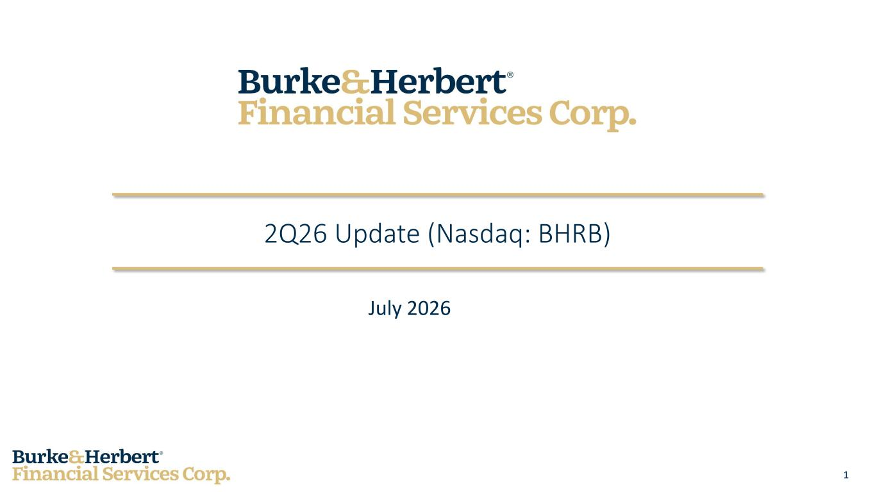
14
1 July 2026 2Q26 Update (Nasdaq: BHRB)

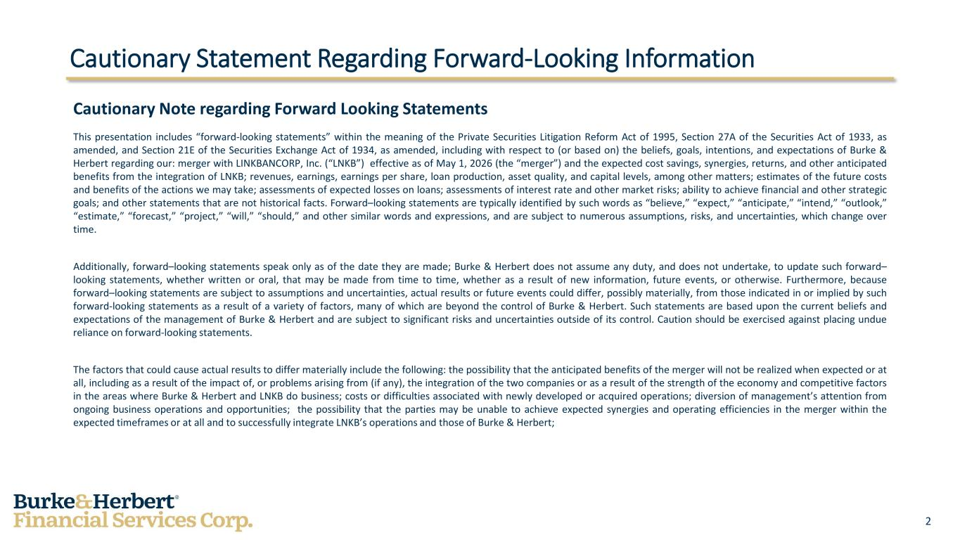
2 Cautionary Statement Regarding Forward-Looking Information Cautionary Note regarding Forward Looking Statements This presentation includes “forward-looking statements” within the meaning of the Private Securities Litigation Reform Act of 1995, Section 27A of the Securities Act of 1933, as amended, and Section 21E of the Securities Exchange Act of 1934, as amended, including with respect to (or based on) the beliefs, goals, intentions, and expectations of Burke & Herbert regarding our: merger with LINKBANCORP, Inc. (“LNKB”) effective as of May 1, 2026 (the “merger”) and the expected cost savings, synergies, returns, and other anticipated benefits from the integration of LNKB; revenues, earnings, earnings per share, loan production, asset quality, and capital levels, among other matters; estimates of the future costs and benefits of the actions we may take; assessments of expected losses on loans; assessments of interest rate and other market risks; ability to achieve financial and other strategic goals; and other statements that are not historical facts. Forward–looking statements are typically identified by such words as “believe,” “expect,” “anticipate,” “intend,” “outlook,” “estimate,” “forecast,” “project,” “will,” “should,” and other similar words and expressions, and are subject to numerous assumptions, risks, and uncertainties, which change over time. Additionally, forward–looking statements speak only as of the date they are made; Burke & Herbert does not assume any duty, and does not undertake, to update such forward– looking statements, whether written or oral, that may be made from time to time, whether as a result of new information, future events, or otherwise. Furthermore, because forward–looking statements are subject to assumptions and uncertainties, actual results or future events could differ, possibly materially, from those indicated in or implied by such forward-looking statements as a result of a variety of factors, many of which are beyond the control of Burke & Herbert. Such statements are based upon the current beliefs and expectations of the management of Burke & Herbert and are subject to significant risks and uncertainties outside of its control. Caution should be exercised against placing undue reliance on forward-looking statements. The factors that could cause actual results to differ materially include the following: the possibility that the anticipated benefits of the merger will not be realized when expected or at all, including as a result of the impact of, or problems arising from (if any), the integration of the two companies or as a result of the strength of the economy and competitive factors in the areas where Burke & Herbert and LNKB do business; costs or difficulties associated with newly developed or acquired operations; diversion of management’s attention from ongoing business operations and opportunities; the possibility that the parties may be unable to achieve expected synergies and operating efficiencies in the merger within the expected timeframes or at all and to successfully integrate LNKB’s operations and those of Burke & Herbert;

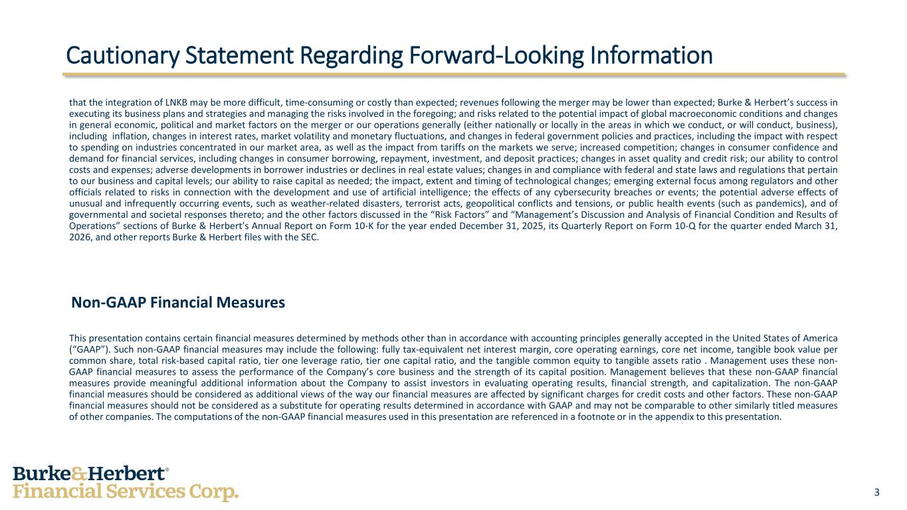
3 Cautionary Statement Regarding Forward-Looking Information that the integration of LNKB may be more difficult, time-consuming or costly than expected; revenues following the merger may be lower than expected; Burke & Herbert’s success in executing its business plans and strategies and managing the risks involved in the foregoing; and risks related to the potential impact of global macroeconomic conditions and changes in general economic, political and market factors on the merger or our operations generally (either nationally or locally in the areas in which we conduct, or will conduct, business), including inflation, changes in interest rates, market volatility and monetary fluctuations, and changes in federal government policies and practices, including the impact with respect to spending on industries concentrated in our market area, as well as the impact from tariffs on the markets we serve; increased competition; changes in consumer confidence and demand for financial services, including changes in consumer borrowing, repayment, investment, and deposit practices; changes in asset quality and credit risk; our ability to control costs and expenses; adverse developments in borrower industries or declines in real estate values; changes in and compliance with federal and state laws and regulations that pertain to our business and capital levels; our ability to raise capital as needed; the impact, extent and timing of technological changes; emerging external focus among regulators and other officials related to risks in connection with the development and use of artificial intelligence; the effects of any cybersecurity breaches or events; the potential adverse effects of unusual and infrequently occurring events, such as weather-related disasters, terrorist acts, geopolitical conflicts and tensions, or public health events (such as pandemics), and of governmental and societal responses thereto; and the other factors discussed in the “Risk Factors” and “Management’s Discussion and Analysis of Financial Condition and Results of Operations” sections of Burke & Herbert’s Annual Report on Form 10-K for the year ended December 31, 2025, its Quarterly Report on Form 10-Q for the quarter ended March 31, 2026, and other reports Burke & Herbert files with the SEC. Non-GAAP Financial Measures This presentation contains certain financial measures determined by methods other than in accordance with accounting principles generally accepted in the United States of America (“GAAP”). Such non-GAAP financial measures may include the following: fully tax-equivalent net interest margin, core operating earnings, core net income, tangible book value per common share, total risk-based capital ratio, tier one leverage ratio, tier one capital ratio, and the tangible common equity to tangible assets ratio . Management uses these non- GAAP financial measures to assess the performance of the Company’s core business and the strength of its capital position. Management believes that these non-GAAP financial measures provide meaningful additional information about the Company to assist investors in evaluating operating results, financial strength, and capitalization. The non-GAAP financial measures should be considered as additional views of the way our financial measures are affected by significant charges for credit costs and other factors. These non-GAAP financial measures should not be considered as a substitute for operating results determined in accordance with GAAP and may not be comparable to other similarly titled measures of other companies. The computations of the non-GAAP financial measures used in this presentation are referenced in a footnote or in the appendix to this presentation.

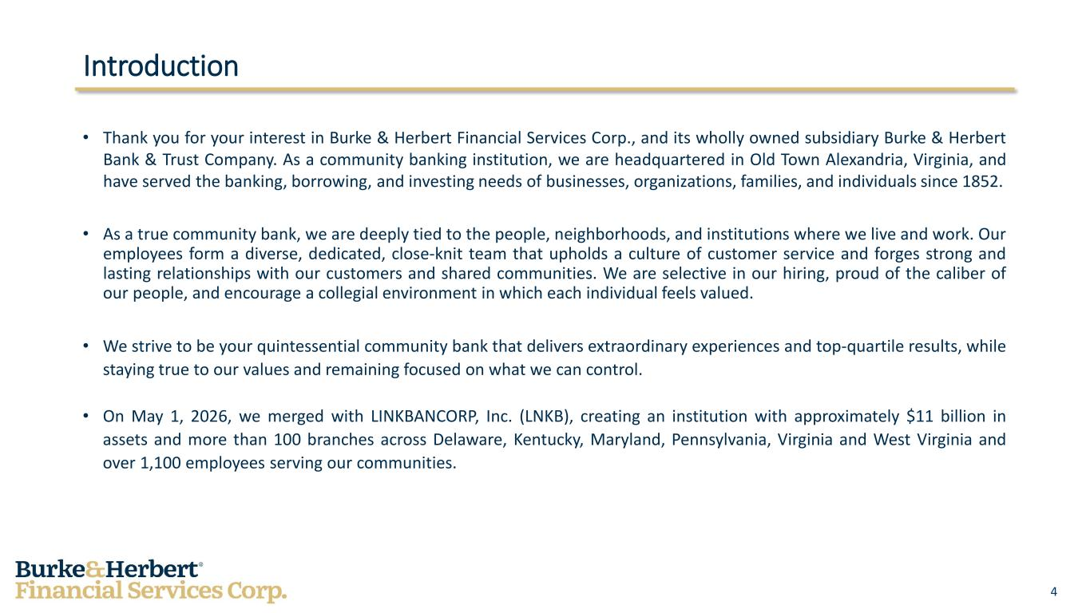
4 Introduction • Thank you for your interest in Burke & Herbert Financial Services Corp., and its wholly owned subsidiary Burke & Herbert Bank & Trust Company. As a community banking institution, we are headquartered in Old Town Alexandria, Virginia, and have served the banking, borrowing, and investing needs of businesses, organizations, families, and individuals since 1852. • As a true community bank, we are deeply tied to the people, neighborhoods, and institutions where we live and work. Our employees form a diverse, dedicated, close-knit team that upholds a culture of customer service and forges strong and lasting relationships with our customers and shared communities. We are selective in our hiring, proud of the caliber of our people, and encourage a collegial environment in which each individual feels valued. • We strive to be your quintessential community bank that delivers extraordinary experiences and top-quartile results, while staying true to our values and remaining focused on what we can control. • On May 1, 2026, we merged with LINKBANCORP, Inc. (LNKB), creating an institution with approximately $11 billion in assets and more than 100 branches across Delaware, Kentucky, Maryland, Pennsylvania, Virginia and West Virginia and over 1,100 employees serving our communities.

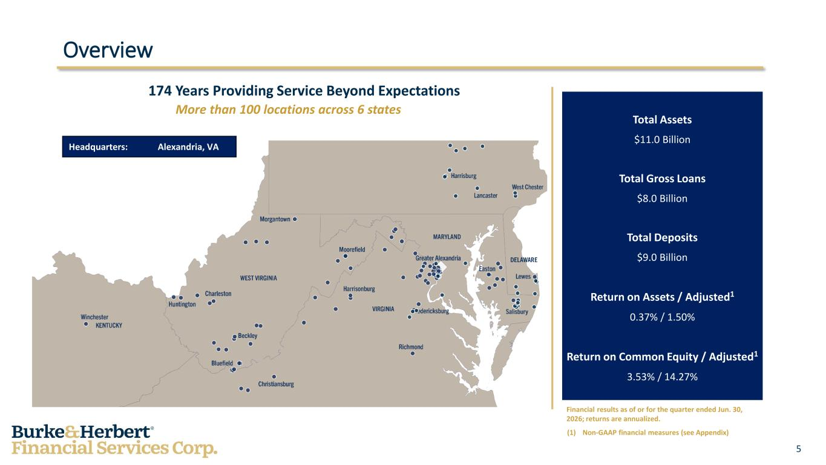
5 Overview Headquarters: Alexandria, VA 174 Years Providing Service Beyond Expectations More than 100 locations across 6 states Total Assets $11.0 Billion Total Gross Loans $8.0 Billion Total Deposits $9.0 Billion Return on Assets / Adjusted1 0.37% / 1.50% Return on Common Equity / Adjusted1 3.53% / 14.27% Financial results as of or for the quarter ended Jun. 30, 2026; returns are annualized. (1) Non-GAAP financial measures (see Appendix)

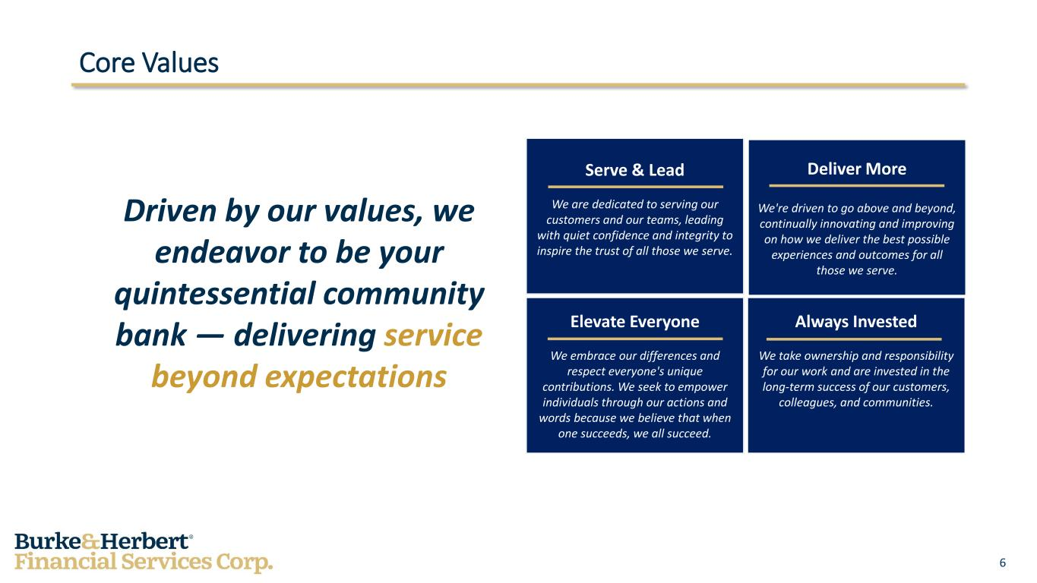
6 Core Values Driven by our values, we endeavor to be your quintessential community bank — delivering service beyond expectations Serve & Lead We are dedicated to serving our customers and our teams, leading with quiet confidence and integrity to inspire the trust of all those we serve. Deliver More We're driven to go above and beyond, continually innovating and improving on how we deliver the best possible experiences and outcomes for all those we serve. Elevate Everyone We embrace our differences and respect everyone's unique contributions. We seek to empower individuals through our actions and words because we believe that when one succeeds, we all succeed. Always Invested We take ownership and responsibility for our work and are invested in the long-term success of our customers, colleagues, and communities.

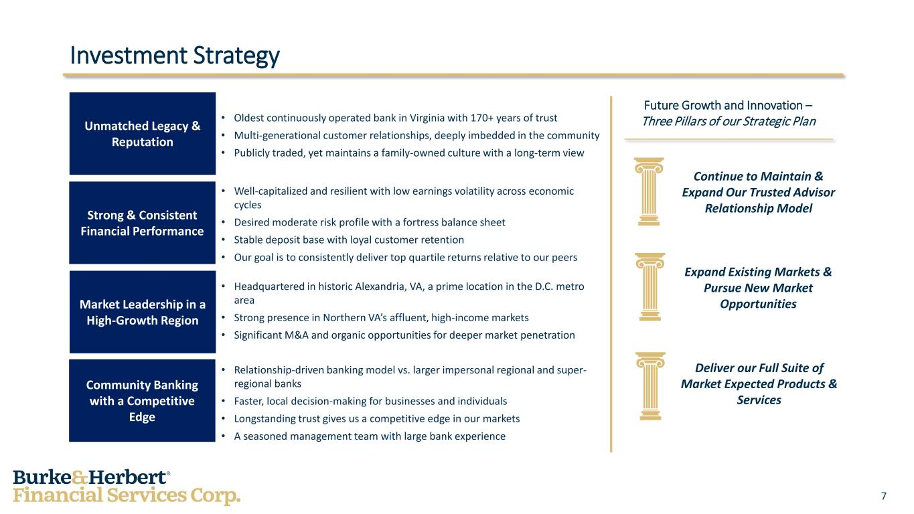
7 Investment Strategy Unmatched Legacy & Reputation Strong & Consistent Financial Performance Market Leadership in a High-Growth Region Community Banking with a Competitive Edge • Oldest continuously operated bank in Virginia with 170+ years of trust • Multi-generational customer relationships, deeply imbedded in the community • Publicly traded, yet maintains a family-owned culture with a long-term view • Well-capitalized and resilient with low earnings volatility across economic cycles • Desired moderate risk profile with a fortress balance sheet • Stable deposit base with loyal customer retention • Our goal is to consistently deliver top quartile returns relative to our peers • Headquartered in historic Alexandria, VA, a prime location in the D.C. metro area • Strong presence in Northern VA’s affluent, high-income markets • Significant M&A and organic opportunities for deeper market penetration • Relationship-driven banking model vs. larger impersonal regional and super- regional banks • Faster, local decision-making for businesses and individuals • Longstanding trust gives us a competitive edge in our markets • A seasoned management team with large bank experience Future Growth and Innovation – Three Pillars of our Strategic Plan Continue to Maintain & Expand Our Trusted Advisor Relationship Model Expand Existing Markets & Pursue New Market Opportunities Deliver our Full Suite of Market Expected Products & Services

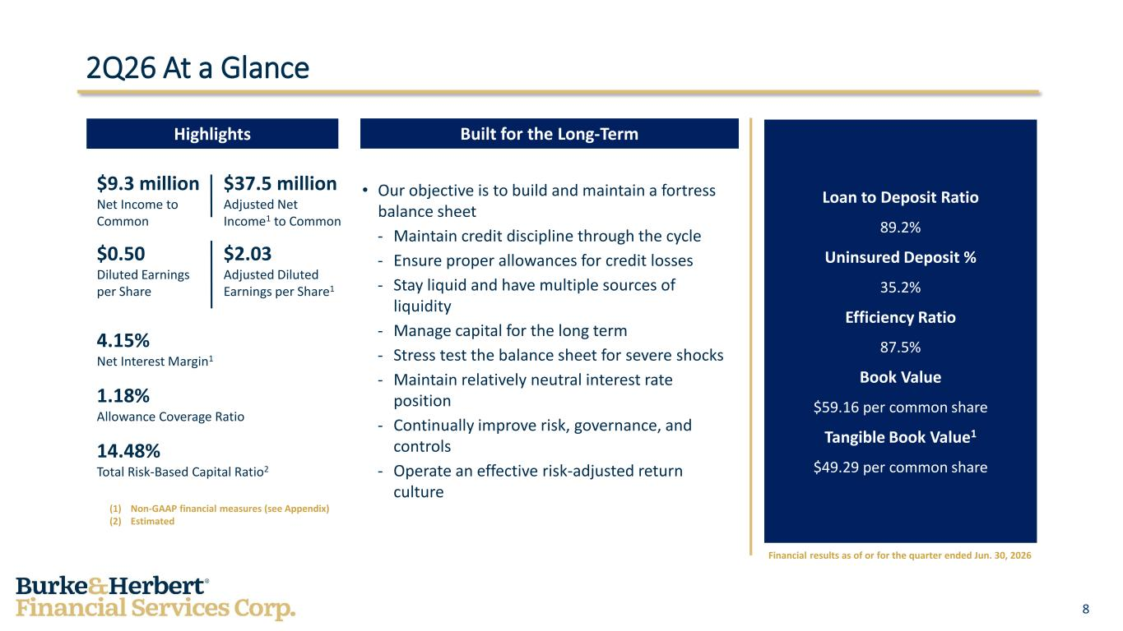
8 2Q26 At a Glance Highlights Built for the Long-Term $9.3 million Net Income to Common $0.50 Diluted Earnings per Share 4.15% Net Interest Margin1 1.18% Allowance Coverage Ratio 14.48% Total Risk-Based Capital Ratio2 (1) Non-GAAP financial measures (see Appendix) (2) Estimated • Our objective is to build and maintain a fortress balance sheet - Maintain credit discipline through the cycle - Ensure proper allowances for credit losses - Stay liquid and have multiple sources of liquidity - Manage capital for the long term - Stress test the balance sheet for severe shocks - Maintain relatively neutral interest rate position - Continually improve risk, governance, and controls - Operate an effective risk-adjusted return culture Loan to Deposit Ratio 89.2% Uninsured Deposit % 35.2% Efficiency Ratio 87.5% Book Value $59.16 per common share Tangible Book Value1 $49.29 per common share Financial results as of or for the quarter ended Jun. 30, 2026 $37.5 million Adjusted Net Income1 to Common $2.03 Adjusted Diluted Earnings per Share1

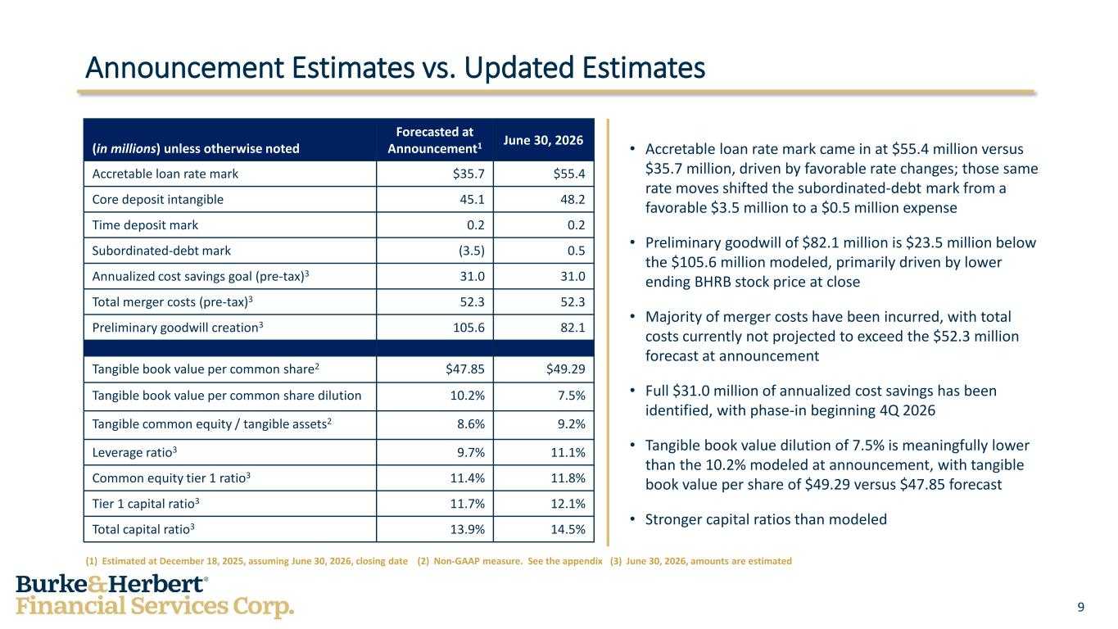
9 Announcement Estimates vs. Updated Estimates (1) Estimated at December 18, 2025, assuming June 30, 2026, closing date (2) Non-GAAP measure. See the appendix (3) June 30, 2026, amounts are estimated (in millions) unless otherwise noted Forecasted at Announcement1 June 30, 2026 Accretable loan rate mark $35.7 $55.4 Core deposit intangible 45.1 48.2 Time deposit mark 0.2 0.2 Subordinated-debt mark (3.5) 0.5 Annualized cost savings goal (pre-tax)3 31.0 31.0 Total merger costs (pre-tax)3 52.3 52.3 Preliminary goodwill creation3 105.6 82.1 Tangible book value per common share2 $47.85 $49.29 Tangible book value per common share dilution 10.2% 7.5% Tangible common equity / tangible assets2 8.6% 9.2% Leverage ratio3 9.7% 11.1% Common equity tier 1 ratio3 11.4% 11.8% Tier 1 capital ratio3 11.7% 12.1% Total capital ratio3 13.9% 14.5% • Accretable loan rate mark came in at $55.4 million versus $35.7 million, driven by favorable rate changes; those same rate moves shifted the subordinated-debt mark from a favorable $3.5 million to a $0.5 million expense • Preliminary goodwill of $82.1 million is $23.5 million below the $105.6 million modeled, primarily driven by lower ending BHRB stock price at close • Majority of merger costs have been incurred, with total costs currently not projected to exceed the $52.3 million forecast at announcement • Full $31.0 million of annualized cost savings has been identified, with phase-in beginning 4Q 2026 • Tangible book value dilution of 7.5% is meaningfully lower than the 10.2% modeled at announcement, with tangible book value per share of $49.29 versus $47.85 forecast • Stronger capital ratios than modeled

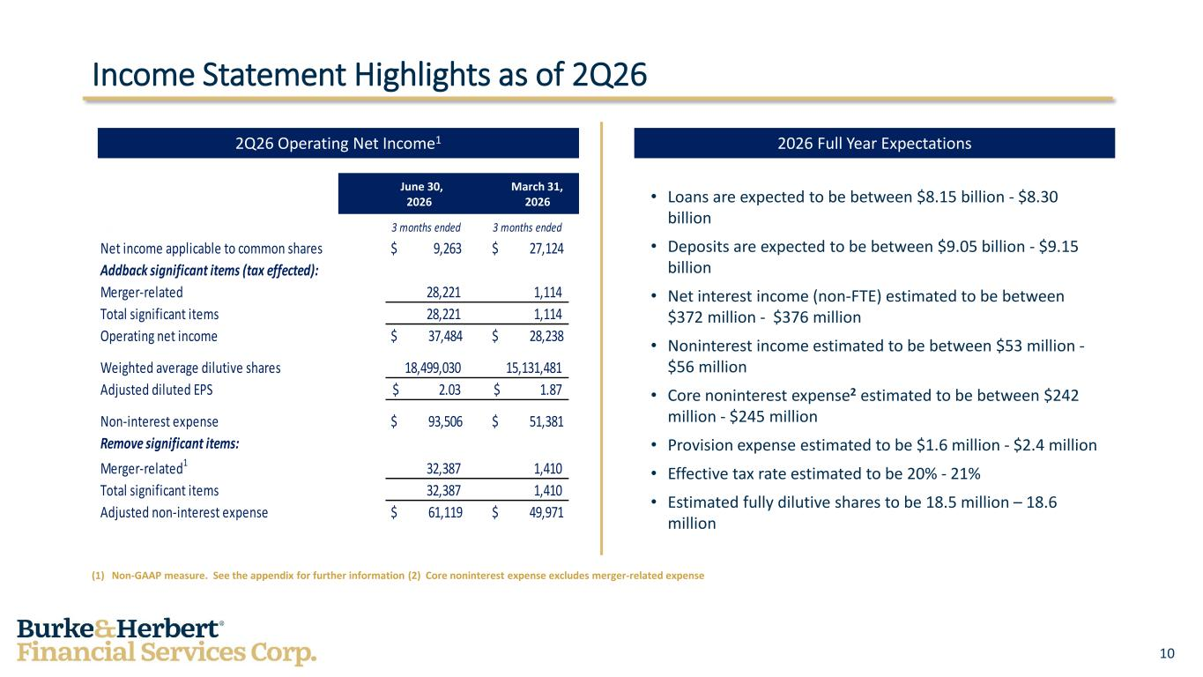
10 Income Statement Highlights as of 2Q26 (1) Non-GAAP measure. See the appendix for further information (2) Core noninterest expense excludes merger-related expense • Loans are expected to be between $8.15 billion - $8.30 billion • Deposits are expected to be between $9.05 billion - $9.15 billion • Net interest income (non-FTE) estimated to be between $372 million - $376 million • Noninterest income estimated to be between $53 million - $56 million • Core noninterest expense2 estimated to be between $242 million - $245 million • Provision expense estimated to be $1.6 million - $2.4 million • Effective tax rate estimated to be 20% - 21% • Estimated fully dilutive shares to be 18.5 million – 18.6 million 2Q26 Operating Net Income1 2026 Full Year Expectations June 30, March 31, 2026 2026 3 months ended 3 months ended Net income applicable to common shares $ 9,263 $ 27,124 Addback significant items (tax effected): Merger-related 28,221 1,114 Total significant items 28,221 1,114 Operating net income $ 37,484 $ 28,238 Weighted average dilutive shares 18,499,030 15,131,481 Adjusted diluted EPS 2.03$ 1.87$ Non-interest expense $ 93,506 $ 51,381 Remove significant items: Merger-related1 32,387 1,410 Total significant items 32,387 1,410 Adjusted non-interest expense $ 61,119 $ 49,971

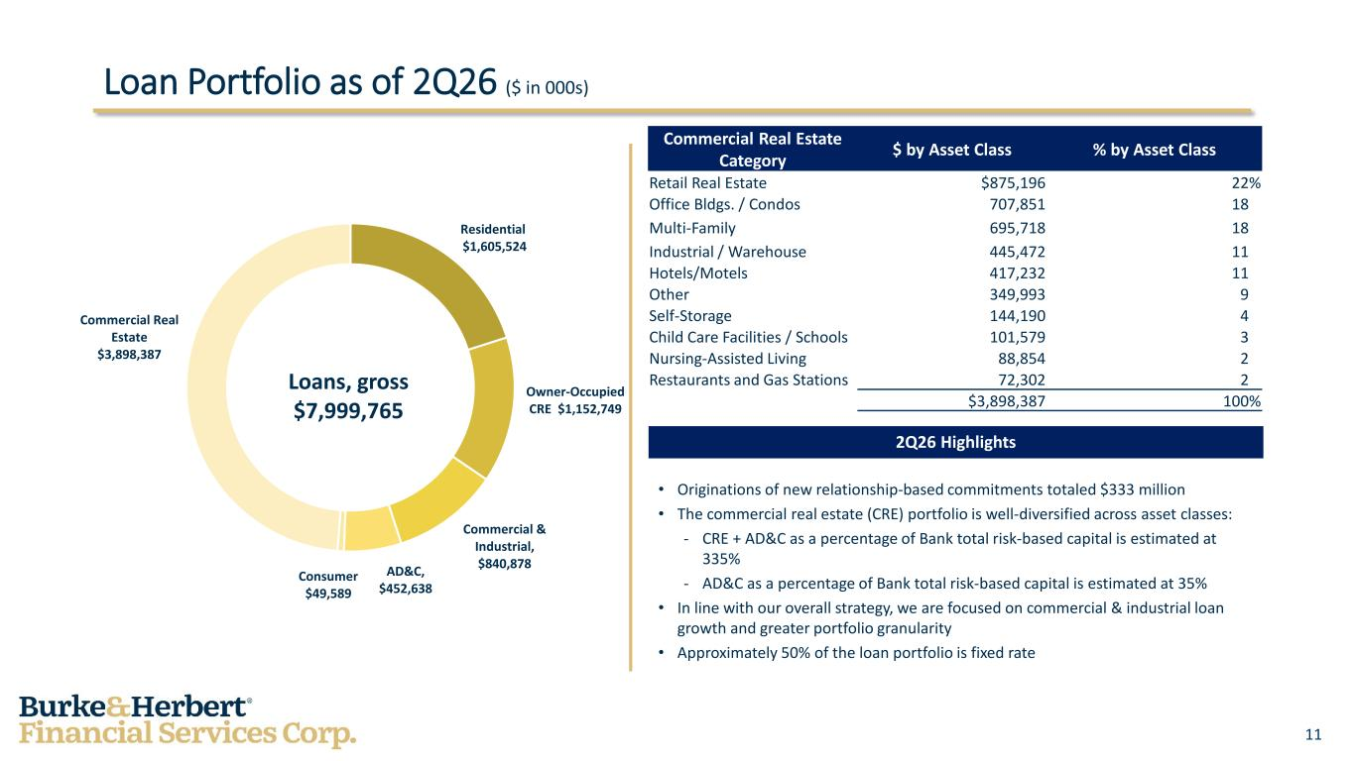
11 Loan Portfolio as of 2Q26 ($ in 000s) Residential $1,605,524 Owner-Occupied CRE $1,152,749 Commercial & Industrial, $840,878 AD&C, $452,638 Consumer $49,589 Commercial Real Estate $3,898,387 Loans, gross $7,999,765 Commercial Real Estate Category $ by Asset Class % by Asset Class Retail Real Estate $875,196 22% Office Bldgs. / Condos 707,851 18% Multi-Family 695,718 18% Industrial / Warehouse 445,472 11% Hotels/Motels 417,232 11% Other 349,993 9% Self-Storage 144,190 4% Child Care Facilities / Schools 101,579 3% Nursing-Assisted Living 88,854 2% Restaurants and Gas Stations 72,302 2% $3,898,387 100% 2Q26 Highlights • Originations of new relationship-based commitments totaled $333 million • The commercial real estate (CRE) portfolio is well-diversified across asset classes: - CRE + AD&C as a percentage of Bank total risk-based capital is estimated at 335% - AD&C as a percentage of Bank total risk-based capital is estimated at 35% • In line with our overall strategy, we are focused on commercial & industrial loan growth and greater portfolio granularity • Approximately 50% of the loan portfolio is fixed rate

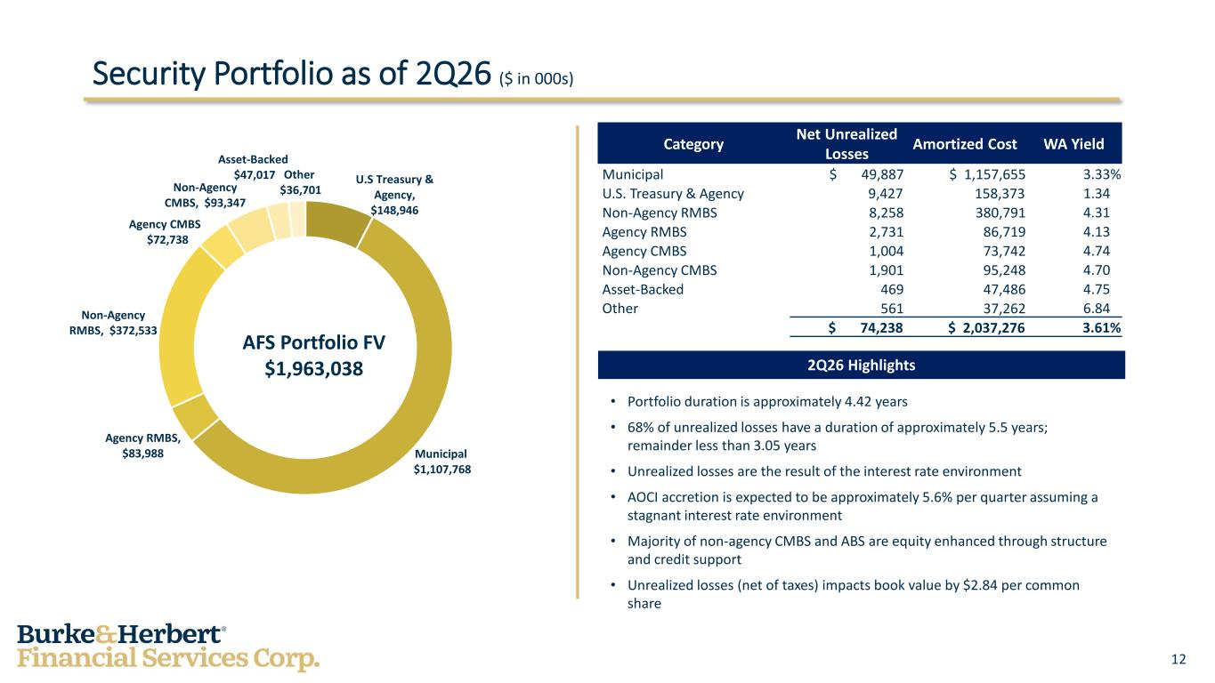
12 Security Portfolio as of 2Q26 ($ in 000s) U.S Treasury & Agency, $148,946 Municipal $1,107,768 Agency RMBS, $83,988 Non-Agency RMBS, $372,533 Agency CMBS $72,738 Non-Agency CMBS, $93,347 Asset-Backed $47,017 Other $36,701 AFS Portfolio FV $1,963,038 Category Net Unrealized Losses Amortized Cost WA Yield Municipal $ 49,887 $ 1,157,655 3.33% U.S. Treasury & Agency 9,427 158,373 1.34% Non-Agency RMBS 8,258 380,791 4.31% Agency RMBS 2,731 86,719 4.13% Agency CMBS 1,004 73,742 4.74% Non-Agency CMBS 1,901 95,248 4.70% Asset-Backed 469 47,486 4.75% Other 561 37,262 6.84% $ 74,238 $ 2,037,276 3.61% 2Q26 Highlights • Portfolio duration is approximately 4.42 years • 68% of unrealized losses have a duration of approximately 5.5 years; remainder less than 3.05 years • Unrealized losses are the result of the interest rate environment • AOCI accretion is expected to be approximately 5.6% per quarter assuming a stagnant interest rate environment • Majority of non-agency CMBS and ABS are equity enhanced through structure and credit support • Unrealized losses (net of taxes) impacts book value by $2.84 per common share

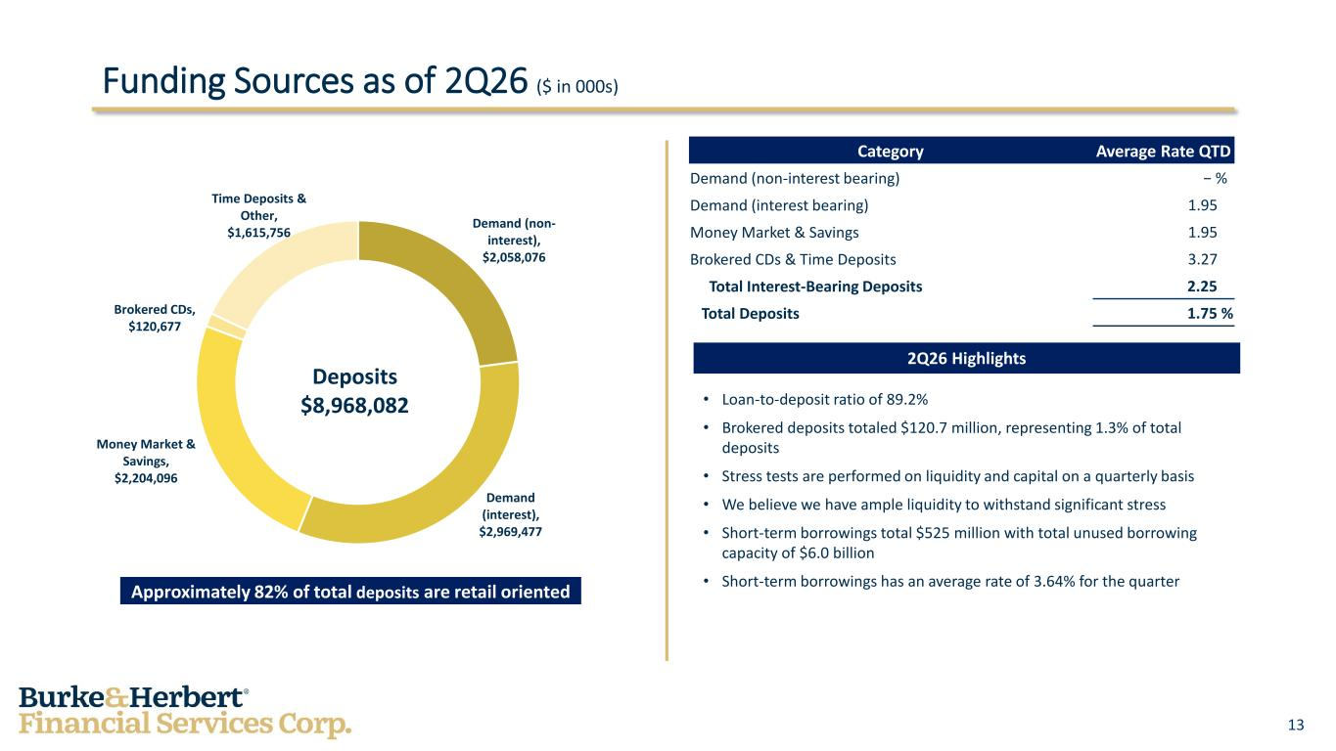
13 Funding Sources as of 2Q26 ($ in 000s) Demand (non- interest), $2,058,076 Demand (interest), $2,969,477 Money Market & Savings, $2,204,096 Brokered CDs, $120,677 Time Deposits & Other, $1,615,756 Deposits $8,968,082 Category Average Rate QTD Demand (non-interest bearing) − % Demand (interest bearing) 1.95 % Money Market & Savings 1.95 % Brokered CDs & Time Deposits 3.27 % Total Interest-Bearing Deposits 2.25 % Total Deposits 1.75 % 2Q26 Highlights • Loan-to-deposit ratio of 89.2% • Brokered deposits totaled $120.7 million, representing 1.3% of total deposits • Stress tests are performed on liquidity and capital on a quarterly basis • We believe we have ample liquidity to withstand significant stress • Short-term borrowings total $525 million with total unused borrowing capacity of $6.0 billion • Short-term borrowings has an average rate of 3.64% for the quarterApproximately 82% of total deposits are retail oriented

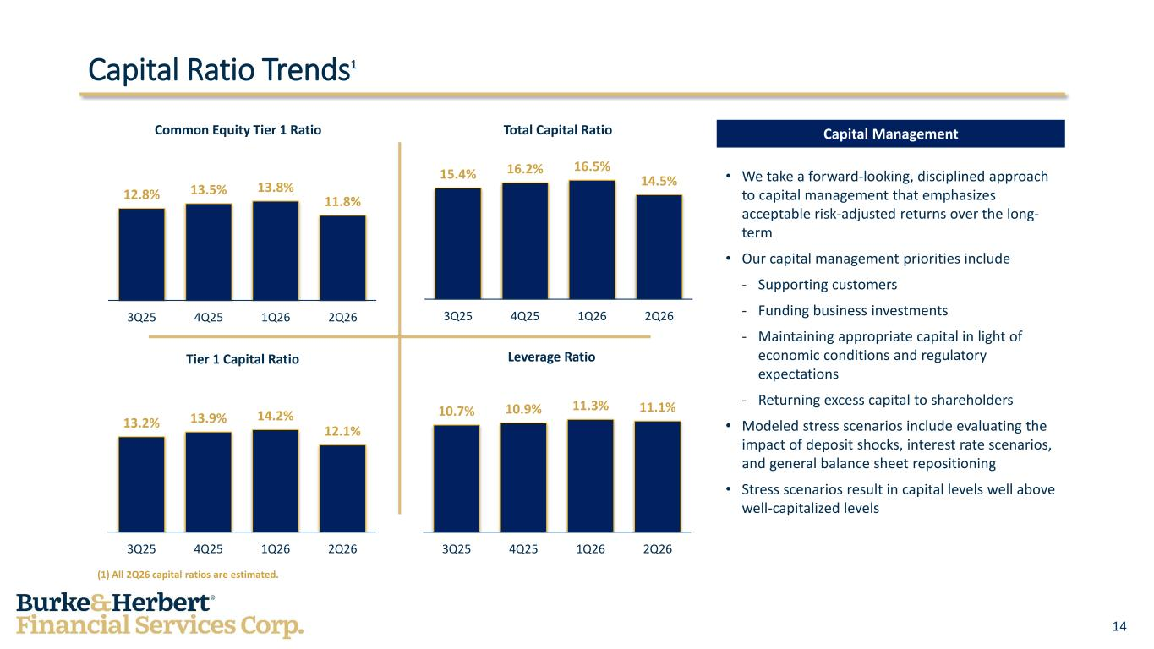
14 13.2% 13.9% 14.2% 12.1% 3Q25 4Q25 1Q26 2Q26 Tier 1 Capital Ratio Capital Ratio Trends1 12.8% 13.5% 13.8% 11.8% 3Q25 4Q25 1Q26 2Q26 Common Equity Tier 1 Ratio 15.4% 16.2% 16.5% 14.5% 3Q25 4Q25 1Q26 2Q26 Total Capital Ratio 10.7% 10.9% 11.3% 11.1% 3Q25 4Q25 1Q26 2Q26 Leverage Ratio Capital Management • We take a forward-looking, disciplined approach to capital management that emphasizes acceptable risk-adjusted returns over the long- term • Our capital management priorities include - Supporting customers - Funding business investments - Maintaining appropriate capital in light of economic conditions and regulatory expectations - Returning excess capital to shareholders • Modeled stress scenarios include evaluating the impact of deposit shocks, interest rate scenarios, and general balance sheet repositioning • Stress scenarios result in capital levels well above well-capitalized levels (1) All 2Q26 capital ratios are estimated.

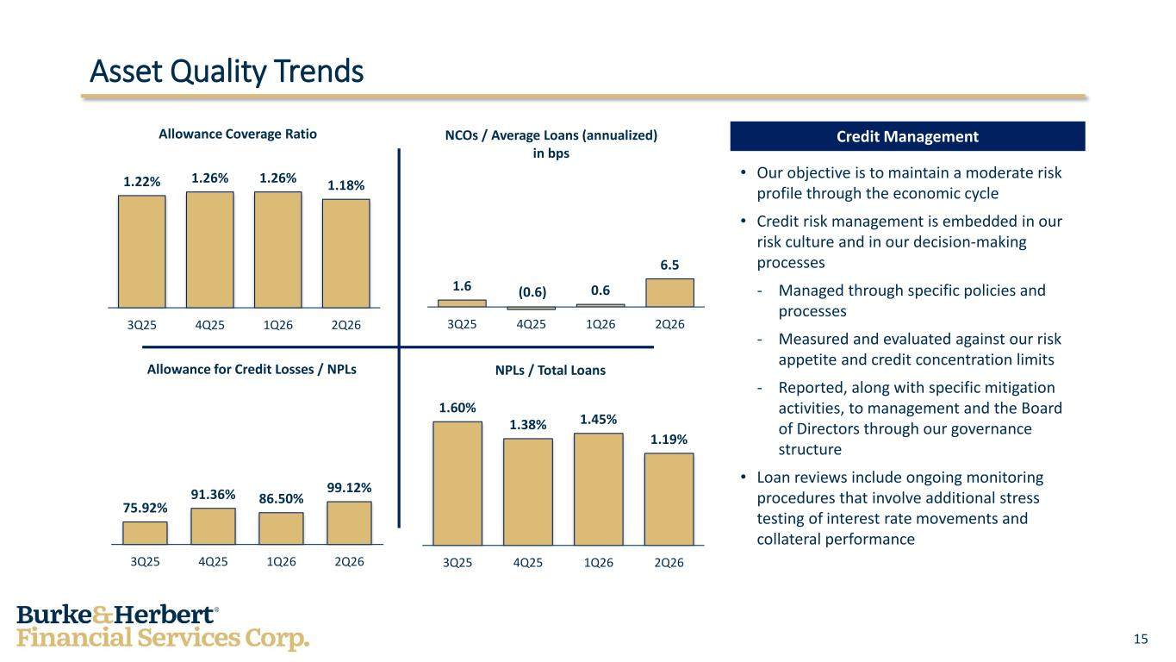
15 Asset Quality Trends 1.22% 1.26% 1.26% 1.18% 3Q25 4Q25 1Q26 2Q26 Allowance Coverage Ratio 1.6 (0.6) 0.6 6.5 3Q25 4Q25 1Q26 2Q26 NCOs / Average Loans (annualized) in bps 75.92% 91.36% 86.50% 99.12% 3Q25 4Q25 1Q26 2Q26 Allowance for Credit Losses / NPLs 1.60% 1.38% 1.45% 1.19% 3Q25 4Q25 1Q26 2Q26 NPLs / Total Loans Credit Management • Our objective is to maintain a moderate risk profile through the economic cycle • Credit risk management is embedded in our risk culture and in our decision-making processes - Managed through specific policies and processes - Measured and evaluated against our risk appetite and credit concentration limits - Reported, along with specific mitigation activities, to management and the Board of Directors through our governance structure • Loan reviews include ongoing monitoring procedures that involve additional stress testing of interest rate movements and collateral performance

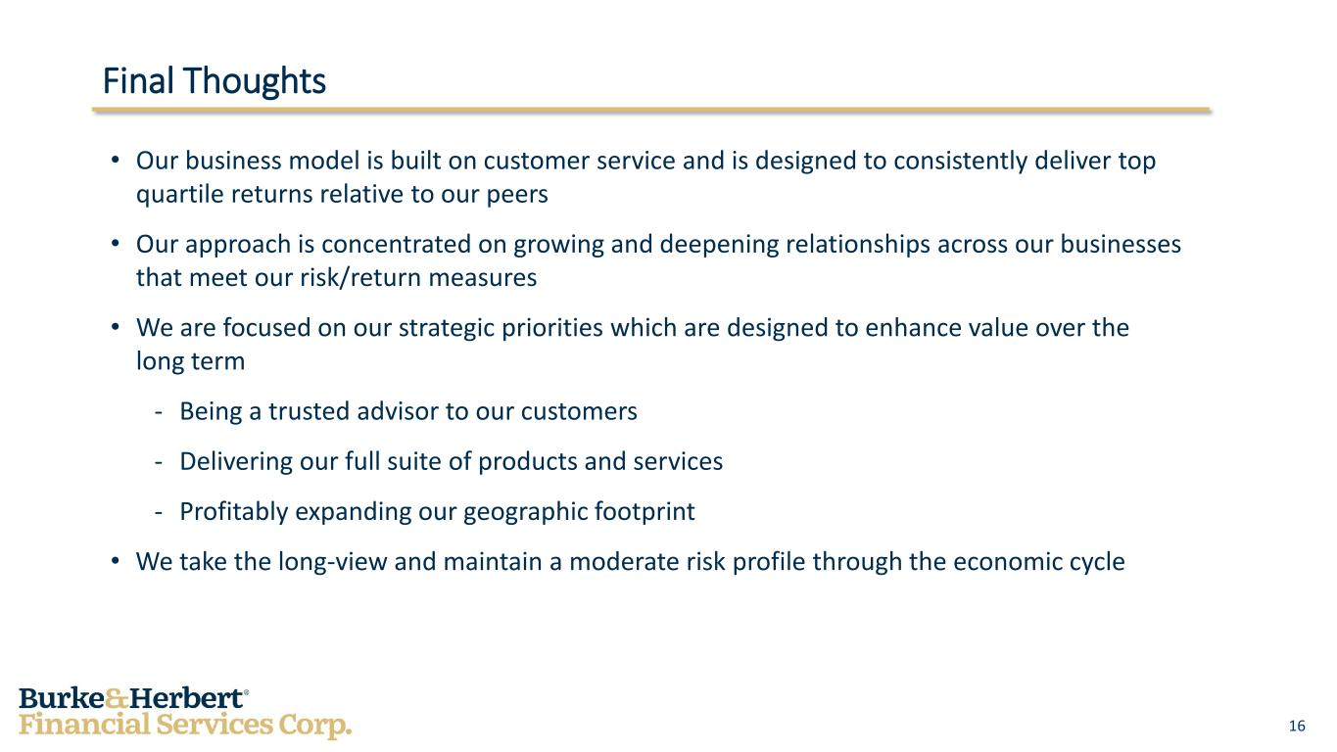
16 Final Thoughts • Our business model is built on customer service and is designed to consistently deliver top quartile returns relative to our peers • Our approach is concentrated on growing and deepening relationships across our businesses that meet our risk/return measures • We are focused on our strategic priorities which are designed to enhance value over the long term - Being a trusted advisor to our customers - Delivering our full suite of products and services - Profitably expanding our geographic footprint • We take the long-view and maintain a moderate risk profile through the economic cycle

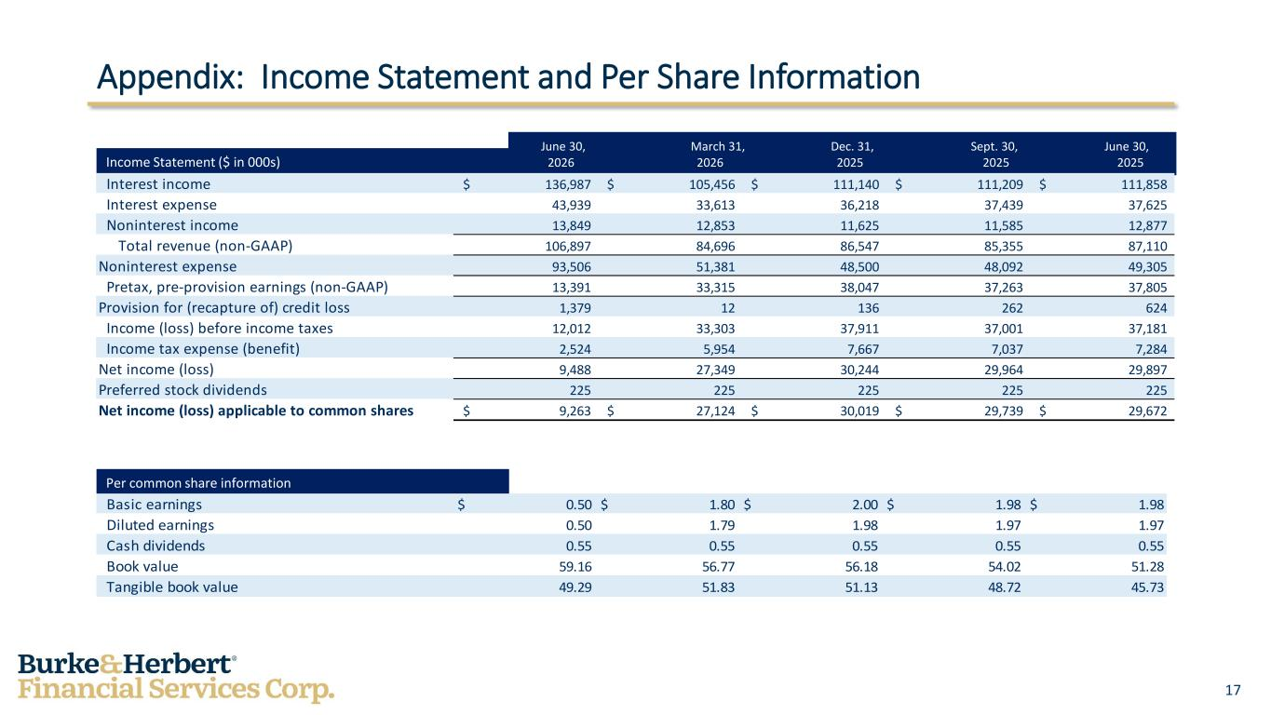
17 Appendix: Income Statement and Per Share Information Income Statement ($ in 000s) June 30, March 31, Dec. 31, Sept. 30, June 30, 2026 2026 2025 2025 2025 Per common share information Basic earnings $ 0.50 $ 1.80 $ 2.00 $ 1.98 $ 1.98 Diluted earnings 0.50 1.79 1.98 1.97 1.97 Cash dividends 0.55 0.55 0.55 0.55 0.55 Book value 59.16 56.77 56.18 54.02 51.28 Tangible book value 49.29 51.83 51.13 48.72 45.73 Interest income $ 136,987 $ 105,456 $ 111,140 $ 111,209 $ 111,858 Interest expense 43,939 33,613 36,218 37,439 37,625 Noninterest income 13,849 12,853 11,625 11,585 12,877 Total revenue (non-GAAP) 106,897 84,696 86,547 85,355 87,110 Noninterest expense 93,506 51,381 48,500 48,092 49,305 Pretax, pre-provision earnings (non-GAAP) 13,391 33,315 38,047 37,263 37,805 Provision for (recapture of) credit loss 1,379 12 136 262 624 Income (loss) before income taxes 12,012 33,303 37,911 37,001 37,181 Income tax expense (benefit) 2,524 5,954 7,667 7,037 7,284 Net income (loss) 9,488 27,349 30,244 29,964 29,897 Preferred stock dividends 225 225 225 225 225 Net income (loss) applicable to common shares $ 9,263 $ 27,124 $ 30,019 $ 29,739 $ 29,672

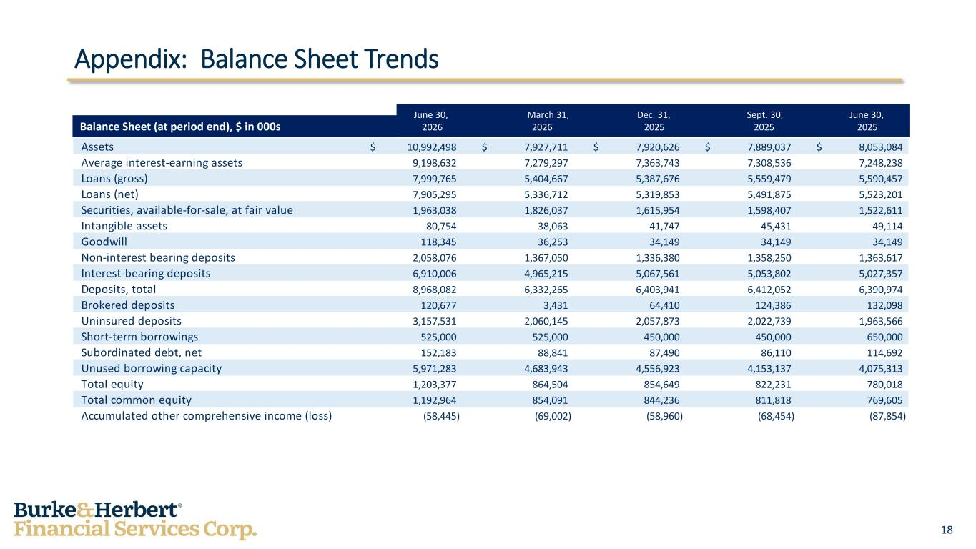
18 Appendix: Balance Sheet Trends Balance Sheet (at period end), $ in 000s June 30, March 31, Dec. 31, Sept. 30, June 30, 2026 2026 2025 2025 2025 Assets 10,992,498$ 7,927,711$ 7,920,626$ 7,889,037$ 8,053,084$ Average interest-earning assets 9,198,632 7,279,297 7,363,743 7,308,536 7,248,238 Loans (gross) 7,999,765 5,404,667 5,387,676 5,559,479 5,590,457 Loans (net) 7,905,295 5,336,712 5,319,853 5,491,875 5,523,201 Securities, available-for-sale, at fair value 1,963,038 1,826,037 1,615,954 1,598,407 1,522,611 Intangible assets 80,754 38,063 41,747 45,431 49,114 Goodwill 118,345 36,253 34,149 34,149 34,149 Non-interest bearing deposits 2,058,076 1,367,050 1,336,380 1,358,250 1,363,617 Interest-bearing deposits 6,910,006 4,965,215 5,067,561 5,053,802 5,027,357 Deposits, total 8,968,082 6,332,265 6,403,941 6,412,052 6,390,974 Brokered deposits 120,677 3,431 64,410 124,386 132,098 Uninsured deposits 3,157,531 2,060,145 2,057,873 2,022,739 1,963,566 Short-term borrowings 525,000 525,000 450,000 450,000 650,000 Subordinated debt, net 152,183 88,841 87,490 86,110 114,692 Unused borrowing capacity 5,971,283 4,683,943 4,556,923 4,153,137 4,075,313 Total equity 1,203,377 864,504 854,649 822,231 780,018 Total common equity 1,192,964 854,091 844,236 811,818 769,605 Accumulated other comprehensive income (loss) (58,445) (69,002) (58,960) (68,454) (87,854)

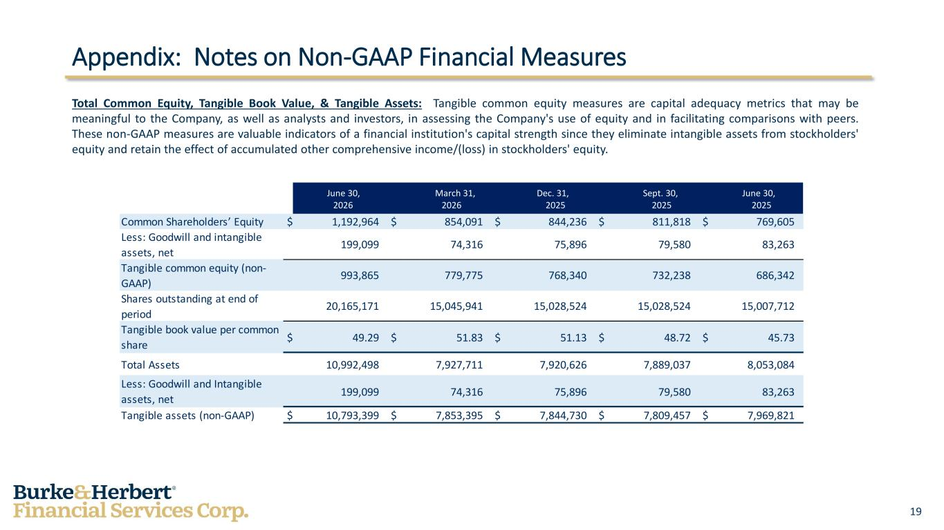
19 Appendix: Notes on Non-GAAP Financial Measures Total Common Equity, Tangible Book Value, & Tangible Assets: Tangible common equity measures are capital adequacy metrics that may be meaningful to the Company, as well as analysts and investors, in assessing the Company's use of equity and in facilitating comparisons with peers. These non-GAAP measures are valuable indicators of a financial institution's capital strength since they eliminate intangible assets from stockholders' equity and retain the effect of accumulated other comprehensive income/(loss) in stockholders' equity. June 30, March 31, Dec. 31, Sept. 30, June 30, 2026 2026 2025 2025 2025 Common Shareholders’ Equity $ 1,192,964 $ 854,091 $ 844,236 $ 811,818 $ 769,605 Less: Goodwill and intangible assets, net 199,099 74,316 75,896 79,580 83,263 Tangible common equity (non- GAAP) 993,865 779,775 768,340 732,238 686,342 Shares outstanding at end of period 20,165,171 15,045,941 15,028,524 15,028,524 15,007,712 Tangible book value per common share $ 49.29 $ 51.83 $ 51.13 $ 48.72 $ 45.73 Total Assets 10,992,498 7,927,711 7,920,626 7,889,037 8,053,084 Less: Goodwill and Intangible assets, net 199,099 74,316 75,896 79,580 83,263 Tangible assets (non-GAAP) $ 10,793,399 $ 7,853,395 $ 7,844,730 $ 7,809,457 $ 7,969,821

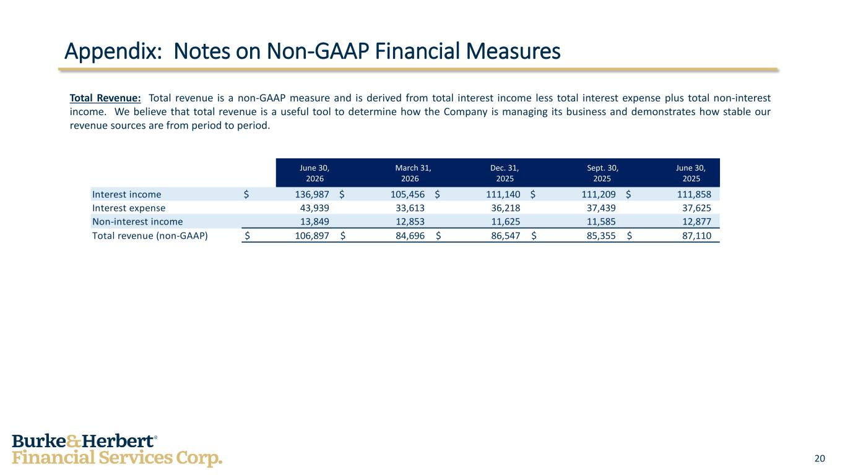
20 Appendix: Notes on Non-GAAP Financial Measures Total Revenue: Total revenue is a non-GAAP measure and is derived from total interest income less total interest expense plus total non-interest income. We believe that total revenue is a useful tool to determine how the Company is managing its business and demonstrates how stable our revenue sources are from period to period. June 30, March 31, Dec. 31, Sept. 30, June 30, 2026 2026 2025 2025 2025 Interest income $ 136,987 $ 105,456 $ 111,140 $ 111,209 $ 111,858 Interest expense 43,939 33,613 36,218 37,439 37,625 Non-interest income 13,849 12,853 11,625 11,585 12,877 Total revenue (non-GAAP) $ 106,897 $ 84,696 $ 86,547 $ 85,355 $ 87,110

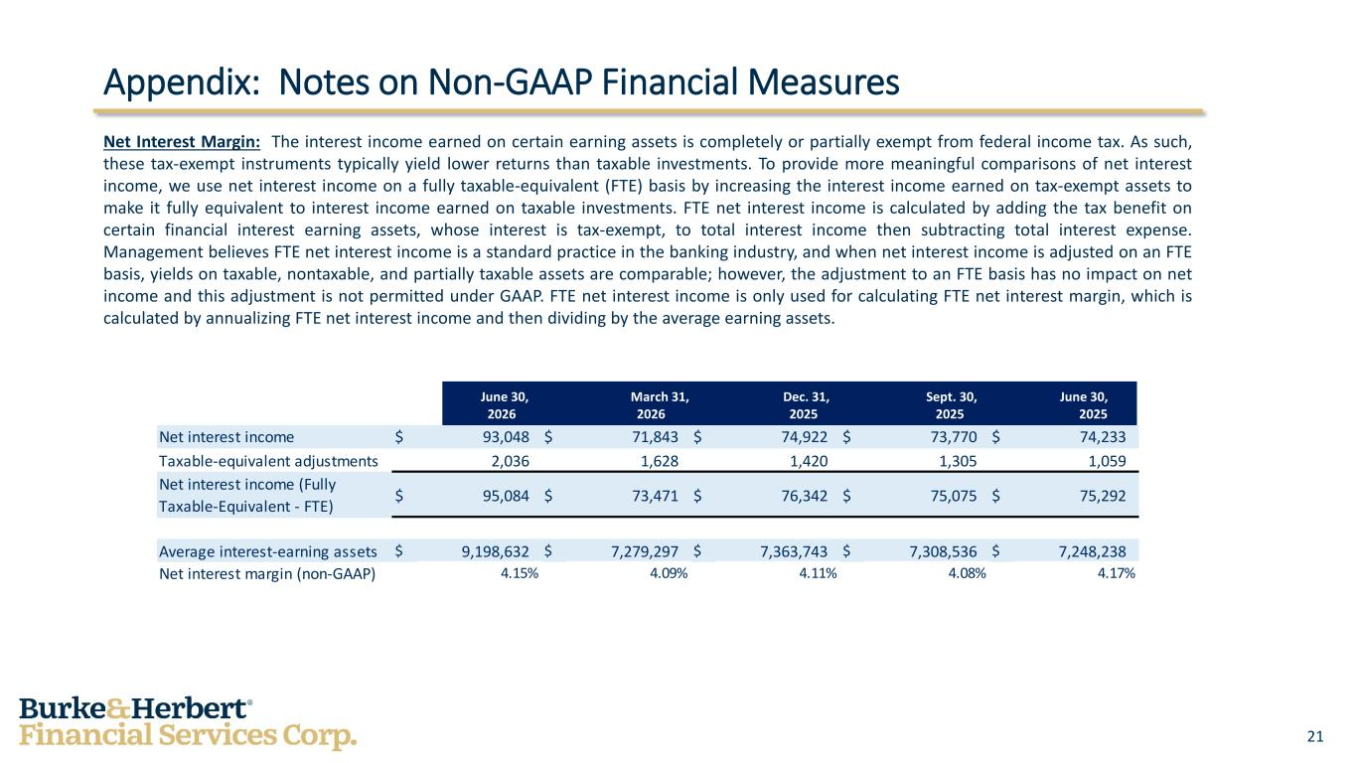
21 Appendix: Notes on Non-GAAP Financial Measures Net Interest Margin: The interest income earned on certain earning assets is completely or partially exempt from federal income tax. As such, these tax-exempt instruments typically yield lower returns than taxable investments. To provide more meaningful comparisons of net interest income, we use net interest income on a fully taxable-equivalent (FTE) basis by increasing the interest income earned on tax-exempt assets to make it fully equivalent to interest income earned on taxable investments. FTE net interest income is calculated by adding the tax benefit on certain financial interest earning assets, whose interest is tax-exempt, to total interest income then subtracting total interest expense. Management believes FTE net interest income is a standard practice in the banking industry, and when net interest income is adjusted on an FTE basis, yields on taxable, nontaxable, and partially taxable assets are comparable; however, the adjustment to an FTE basis has no impact on net income and this adjustment is not permitted under GAAP. FTE net interest income is only used for calculating FTE net interest margin, which is calculated by annualizing FTE net interest income and then dividing by the average earning assets. June 30, March 31, Dec. 31, Sept. 30, June 30, 2026 2026 2025 2025 2025 Net interest income $ 93,048 $ 71,843 $ 74,922 $ 73,770 $ 74,233 Taxable-equivalent adjustments 2,036 1,628 1,420 1,305 1,059 Net interest income (Fully Taxable-Equivalent - FTE) $ 95,084 $ 73,471 $ 76,342 $ 75,075 $ 75,292 Average interest-earning assets $ 9,198,632 $ 7,279,297 $ 7,363,743 $ 7,308,536 $ 7,248,238 Net interest margin (non-GAAP) 4.15% 4.09% 4.11% 4.08% 4.17%

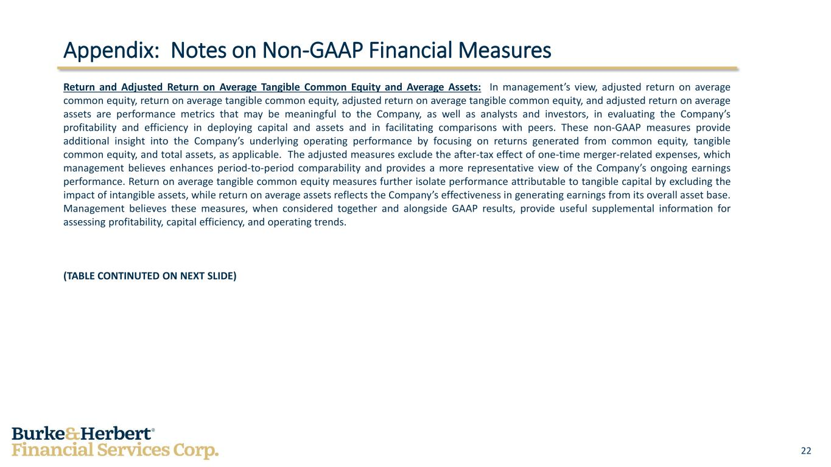
22 Appendix: Notes on Non-GAAP Financial Measures Return and Adjusted Return on Average Tangible Common Equity and Average Assets: In management’s view, adjusted return on average common equity, return on average tangible common equity, adjusted return on average tangible common equity, and adjusted return on average assets are performance metrics that may be meaningful to the Company, as well as analysts and investors, in evaluating the Company’s profitability and efficiency in deploying capital and assets and in facilitating comparisons with peers. These non-GAAP measures provide additional insight into the Company’s underlying operating performance by focusing on returns generated from common equity, tangible common equity, and total assets, as applicable. The adjusted measures exclude the after-tax effect of one-time merger-related expenses, which management believes enhances period-to-period comparability and provides a more representative view of the Company’s ongoing earnings performance. Return on average tangible common equity measures further isolate performance attributable to tangible capital by excluding the impact of intangible assets, while return on average assets reflects the Company’s effectiveness in generating earnings from its overall asset base. Management believes these measures, when considered together and alongside GAAP results, provide useful supplemental information for assessing profitability, capital efficiency, and operating trends. (TABLE CONTINUTED ON NEXT SLIDE)

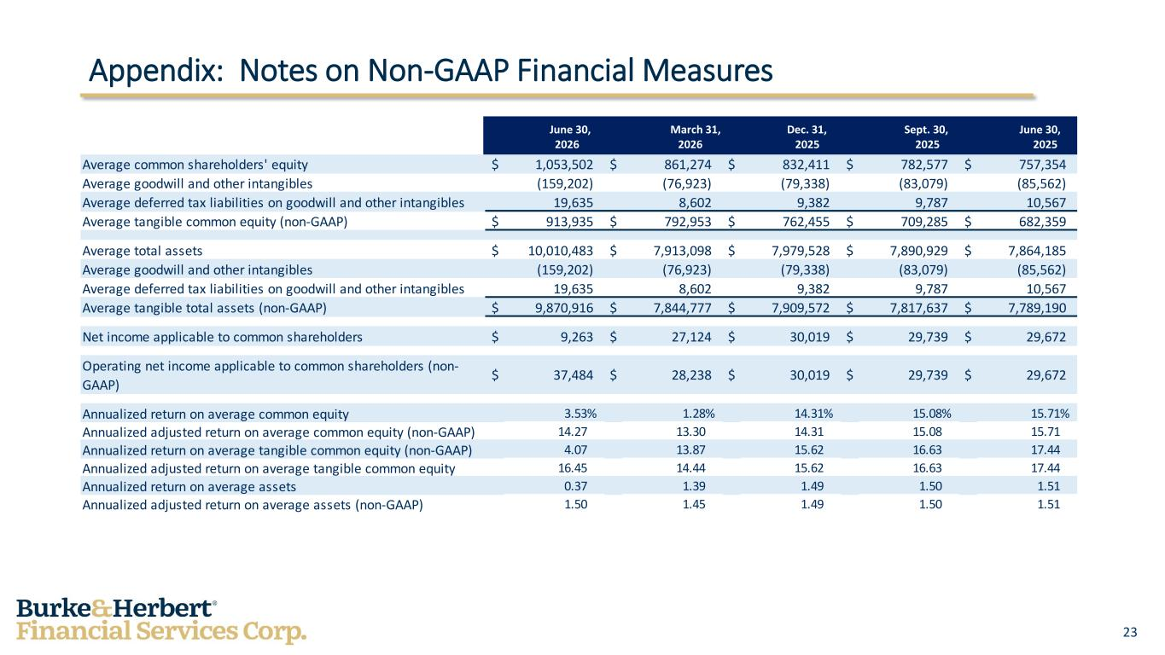
23 Appendix: Notes on Non-GAAP Financial Measures June 30, March 31, Dec. 31, Sept. 30, June 30, 2026 2026 2025 2025 2025 Average common shareholders' equity $ 1,053,502 $ 861,274 $ 832,411 $ 782,577 $ 757,354 Average goodwill and other intangibles (159,202) (76,923) (79,338) (83,079) (85,562) Average deferred tax liabilities on goodwill and other intangibles 19,635 8,602 9,382 9,787 10,567 Average tangible common equity (non-GAAP) $ 913,935 $ 792,953 $ 762,455 $ 709,285 $ 682,359 Average total assets $ 10,010,483 $ 7,913,098 $ 7,979,528 $ 7,890,929 $ 7,864,185 Average goodwill and other intangibles (159,202) (76,923) (79,338) (83,079) (85,562) Average deferred tax liabilities on goodwill and other intangibles 19,635 8,602 9,382 9,787 10,567 Average tangible total assets (non-GAAP) $ 9,870,916 $ 7,844,777 $ 7,909,572 $ 7,817,637 $ 7,789,190 Net income applicable to common shareholders $ 9,263 $ 27,124 $ 30,019 $ 29,739 $ 29,672 Operating net income applicable to common shareholders (non- GAAP) $ 37,484 $ 28,238 $ 30,019 $ 29,739 $ 29,672 Annualized return on average common equity 3.53% 1.28% 14.31% 15.08% 15.71% Annualized adjusted return on average common equity (non-GAAP) 14.27 13.30 14.31 15.08 15.71 Annualized return on average tangible common equity (non-GAAP) 4.07 13.87 15.62 16.63 17.44 Annualized adjusted return on average tangible common equity 16.45 14.44 15.62 16.63 17.44 Annualized return on average assets 0.37 1.39 1.49 1.50 1.51 Annualized adjusted return on average assets (non-GAAP) 1.50 1.45 1.49 1.50 1.51

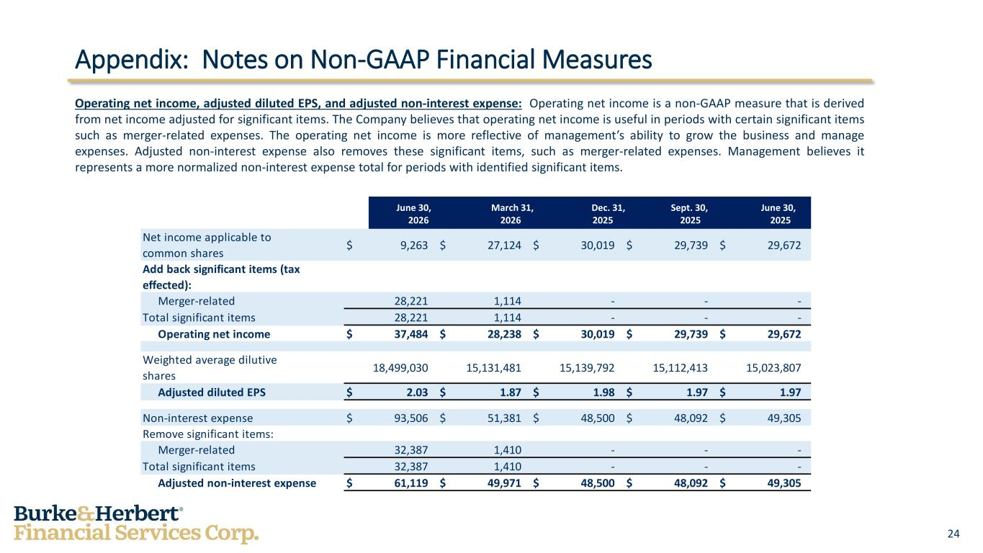
24 Appendix: Notes on Non-GAAP Financial Measures Operating net income, adjusted diluted EPS, and adjusted non-interest expense: Operating net income is a non-GAAP measure that is derived from net income adjusted for significant items. The Company believes that operating net income is useful in periods with certain significant items such as merger-related expenses. The operating net income is more reflective of management’s ability to grow the business and manage expenses. Adjusted non-interest expense also removes these significant items, such as merger-related expenses. Management believes it represents a more normalized non-interest expense total for periods with identified significant items. June 30, March 31, Dec. 31, Sept. 30, June 30, 2026 2026 2025 2025 2025 Net income applicable to common shares $ 9,263 $ 27,124 $ 30,019 $ 29,739 $ 29,672 Add back significant items (tax effected): Merger-related 28,221 1,114 - - - Total significant items 28,221 1,114 - - - Operating net income $ 37,484 $ 28,238 $ 30,019 $ 29,739 $ 29,672 Weighted average dilutive shares 18,499,030 15,131,481 15,139,792 15,112,413 15,023,807 Adjusted diluted EPS $ 2.03 $ 1.87 $ 1.98 $ 1.97 $ 1.97 Non-interest expense $ 93,506 $ 51,381 $ 48,500 $ 48,092 $ 49,305 Remove significant items: Merger-related 32,387 1,410 - - - Total significant items 32,387 1,410 - - - Adjusted non-interest expense $ 61,119 $ 49,971 $ 48,500 $ 48,092 $ 49,305

